**ספר פרויקט**

**שם האפליקציה :** **FindYourSherulLeumi**

אפליקציה לחיפוש תקני שירות-לאומי למועמדים לשירות-הלאומי



**שם הסטודנט: שיר שגב**

**ת"ז, 207385592**

**מנחה: נתן דילברי**

הפרויקט מוגש כפרויקט גמר לקבלת דיפלומת הנדסאי

במגמת : תוכנה

המרכז לעיצוב וטכנולוגיה באריאל

**תוכן עניינים**

1. מבוא 4

1.1 מטרת הפרויקט 4

1.2 רקע 4

1.3 סקירת מצב קיים בשוק 4

1.4 תיאור 4

1.5 מה הפרויקט אמור לשפר או לחדש 4

2. תיאור התוכנה 5

2.1 תכנון מערכת 5

2.2 דרישות ופונקציונאליות 5

3. נתונים טכניים 5

3.1 ממשקים מוצעים 5

3.2 סוגי שירותים 5

3.3 ציוד חומרה ותוכנה נדרשים לביצוע הפרויקט 5

3.4 ציוד חומרה ותוכנה נדרשים לביצוע הפרויקט 6

3.5 בעיות צפויות במהלך פיתוח ופתרונות אפשריים 6

3.6 דרישות המערכת 6

3.7 גבולות המערכת 6

4. ארכיטקטורה ופונקציונאליות 7

4.1 ארכיטקטורת המערכת 7

4.2 טופולוגיית ארכיטקטורת המערכת 7

5. שימוש במבני נתונים וארגון קבצים 8

5.1 בסיס הנתונים 8

5.2 שיטת אחסון נתונים 8

5.3 מנגנוני התאוששות 8

6. טכנולוגיות בשימוש 9

6.1 שפות הפיתוח 9

7. תרשימי מערכת מרכזיים 10

USE CASE 10

8. אבטחת מידע 18

8.1 יעדים עיקריים 18

8.2 נכסים מרכזיים 18

8.3 גורמי סיכון 18

8.4 אסטרטגיית הגנה 18

8.5 אמצעים 18

8.6 בעיות אפשרית בתהליך הזדהות 19

9. בדיקות המערכת 19

9.1 בדיקות תהליכיות ברמת המשתמש 19

10. קוד האפליקציה 20

11. סיכום תהליך הפרויקט 138

11.1 תהליך הפיתוח 138

11.2 משאבים הנדרשים לפרויקט 138

11.3 תרשים גאנט 138

12. ביבליוגרפיה 139

1. מבוא
   1. מטרת הפרויקט

מטרת הפרויקט היא להקל על מועמדים לשירות לאומי את תהליך חיפוש התקן המתאים להם בתוך מגוון רחב של תקני שירות לאומי ברחבי הארץ מעמותות שונות, בעזרת ריכוז כל התקנים באפליקציה אחת, בצורה נוחה, פשוטה ונגישה.

* 1. רקע

בכל שנה ישנם נערים ונערות אשר קיבלו פטור מהשירות הצבאי מסיבות שונות, שבכל זאת רוצים לתרום למדינה ע"י התנדבות בשירות הלאומי .  
קיימים כיום 8 גופים שונים המוכרים כעמותות שירות לאומי. כל עמותה אחראית על איתור, מיון, ושיבוץ המתנדבים בתקנים השונים. לאור ריבוי התקנים ומגוון אגודות השירות הלאומי, חיפוש תקן מתאים נהפך לתהליך מבלבל ומסורבל, אשר מהווה אתגר לנער/נערה, בייחוד שחיפוש התקן המתאים בד"כ מתבצע בכיתה י"ב ועליהם גם ללמוד לבגרויות.

* 1. סקירת מצב קיים בשוק

בכל שנה נפתחים עוד ועוד תקני שירות לאומי במגוון תחומים ומועמדי השירות הלאומי לא מודעים לכל התחומים ולכל התקנים האופציונליים היכולים לעניין אותם ולהתאים להם, וכן לפני שהמועמד מתקבל תפקיד ישנם מיונים לתפקידים השונים ועליו להשקיע זמן ומחשבה בתהליך.

כיום עוד לא קיימת מערכת המשלבת מאגר של תקני שירות לאומי ממספר עמותות (אלא, כל עמותה מציגה את התקנים שלה בלבד) ואין ריכוז של המידע במערכת אחת, מה שיכול להקל משמעותית למועמד את תהליך החיפוש.

* 1. תיאור

הפרויקט מאפשר לרכז את כל התקנים השונים באפליקציה אחת ולהקל למתנדב/ת את תהליך חיפוש התקן המתאים במקום אחד ממגוון תחומים שונים ומגוון עמותות.

* 1. מה הפרויקט אמור לשפר או לחדש

לאחר הבנת הצורך להקל בתהליך חיפוש תקן שירות לאומי עבור מועמדים ולהיחשף בקלות למגוון רחב יותר של תפקידים מעמותות שירות לאומי שונות, הוחלט לייצר פתרון שיאפשר לרכז את התקנים במאגר מידע אחד, התקנים יופיעו באפליקציה אחת עם הפרטים החשובים על התקן כגון: עמותה, תחום וכו' וכן, הרכז/ת שאחראי/ת על תקן יוכל להוסיף תקנים למערכת, וע"י כך תהליך חיפוש התקן המתאים יקל משמעותית על המועמד.

1. תיאור התוכנה
   1. תכנון מערכת

מבחינת סביבת הטמעה ושימוש, האפליקציה תיכתב בשפת Java בסביבת אנדרואיד, באמצעות ANDROID STUDIO.   
האפליקציה תוכל לתמוך במספר משתמשים במקביל ובכך לאפשר עבודה רציפה ומקבילית של המשתמשים.

* 1. דרישות ופונקציונאליות

האפליקציה תצטרך לתמוך בחיבור לרשת, על מנת לבצע חיבור לבסיס הנתונים MySQL לצורך אימות ושליפת נתוני הנתונים.

בנוסף, האפליקציה תצטרך לתמוך במסך מגע לצורך ניווט ושימוש בה.

1. נתונים טכניים
   1. ממשקים מוצעים

אפליקציה למכשירים בעלי מערכת הפעלה אנדרואיד.

* 1. סוגי שירותים

**שירות למשתמש מסוג מתנדב/ת** – השירות יתאפשר למשתמש שנרשם למערכת, השירות ידרוש אימות זהות משתמש ע"י login, לאחר שיאושר שהמשתמש אכן רשום למערכת והמערכת תזהה שהמשתמש הוא מתנדב, הוא יקבל בהתאם גישה לDatabase לצורך שליפת מידע וקבלת נתונים.

**שירות למשתמש מסוג רכז/ת** – השירות יתאפשר למשתמש שנרשם למערכת, השירות ידרוש אימות זהות משתמש ע"י login, לאחר שיאושר שהמשתמש אכן רשום למערכת והמערכת תזהה שהמשתמש הוא רכז/ת, הוא יקבל בהתאם גישה לDatabase לצורך שליפת מידע, קבלת נתונים והוספת מידע חדש. שירות זה מאפשר לרכז/ת להוסיף תקנים חדשים למערכת וכן, למחוק אותם בהתאם לרלוונטיות של התקן.

* 1. ציוד חומרה ותוכנה נדרשים לביצוע הפרויקט
* תוכנת Android Studio
* תוכנת Visual Studio Code
* תוכנת MySQL Workbench
  1. ציוד חומרה ותוכנה נדרשים לביצוע הפרויקט
* מכשיר בעל מערכת הפעלה אנדרואיד / Emulator להרצת מערכת Android
* מחשב PC
* גישה לאינטרנט
  1. בעיות צפויות במהלך פיתוח ופתרונות אפשריים

|  |  |
| --- | --- |
| **בעיה** | **פתרון** |
| בעיות חיבור בין בסיס הנתונים בצד הלקוח | אימות הנתונים מול השרת |
| בעיות אימות נתוני המשתמש של הלקוח אל מול השרת | ווידוא כי מערכת שחזור הסיסמאות עובדת תקין |
| בעיות בזמן בניית ותכנון בסיס הנתונים מבחינת מבנה , חיבור בין בסיס הנתונים שמכיל את נתוני התקנים ושליפתם לכל רכז/ת ספציפי | בדיקת הדרך הנכונה ביותר לבניית בסיס הנתונים, כולל ארכיטקטורה, בדיקה שהמידע מסודר כצורך ולפי הקריטריונים הרצויים והתייעצות עם המנחה |
| בעיות של ביצועים של התוכנה כלומר איטיות, תקיעות, קריסות וכדומה | בדיקת הקוד הכולל של האפליקציה לוודא סדר בקוד וכתיבה נכונה ושימוש בבקשות HTTP המחזירות קוד שגיאה במקרה של תקלה כלשהי |
| בעיית העברת מידע בפורמט אחיד בין מערכות שונות המתבססות על שפות תכנות שונות | העברת נתונים בין השרתים כאובייקטי JSON על מנת ליצור פורמט אחיד |

* 1. דרישות המערכת

**צד הלקוח:** מכשיר סמארטפון בעל מערכת הפעלה אנדרואיד.

**צד שרת:** NodeJS וMySQL לDatabase

* 1. גבולות המערכת

לאפליקציה נדרש קישור לרשת האינטרנטית על מנת לגשת לשרת ולכן, ללא קישור לאינטרנט לא ניתן יהיה לגשת לנתונים.

1. ארכיטקטורה ופונקציונאליות
   1. ארכיטקטורת המערכת

מכיוון שהמערכת כוללת בתוכה אובייקטים רבים, לוגיקות ומניפולציות על אותם אובייקטים, אחסון של אובייקטים שונים במסד הנתונים ,שליפתם בעת הצורך, הצגתם למשתמש ועוד חלקי קוד רבים, לכן ישנו צורך לבנות את המערכת מעוצבת על ידי ארכיטקטורה, שתקל על מהלך הפיתוח המסועף.

מודל שרת-לקוח הוא ארכיטקטורת תוכנה המפרידה בין שכבה ושכבה, כך שלכל שכבה יש גישה רק לשכבה שמעליה או מתחתיה. כך יותר קל לנהל את עבודת הפרויקט בצורה יעילה ומסודרת. בנוסף לכך במידה ויהיה צורך לבצע שינויים באחת מן השכבות לא יהיה צורך לשנות את הפרויקט כולו וכן ארכיטקטורת זו תאפשר החלפה או שדרוג בעתיד של כל אחת מהשכבות באופן בלתי תלוי בשכבות האחרות, בהתאם לדרישות או לשינויים בטכנולוגיה.

מבנה המערכת:

צד שרת + מסד נתונים

צד לקוח

* 1. טופולוגיית ארכיטקטורת המערכת

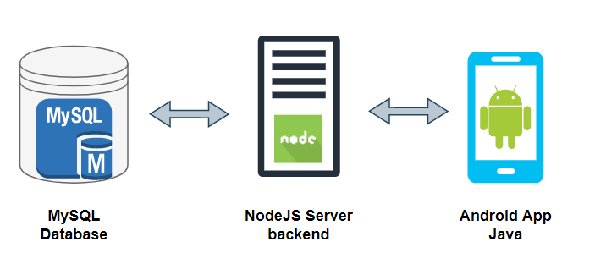

1. שימוש במבני נתונים וארגון קבצים
   1. בסיס הנתונים

ימומש באמצעות MySQL בצד השרת

בסיס הנתונים של המערכת יכיל 4 טבלאות:

1. טבלת תקני שירות לאומי.
2. טבלה עבור מועמדים.
3. טבלת עבור רכזים.
4. טבלת רמות משתמשים.

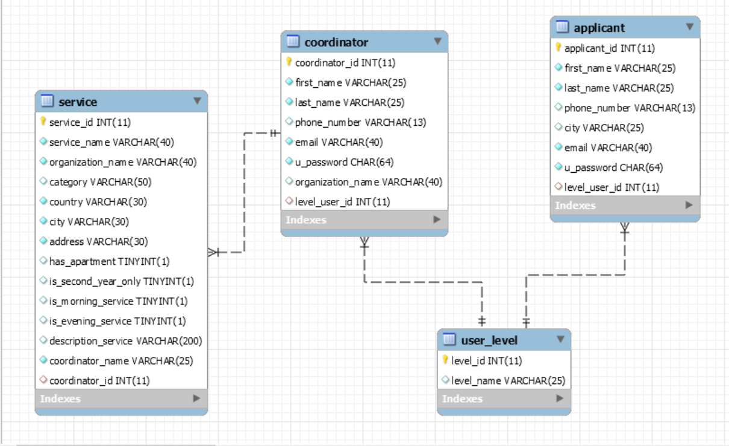

* 1. שיטת אחסון נתונים

הנתונים ישמרו בסיס הנתונים MySQL

* 1. מנגנוני התאוששות

המידע יגובה על בסיס יומי

1. טכנולוגיות בשימוש

* **Android Studio -** הינה סביבת עבודה (IDE – Integrated Development Environment) של Google לפיתוח אפליקציות למערכת ההפעלה Android שנבנתה על בסיס IntelliJ IDEA ותוכננה לפיתוח במערכת Android.

פיתוח האפליקציות ניתן לביצוע בשפות Java או Kotlin (בפרויקט הנ"ל הפיתוח התבצע בשפת Java).

* **שרת Node.js -** Node.js הוא מפרש לשפת JavaScript שנכתב ב-C++ ומבוסס על מנוע V8. הוא תוכנן לכתיבת אפליקציות רשת כגון שרתי HTTP. Node.js בניגוד לJavaScript אינו מורץ בצד הלקוח, אלא בצד השרת.
* **MySQL –** הוא מסד נתונים טבלאי, מבוסס שפת SQL‏ (Structured Query Language). התוכנה פותחה במקור ע"י חברת MySQL AB אך כיום בבעלות חברת Oracle. בMySQL משתמשות מערכות ניהול תוכן רבות כבסיס נתונים.
  1. שפות הפיתוח
* **Java -** שפת תכנות מונחית עצמים. שפת Java משמשת לפיתוח תוכנות ואפליקציות הן למחשב והן למכשירי סלולר.
* **XML (eXtensible Markup Language) -** תקן לקידוד וייצוג נתונים ומידע באופן טקסטואלי, תקן ה-XML מגדיר כיצד לייצג מידע, בפורמט שניתן לקריאה ע"י אדם וע"י מכונה. ייצוג המידע מתבצע תוך שימוש בתגיות שמגדירות רכיבי מידע.

1. תרשימי מערכת מרכזיים

USE CASE **6.1**

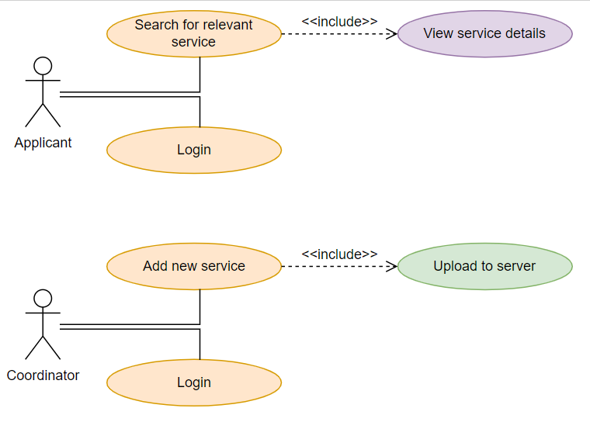

**6.2** ממשקי מערכת

**דף כניסה – עברית/אנגלית**

לצורך כניסה למערכת יש להקיש כתובת אימייל וסיסמה

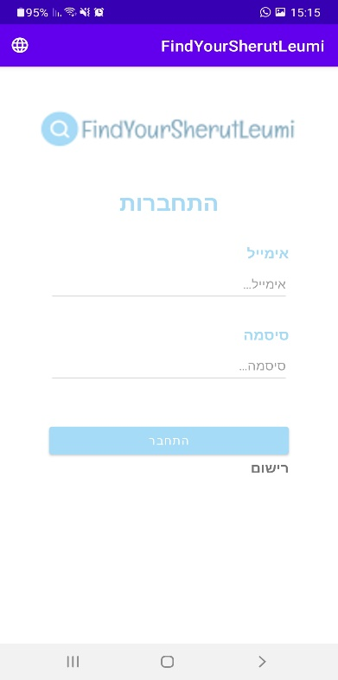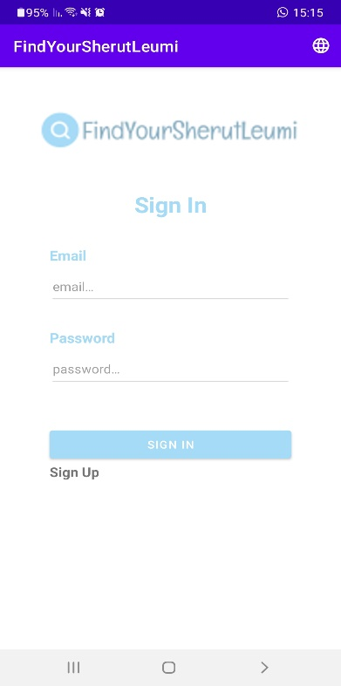

לאחר לחיצה על מקש החלפת שפה – ניתן לבחור עברית/אנגלית

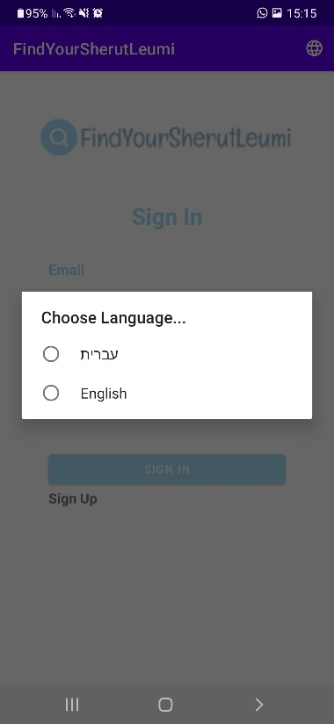

**דף רישום למערכת**

ניתן להירשם למערכת לאחר בחירת סוג הרשמה

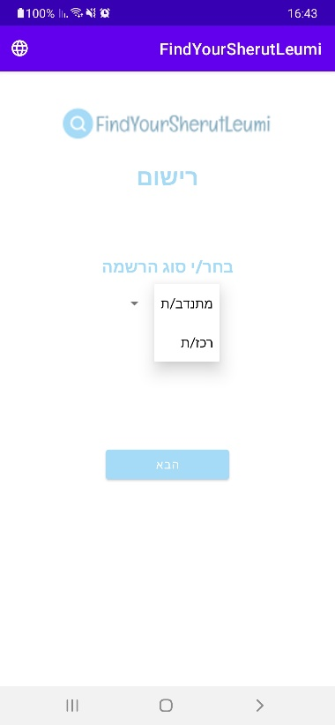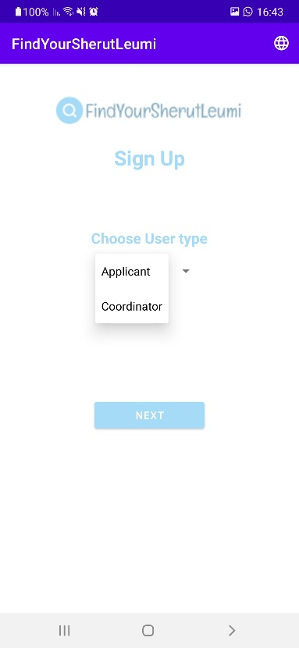

עמוד מילוי פרטים לאחר בחירת סוג משתמש

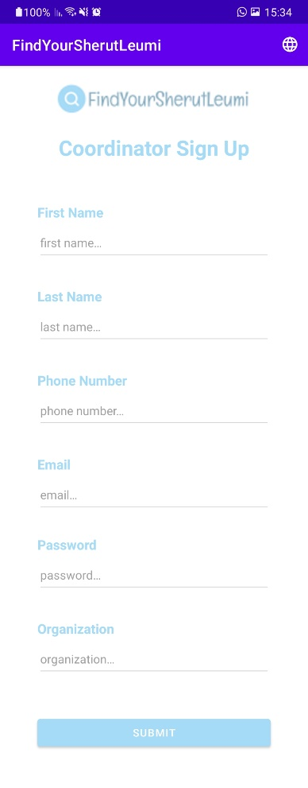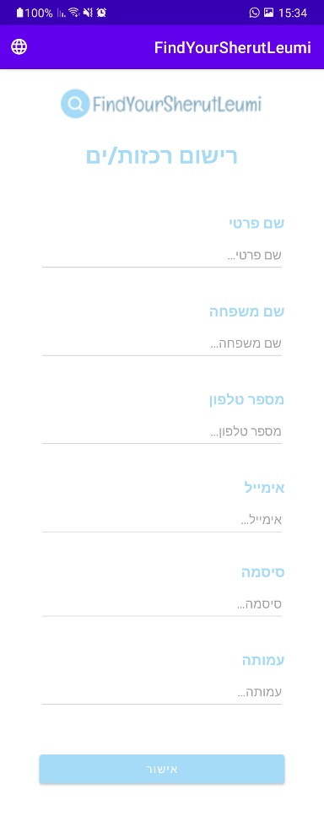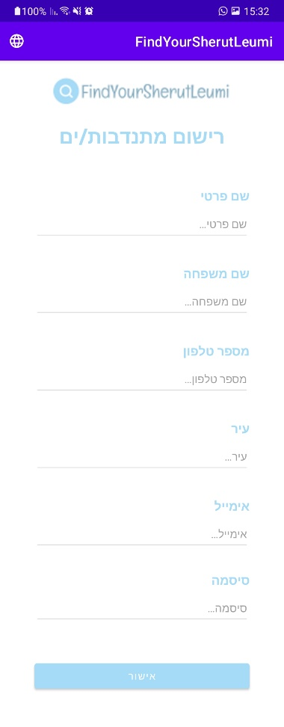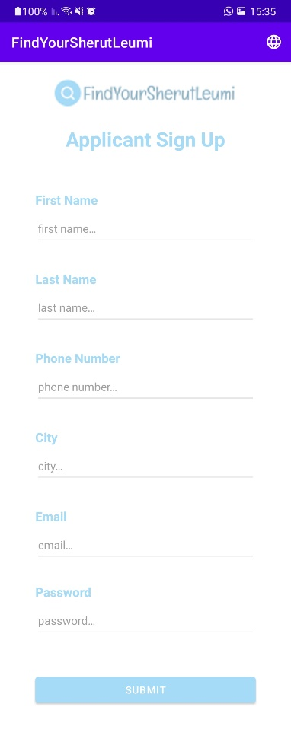

**העמוד הראשי – מתנדב/ת**

התקנים הזמינים באפליקציה

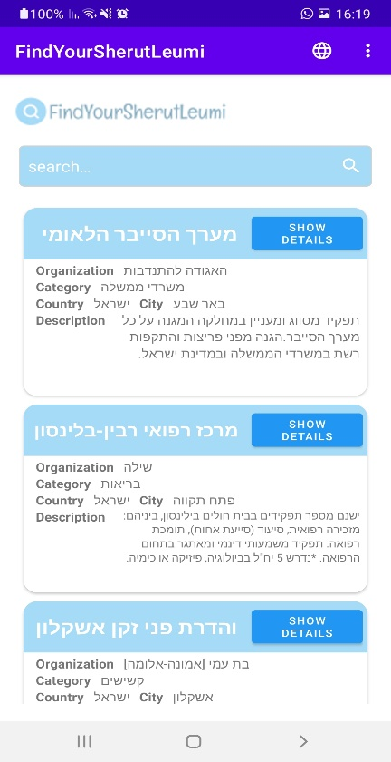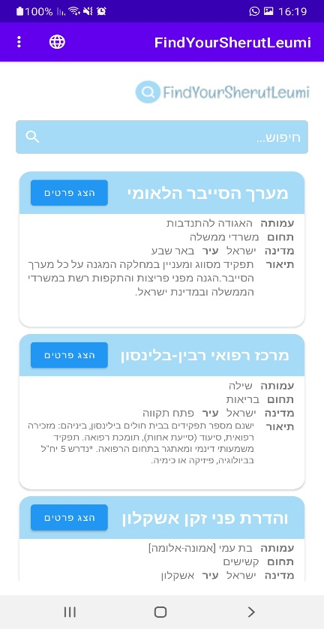

**העמוד הראשי – רכז/ת**

התקנים הזמינים באפליקציה

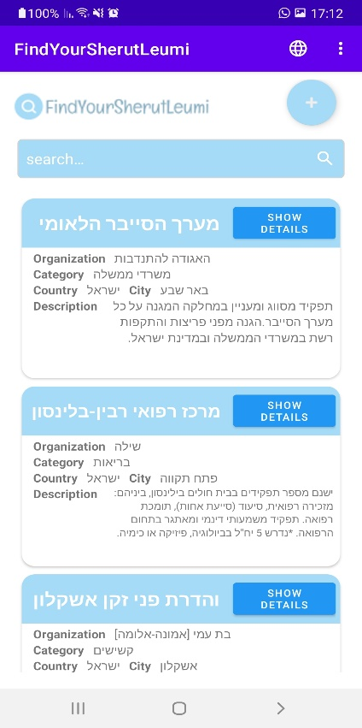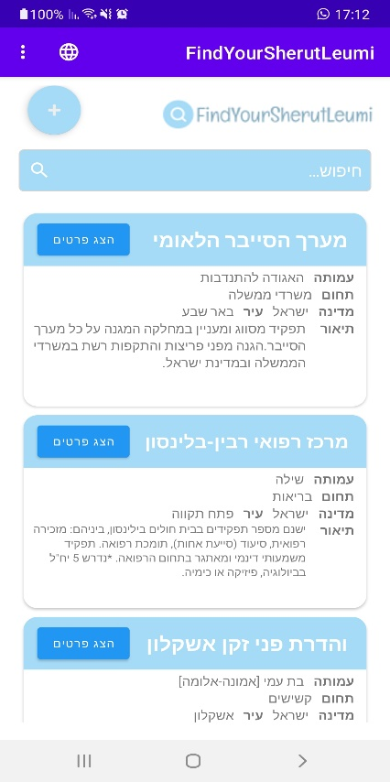

**עמוד פרטי תקן**

הפרטים המלאים של אותו תקן

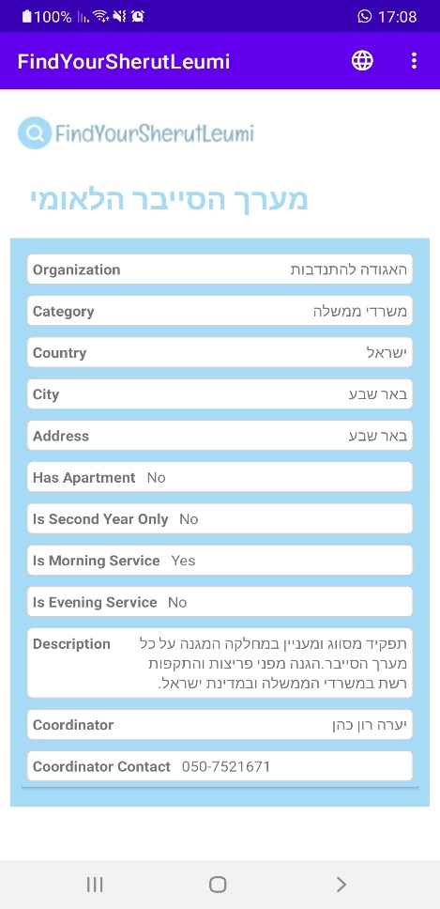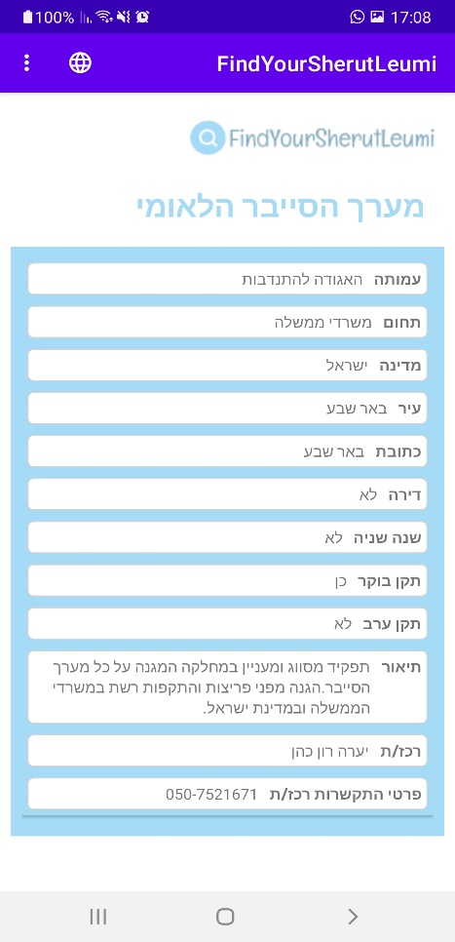

לאחר לחיצה על התפריט בראש האפליקציה – ניתן לגשת להגדרות או להתנתק מהמערכת

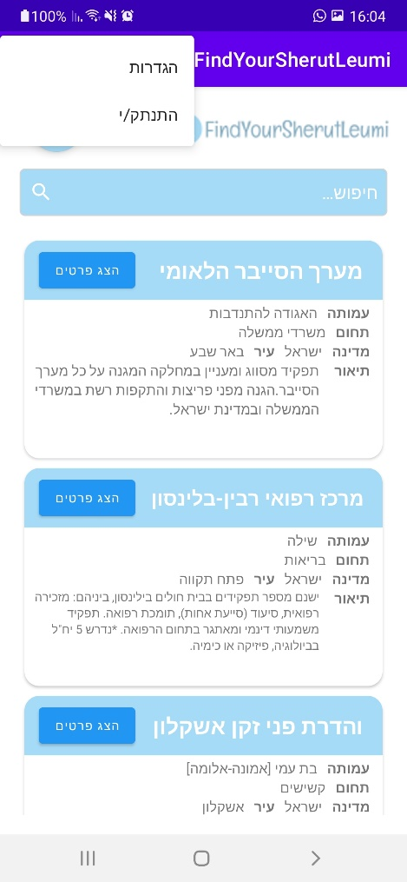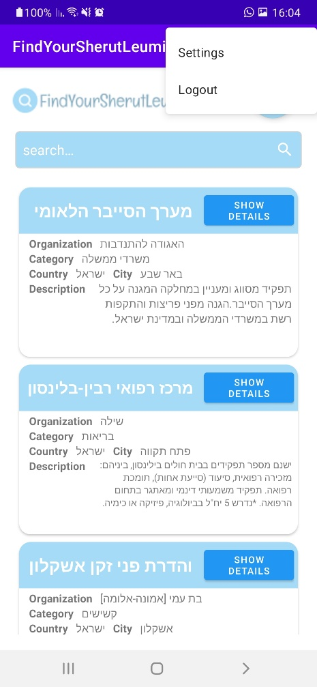

**עמוד הגדרות – מתנדב/ת**

ניתן לערוך פרטים אישיים ולמחוק את החשבון

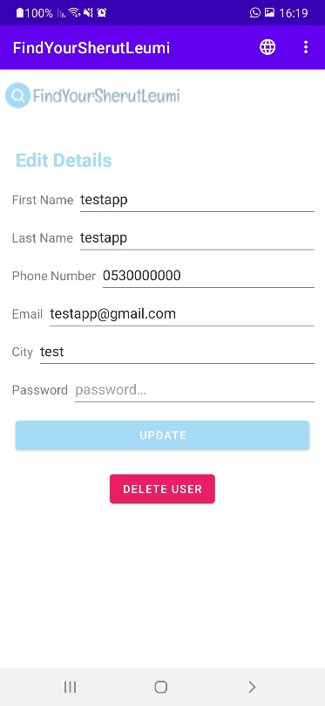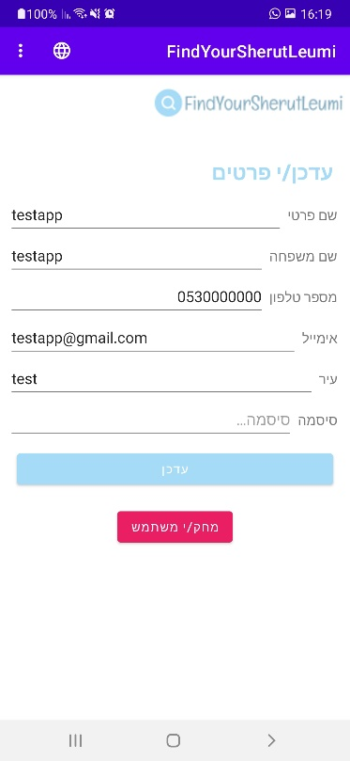

**עמוד הגדרות – רכז/ת**

ניתן לערוך פרטים אישיים, למחוק תקן או למחוק את החשבון

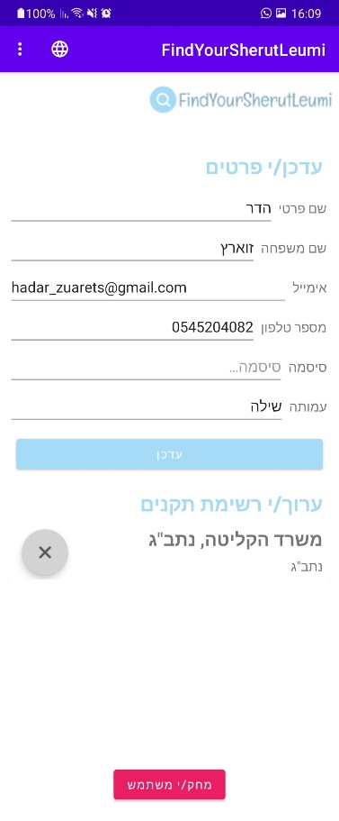

**עמוד הוספת תקן**

הרכז/ת ממלא/ת את כל השדות הנדרשים על מנת להוסיף תקן חדש למערכת

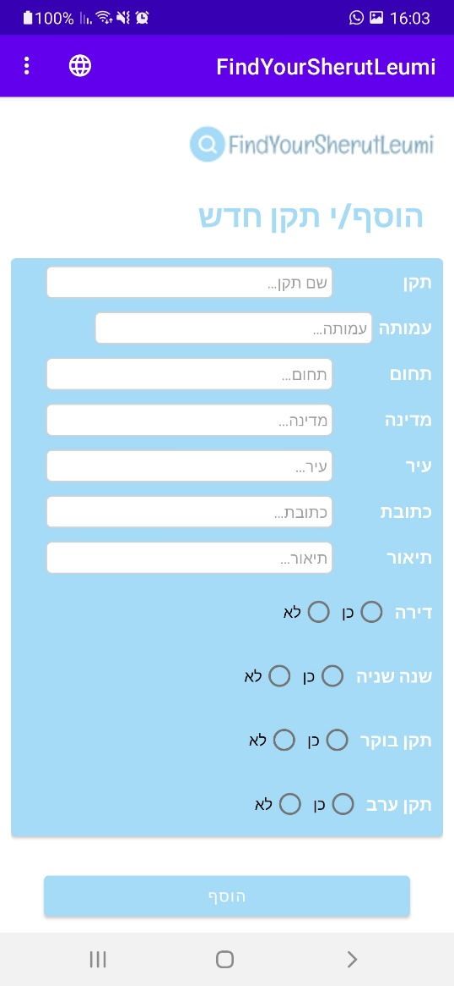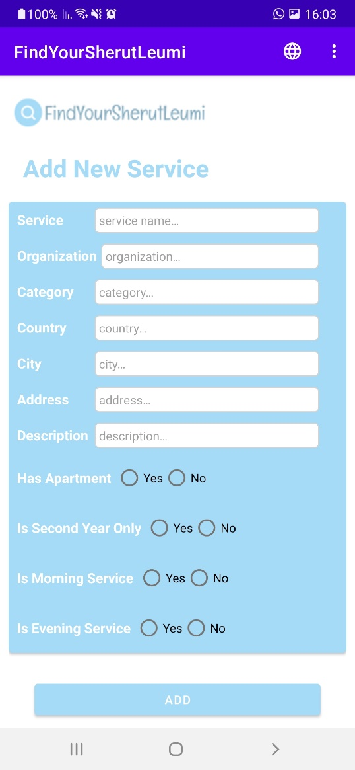

1. אבטחת מידע

החלקים בהם נדרשת אבטחה, סיסמאות המשתמשים שיוכנסו בעת הרשמה יוצפנו בקוד השרת בשיטת BYCRYPT, לאחר מילוי פרטי ההרשמה ואישורם, הסיסמא תעבור הצפנה וכך תישמר במסד הנתונים. כאשר המשתמש יתחבר למערכת, הוא יכניס את סיסמתו המקורית אשר תעבור שוב הצפנה, וסיסמא זו תיבדק מול הסיסמא המוצפנת ששמורה במסד הנתונים.

* 1. יעדים עיקריים

הגבלת גישה לאלו הלא רשאים.

שמירה על יעילות וזמינות הגישה אל המידע.

* 1. נכסים מרכזיים

חיסיון המידע - המידע יהיה נגיש לגורם מורשה בלבד וכן, מערכת המידע יהיו זמינים בהתאם לרמת המשתמש שהוגדרה בעת ההרשמה למערכת.

* 1. גורמי סיכון

**טכנולוגיות** – מערכות החומרה, התוכנה והתקשורת המהוות "מערכות".

**אנשים** – המשתמשים בטכנולוגיות מהווים חוליה חלשה במיוחד, מכיוון שהם מפעילים או משתמשים בטכנולוגיות, ונוטים לעשות שגיאות המייצרות פרצות במערך ההגנה אשר מאפשרות לתוקף לנצלן.

**תהליכים** – מידת הנזק משגיאת אנוש או נקודת תורפה טכנולוגית עשויה לִהצטמצם מאוד אם מבוצע תכנון נכון של התהליכים בארגון. הגדרת תהליכים בצורה נכונה מאפשר זיהוי מוקדם של פגיעה או ניסיון פגיעה במערכות.

* 1. אסטרטגיית הגנה

על מנת לאבטח את פרטיות המשתמשים, על כל משתמש ליצור פרופיל המכיל שם משתמש וסיסמא. הסיסמה נשמרת מוצפנת ובעת התחברות למערכת, מתבצע אימות בין הקלט לבין המידע השמור במערכת, רק לאחר אימות הפרטים, המשתמש יקבל גישה לאפליקציה.

* 1. אמצעים

**הרשאות** - מתן אפשרות למשתמש מסוים לבצע פעולה נתונה במערכת מידע. הפעולות עשויות להיות יצירה, כתיבה, מחיקה או שינוי של קובץ או כל פעולה אחרת שהמערכת תוכננה להכיל. מערכת הרשאות מתבססת על הזדהות כתנאי מקדים, שכן המערכת נדרשת לקשר בין משתמש לפעולה.

**הזדהות** - תהליך בו משתמש (אדם או שירות ממוחשב) מספק למערכת מידע פריט מידע המזהה אותו ואמצעי לווידוא הזיהוי. האמצעי הנפוץ ביותר הוא השימוש בשם משתמש וסיסמה.

* 1. בעיות אפשרית בתהליך הזדהות

אובדן יכולת התחברות (לרוב איבוד סיסמה או שם משתמש).

אובדן תקשורת עם השרת.

שינוי הסיסמה על ידי פריצה.

1. בדיקות המערכת
   1. בדיקות תהליכיות ברמת המשתמש

|  |  |
| --- | --- |
| **פעולה לביצוע** | **תוצאה** |
| פתיחת האפליקציה | הצגת עמוד התחברות |
| בחירת שפה של האפליקציה | הצגת חלון שפות ושינוי שפה בהתאם |
| רישום לאפליקציה | הצגת עמוד התחברות |
| התחברות לאפליקציה | הצגת עמוד ראשי |
| צפייה בפרטים מלאים של תקן מסוים | הצגת פרטים מלאים של התקן הנבחר |
| הוספת תקן חדש ממשתמש מסוג רכז/ת | הצגת עמוד הוספת תקן חדש |
| מחיקת תקן ממשתמש מסוג רכז/ת | תקן לא יופיע יותר ברשימת התקנים של הרכז/ת |
| עדכון פרטים אישיים | שינוי הפרטים האישיים והצגתם בהתאם |

* **דרישה:** על המערכת להיות נגישה אך ורק למשתמשים הרשומים למערכת דרך התחברות מאובטחת.
* **בדיקה:** לחיצה על כפתור התחברות כאשר שדות הקלט ריקים / מלאים בפרטים שלא רשומים במערכת, ההתחברות תיכשל והמשתמש לא יעבור לדף הראשי.
* **דרישה:** על המערכת לזהות תוכן ריק בשדות קלט שחובה להזין בהם קלט.
* **בדיקה:** לחיצה על כפתור הוספת תקן כאשר שדות הקלט ריקים, ההוספה תיכשל והתקן לא יתווסף למאגר.

1. קוד האפליקציה

**10.1** צד שרת

**10.1.1** עץ תיקיות

**10.1.2** קבצי JS

**config**

config.js

const mysql = require("mysql2");

// creating a connection with the db

const pool = mysql.createPool({

  host: process.env.DB_HOST,

  user: process.env.DB_USER,

  database: process.env.DB_NAME,

  password: process.env.DB_PASSWORD,

});

module.exports = pool.promise();

**controllers**

applicantController.js

const pool = require("../config/db");

const bcrypt = require("bcrypt");

// GET - gets all applicants from db

exports.getAllApplicants = async (req, res, next) => {

  try {

    const [applicants] = await pool.execute("CALL get_all_applicants()");

    res.status(200).json(applicants[0]);

  } catch (err) {

    console.log(err);

    next(err);

  }

};

// gets specific applicant from db

exports.getApplicantById = async (req, res, next) => {

  const id = req.params.id;

  try {

    const [result, _] = await pool.execute("CALL get_applicant_by_id(?)", [

      id,

    ]);

    const applicant = result[0][0];

    res.status(200).json(applicant);

    console.log(applicant[0]);

  } catch (err) {

    console.log(err);

    next(err);

  }

};

// gets specific applicant from db by email

exports.getApplicantByEmail = async (req, res, next) => {

  const email = req.params.email;

  try {

    const [result, _] = await pool.execute("CALL get_applicant_by_email(?)", [

      email,

    ]);

    const applicant = result[0][0];

    res.status(200).json(applicant);

  } catch (err) {

    console.log(err);

    next(err);

  }

};

// POST - post new applicant to the db

exports.createNewApplicant = async (req, res, next) => {

  const {

    first_name,

    last_name,

    phone_number,

    city,

    email,

    u_password,

  } = req.body;

  try {

      const hash_password = await bcrypt.hash(u_password, 12);

      const applicant = await pool.execute(

      "CALL add_new_applicant(?,?,?,?,?,?)",

      [first_name, last_name, phone_number, city, email, hash_password]

    );

    res.status(201).json({ applicant });

  } catch (err) {

    console.log(err);

    next(err);

  }

};

// PUT - put new update to a applicant from the db

exports.updateApplicantById = async (req, res, next) => {

  const id = req.params.id;

  const {

    first_name,

    last_name,

    phone_number,

    city,

    email,

    u_password,

  } = req.body;

  try {

    const hash_password = await bcrypt.hash(u_password, 12);

    const applicant = await pool.execute(

      "CALL update_applicant(?,?,?,?,?,?,?)",

      [id, first_name, last_name, phone_number, city, email, hash_password]

    );

    res.status(201).json(applicant[0]);

  } catch (err) {

    console.log(err);

    next(err);

  }

};

// DELETE - delete applicant from db by id

exports.deleteApplicantById = async (req, res, next) => {

  const id = req.params.id;

  try {

    const deleted = await pool.execute("CALL delete_applicant(?)", [id]);

    res.sendStatus(200);

  } catch (err) {

    console.log(err);

    next(err);

  }

};

coordinatorController.js

const pool = require("../config/db");

// GET - gets all levels from db

exports.getAllLevels = async (req, res, next) => {

  try {

    const [levels] = await pool.execute("CALL get_all_levels()");

    res.status(200).json(levels[0]);

  } catch (err) {

    console.log(err);

    next(err);

  }

};

// gets specific level from db

exports.getLevelById = async (req, res, next) => {

  const id = req.params.id;

  try {

    const [result, _] = await pool.execute("CALL get_level_by_id(?)", [id]);

    const level = result[0][0];

    res.status(200).json(level);

  } catch (err) {

    console.log(err);

    next(err);

  }

};

// POST - post new level user to the db

exports.createNewLevelUser = async (req, res, next) => {

  const { level_name } = req.body;

  try {

    const level = await pool.execute("CALL add_new_level(?)", [level_name]);

    res.status(201).json({ level });

  } catch (err) {

    console.log(err);

    next(err);

  }

};

// PUT - put new update to a level user from the db

exports.updateLevelById = async (req, res, next) => {

  const id = req.params.id;

  const { level_name } = req.body;

  try {

    const level = await pool.execute("CALL update_level(?,?)", [

      id,

      level_name,

    ]);

    res.status(201).json(level[0]);

  } catch (err) {

    console.log(err);

    next(err);

  }

};

// DELETE - delete level from db by id

exports.deleteLevelById = async (req, res, next) => {

  const id = req.params.id;

  try {

    const deleted = await pool.execute("CALL delete_level(?)", [id]);

    res.status(200).json(deleted[0]);

  } catch (err) {

    console.log(err);

    next(err);

  }

};

generalController.js

const pool = require("../config/db");

const bcrypt = require("bcrypt");

// gets user from db by email

exports.getUserByEmail = async (req, res, next) => {

    const email = req.body.email;

    try {

      const [user, _] = await pool.execute(

        "CALL get_user_by_email(?)",

        [email]

      );

      res.status(200).json(user[0]);

    } catch (err) {

      console.log(err);

      next(err);

    }

  };

exports.authenticateUser = async (req, res, next) => {

  const email = req.body.email;

  const password = req.body.u_password;

  try {

    const [result, _] = await pool.execute("CALL get_user_by_email(?)", [email]);

    const user = result[0][0];

    console.log(user);

    console.log(user.u_password);

    if(user != undefined){

        const isvalid = await bcrypt.compare(password, user.u_password).then((valid) => {

          if(valid){

              res.status(200).json(user);

          } else {

              res.status(401).json("Email and password does not match");

              console.log("code 401");

          }

        })

      .catch((err) => next(err));

    }

    else res.status(401).json("Email does not exist");

  } catch (err) {

    console.log(err);

    next(err);

  }

};

serviceController.js

const pool = require("../config/db");

// GET - gets all services from db

exports.getAllServices = async (req, res, next) => {

  try {

    const [services] = await pool.execute("CALL get_all_services()");

    res.status(200).json(services[0]);

  } catch (err) {

    console.log(err);

    next(err);

  }

};

// gets all services partialy from db

exports.getAllServicesPartially = async (req, res, next) => {

  try {

    const [services] = await pool.execute("CALL get_all_services_partially()");

    res.status(200).json(services[0]);

  } catch (err) {

    console.log(err);

    next(err);

  }

};

// gets specific service from db

exports.getServiceById = async (req, res, next) => {

  const id = req.params.id;

  try {

    const [result, _] = await pool.execute("CALL get_service_by_id(?)", [id]);

    const service = result[0][0];

    res.status(200).json(service);

  } catch (err) {

    console.log(err);

    next(err);

  }

};

// gets specific service from db

exports.getServicesByCoordinatorId = async (req, res, next) => {

  const id = req.params.id;

  try {

    const [service, _] = await pool.execute("CALL get_service_by_coordinator_id(?)", [id]);

    res.status(200).json(service[0]);

  } catch (err) {

    console.log(err);

    next(err);

  }

};

// POST - post new service to the db

exports.createNewService = async (req, res, next) => {

  const {

    service_name,

    organization_name,

    category,

    country,

    city,

    address,

    has_apartment,

    is_second_year_only,

    is_morning_service,

    is_evening_service,

    description_service,

    coordinator_name,

    coordinator_id

  } = req.body;

  try {

    const service = await pool.execute(

      "CALL add_new_service(?,?,?,?,?,?,?,?,?,?,?,?,?)",

      [

        service_name,

        organization_name,

        category,

        country,

        city,

        address,

        has_apartment,

        is_second_year_only,

        is_morning_service,

        is_evening_service,

        description_service,

        coordinator_name,

        coordinator_id

      ]

    );

    res.status(201).json({ service });

  } catch (err) {

    console.log(err);

    next(err);

  }

};

// PUT - put new update to a service from the db

exports.updateServiceById = async (req, res, next) => {

  const id = req.params.id;

  const {

    service_name,

    organization_name,

    category,

    country,

    city,

    address,

    has_apartment,

    is_second_year_only,

    is_morning_service,

    is_evening_service,

    description_service,

    coordinator_name,

  } = req.body;

  try {

    const service = await pool.execute(

      "CALL update_service(?,?,?,?,?,?,?,?,?,?,?,?,?)",

      [

        id,

        service_name,

        organization_name,

        category,

        country,

        city,

        address,

        has_apartment,

        is_second_year_only,

        is_morning_service,

        is_evening_service,

        description_service,

        coordinator_name,

      ]

    );

    res.status(201).json(service[0]);

  } catch (err) {

    console.log(err);

    next(err);

  }

};

// DELETE - delete service from db by id

exports.deleteServiceById = async (req, res, next) => {

  const id = req.params.id;

  try {

    const deleted = await pool.execute("CALL delete_service(?)", [id]);

    res.sendStatus(200);

  } catch (err) {

    console.log(err);

    next(err);

  }

};

// delete all services from db by coordinator id

exports.deleteServicesByCoordinatorId = async (req, res, next) => {

  const id = req.params.id;

  try {

    const deleted = await pool.execute("CALL delete_services_by_coordinator_id(?)", [id]);

    res.sendStatus(200);

  } catch (err) {

    console.log(err);

    next(err);

  }

};

userLevelController.js

const pool = require("../config/db");

// GET - gets all levels from db

exports.getAllLevels = async (req, res, next) => {

  try {

    const [levels] = await pool.execute("CALL get_all_levels()");

    res.status(200).json(levels[0]);

  } catch (err) {

    console.log(err);

    next(err);

  }

};

// gets specific level from db

exports.getLevelById = async (req, res, next) => {

  const id = req.params.id;

  try {

    const [result, _] = await pool.execute("CALL get_level_by_id(?)", [id]);

    const level = result[0][0];

    res.status(200).json(level);

  } catch (err) {

    console.log(err);

    next(err);

  }

};

// POST - post new level user to the db

exports.createNewLevelUser = async (req, res, next) => {

  const { level_name } = req.body;

  try {

    const level = await pool.execute("CALL add_new_level(?)", [level_name]);

    res.status(201).json({ level });

  } catch (err) {

    console.log(err);

    next(err);

  }

};

// PUT - put new update to a level user from the db

exports.updateLevelById = async (req, res, next) => {

  const id = req.params.id;

  const { level_name } = req.body;

  try {

    const level = await pool.execute("CALL update_level(?,?)", [

      id,

      level_name,

    ]);

    res.status(201).json(level[0]);

  } catch (err) {

    console.log(err);

    next(err);

  }

};

// DELETE - delete level from db by id

exports.deleteLevelById = async (req, res, next) => {

  const id = req.params.id;

  try {

    const deleted = await pool.execute("CALL delete_level(?)", [id]);

    res.status(200).json(deleted[0]);

  } catch (err) {

    console.log(err);

    next(err);

  }

};

**routes**

applicantRoute.js

const express = require("express");

const applicantController = require("../controllers/applicantController");

const router = express.Router();

// GET

router.route("/").get(applicantController.getAllApplicants);

router.route("/email/:email").get(applicantController.getApplicantByEmail); // GET by email

router

  .route("/:id")

  .get(applicantController.getApplicantById) // GET by id

  .put(applicantController.updateApplicantById) // PUT by id

  .delete(applicantController.deleteApplicantById); // DELETE by id

// POST

router.post("/add", applicantController.createNewApplicant);

module.exports = router;

coordinatorRoute.js

const express = require("express");

const coordinatorController = require("../controllers/coordinatorController");

const router = express.Router();

// GET

router.route("/").get(coordinatorController.getAllCoordinators);

router.route("/email/:email").get(coordinatorController.getCoordinatorByEmail);

router

  .route("/:id")

  .get(coordinatorController.getCoordinatorById) // GET by id

  .put(coordinatorController.updateCoordinatorById) // PUT by id

  .delete(coordinatorController.deleteCoordinatorById); // DELETE by id

// POST

router.post("/add", coordinatorController.createNewCoordinator);

module.exports = router;

generalRoute.js

const express = require("express");

const generalController = require("../controllers/generalController");

const router = express.Router();

router.route("/").get(generalController.getUserByEmail);

router.route("/").post(generalController.authenticateUser);

module.exports = router;

serviceRoute.js

const express = require("express");

const serviceController = require("../controllers/serviceController");

const router = express.Router();

// GET

router.route("/").get(serviceController.getAllServices);

router.route("/coordinator/:id").get(serviceController.getServicesByCoordinatorId);

// POST

router.post("/add", serviceController.createNewService);

// DELETE

router.route("/coordinator/delete/:id").delete(serviceController.deleteServicesByCoordinatorId);

router

  .route("/:id")

  .get(serviceController.getServiceById) // GET by id

  .put(serviceController.updateServiceById) // PUT by id

  .delete(serviceController.deleteServiceById); // DELETE by id

module.exports = router;

userLevelRoute.js

const express = require("express");

const userLevelController = require("../controllers/userLevelController");

const router = express.Router();

// GET

router.route("/").get(userLevelController.getAllLevels);

router

  .route("/:id")

  .get(userLevelController.getLevelById) // GET by id

  .put(userLevelController.updateLevelById) // PUT by id

  .delete(userLevelController.deleteLevelById); // DELETE by id

// POST

router.post("/add", userLevelController.createNewLevelUser);

module.exports = router;

server.js

require("dotenv").config();

const express = require("express");

const app = express();

app.use(express.urlencoded({ extended: true }));

// const PORT = process.env.PORT || 3000;

app.use(express.json());

app.use("/services", require("./routes/serviceRoute"));

app.use("/userLevels", require("./routes/userLevelRoute"));

app.use("/applicants", require("./routes/applicantRoute"));

app.use("/coordinators", require("./routes/coordinatorRoute"));

app.use("/login", require("./routes/generalRoute"));

app.use((err, req, res, next) => {

  console.log(err.stack);

  console.log(err.name);

  console.log(err.code);

  res.status(500).json({

    massage: "Somthing went wrong...",

  });

});

app.all("/*", (req, res) => {

  res.status(404)

  .json({massage : `${req.method} on ${req.originalUrl} not found`});

})

// app.listen(PORT, () => console.log(`Listening on port ${PORT}...`));

module.exports = app;

connection.js

require("dotenv").config();

const PORT = process.env.PORT || 3000;

const server = require("./server");

const connect = require("http").createServer(server);

module.exports = { connect };

connect.listen(PORT, () => console.log(`Listening on port ${PORT}...`))

**10.2** צד לקוח

**10.2.1** עץ תיקיות

**XML Java**

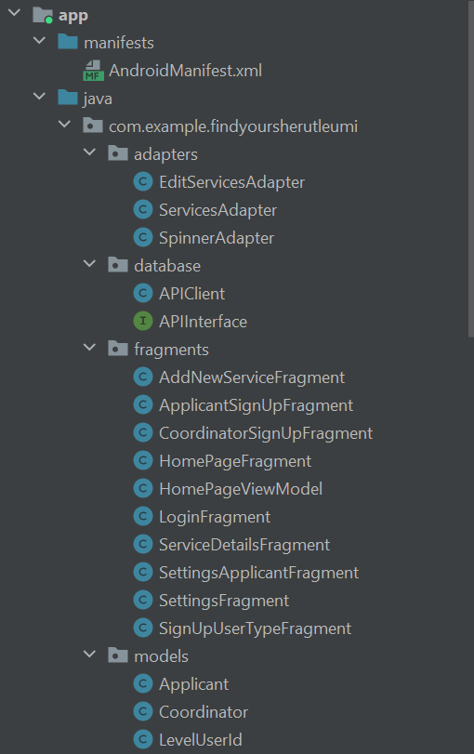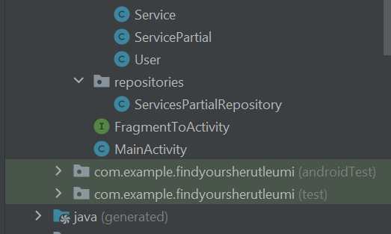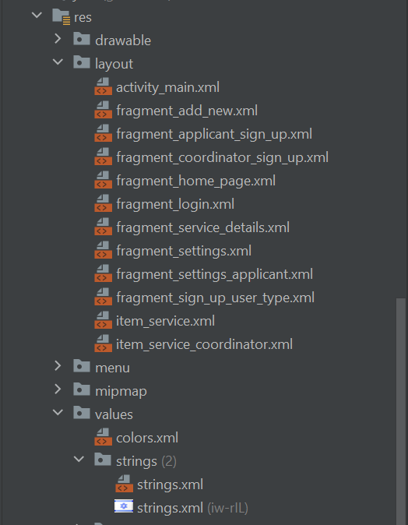

**10.2.2** קבצי Java

**manifests**

<?xml version="1.0" encoding="utf-8"?>  
<manifest xmlns:android="http://schemas.android.com/apk/res/android"  
 xmlns:tools="http://schemas.android.com/tools"  
 package="com.example.findyoursherutleumi">  
 <uses-permission android:name="android.permission.INTERNET"/>  
 <uses-permission android:name="android.permission.ACCESS_NETWORK_STATE"/>  
  
 <application  
 android:allowBackup="true"  
 android:dataExtractionRules="@xml/data_extraction_rules"  
 android:fullBackupContent="@xml/backup_rules"  
 android:icon="@drawable/rounded_logo"  
 android:label="@string/app_name"  
 android:roundIcon="@drawable/rounded_logo"  
 android:supportsRtl="true"  
 android:theme="@style/Theme.FindYourSherutLeumi"  
 android:usesCleartextTraffic="true"  
 tools:targetApi="31">  
 <activity  
 android:name=".MainActivity"  
 android:exported="true">  
 <intent-filter>  
 <action android:name="android.intent.action.MAIN" />  
  
 <category android:name="android.intent.category.LAUNCHER" />  
 </intent-filter>  
 </activity>  
 </application>  
  
</manifest>

**database**

APIClient.java

package com.example.findyoursherutleumi.database;  
  
import androidx.appcompat.app.AppCompatActivity;  
  
import com.example.findyoursherutleumi.models.User;  
import com.google.gson.Gson;  
import com.google.gson.GsonBuilder;  
  
import retrofit2.Retrofit;  
import retrofit2.converter.gson.GsonConverterFactory;  
  
public class APIClient extends AppCompatActivity {  
  
 private static Retrofit *instance*;

// switch BASE_URL if needed  
// private static final String BASE_URL = "http://10.0.2.2:3000/";private static final String *BASE_URL* = "http://192.168.1.104:3000/";  
  
 public static Retrofit getInstance(){  
 if (*instance* == null){  
 Gson gson = new GsonBuilder().setLenient().create();  
 *instance* = new Retrofit.Builder()  
 .baseUrl(*BASE_URL*)  
 .addConverterFactory(GsonConverterFactory.*create*(gson))  
 .build();  
 }  
 return *instance*;  
 }  
  
 public static User getUserService(){  
 User userService = *getInstance*().create(User.class);  
  
 return userService;  
 }  
  
  
  
}

APIInterfacet.java

package com.example.findyoursherutleumi.database;  
  
import com.example.findyoursherutleumi.models.Applicant;  
import com.example.findyoursherutleumi.models.Coordinator;  
import com.example.findyoursherutleumi.models.Service;  
import com.example.findyoursherutleumi.models.ServicePartial;  
import com.example.findyoursherutleumi.models.User;  
  
import java.util.List;  
  
import okhttp3.ResponseBody;  
import retrofit2.Call;  
import retrofit2.http.DELETE;  
import retrofit2.http.Field;  
import retrofit2.http.FormUrlEncoded;  
import retrofit2.http.GET;  
import retrofit2.http.POST;  
import retrofit2.http.PUT;  
import retrofit2.http.Path;  
  
public interface APIInterface {  
 @GET("applicants")  
 Call<List<Applicant>> getAllApplicants();  
  
 @GET("applicants/{id}")  
 Call<Applicant> getApplicantById(@Path("id") int id);  
  
 @GET("services/{id}")  
 Call<Service> getServiceById(@Path("id") int id);  
  
 @GET("services")  
 Call<List<ServicePartial>> getAllServicesPartially();  
  
 @GET("services/coordinator/{id}")  
 Call<List<Service>> getServicesByCoordinatorId(@Path("id") int id);  
  
 @GET("coordinators/{id}")  
 Call<Coordinator> getCoordinatorById(@Path("id") int id);  
  
 @GET("coordinators/email/{email}")  
 Call<Coordinator> getCoordinatorByEmail(@Path("email") String email);  
  
 @GET("applicants/email/{email}")  
 Call<Applicant> getApplicantByEmail(@Path("email") String email);  
  
  
 @POST("login")  
 @FormUrlEncoded  
 Call<User> authenticateUser(@Field("email") String email,  
 @Field("u_password") String password);  
  
 @POST("applicants/add")  
 @FormUrlEncoded  
 Call<Applicant> createNewApplicant(@Field("first_name") String firstName,  
 @Field("last_name") String lastName,  
 @Field("phone_number") String phoneNumber,  
 @Field("city") String city,  
 @Field("email") String email,  
 @Field("u_password") String password);  
  
 @POST("coordinators/add")  
 @FormUrlEncoded  
 Call<Coordinator> createNewCoordinator(@Field("first_name") String firstName,  
 @Field("last_name") String lastName,  
 @Field("phone_number") String phoneNumber,  
 @Field("email") String email,  
 @Field("u_password") String password,  
 @Field("organization_name") String organizationName);  
  
 @POST("services/add")  
 @FormUrlEncoded  
 Call<Service> createNewService(@Field("service_name") String serviceName,  
 @Field("organization_name") String organizationName,  
 @Field("category") String category,  
 @Field("country") String country,  
 @Field("city") String city,  
 @Field("address") String address,  
 @Field("has_apartment") Integer hasApartment,  
 @Field("is_second_year_only") Integer secondYear,  
 @Field("is_morning_service") Integer isMorning,  
 @Field("is_evening_service") Integer isEvening,  
 @Field("description_service") String description,  
 @Field("coordinator_name") String coordinatorName,  
 @Field("coordinator_id") int coordinatorId);  
  
  
 @PUT("coordinators/{id}")  
 @FormUrlEncoded  
 Call<Coordinator> updateCoordinatorById(@Path("id") int coordinator_id,  
 @Field("first_name") String first_name,  
 @Field("last_name") String last_name,  
 @Field("phone_number") String phone_number,  
 @Field("email") String email,  
 @Field("u_password") String u_password,  
 @Field("organization_name") String organization_name);  
  
 @PUT("applicants/{id}")  
 @FormUrlEncoded  
 Call<Applicant> updateApplicantById(@Path("id") int applicant_id,  
 @Field("first_name") String first_name,  
 @Field("last_name") String last_name,  
 @Field("phone_number") String phone_number,  
 @Field("city") String city,  
 @Field("email") String email,  
 @Field("u_password") String u_password);  
  
  
 @DELETE("services/{id}")  
 Call<ResponseBody> deleteServiceById(@Path("id") int service_id);  
  
 @DELETE("applicants/{id}")  
 Call<ResponseBody> deleteApplicantById(@Path("id") int applicant_id);  
  
 @DELETE("coordinators/{id}")  
 Call<ResponseBody> deleteCoordinatorById(@Path("id") int coordinator_id);  
  
 @DELETE("services/coordinator/delete/{id}")  
 Call<ResponseBody> deleteServicesByCoordinatorId (@Path("id") int coordinator_id);  
  
  
}

**models**

Applicant.java

package com.example.findyoursherutleumi.models;  
  
import com.google.gson.annotations.Expose;  
import com.google.gson.annotations.SerializedName;  
  
public class Applicant {  
  
 @SerializedName("applicant_id")  
 @Expose  
 private Integer applicantId;  
 @SerializedName("first_name")  
 @Expose  
 private String firstName;  
 @SerializedName("last_name")  
 @Expose  
 private String lastName;  
 @SerializedName("phone_number")  
 @Expose  
 private String phoneNumber;  
 @SerializedName("city")  
 @Expose  
 private String city;  
 @SerializedName("email")  
 @Expose  
 private String email;  
 @SerializedName("u_password")  
 @Expose  
 private String uPassword;  
 @SerializedName("level_user_id")  
 @Expose  
 private Integer levelUserId;  
  
 public Integer getApplicantId() {  
 return applicantId;  
 }  
  
 public String getFirstName() {  
 return firstName;  
 }  
  
 public void setFirstName(String firstName) {  
 this.firstName = firstName;  
 }  
  
 public String getLastName() {  
 return lastName;  
 }  
  
 public void setLastName(String lastName) {  
 this.lastName = lastName;  
 }  
  
 public String getPhoneNumber() {  
 return phoneNumber;  
 }  
  
 public void setPhoneNumber(String phoneNumber) {  
 this.phoneNumber = phoneNumber;  
 }  
  
 public String getCity() {  
 return city;  
 }  
  
 public void setCity(String city) {  
 this.city = city;  
 }  
  
 public String getEmail() {  
 return email;  
 }  
  
 public void setEmail(String email) {  
 this.email = email;  
 }  
  
 public String getUPassword() {  
 return uPassword;  
 }  
  
 public void setUPassword(String uPassword) {  
 this.uPassword = uPassword;  
 }  
  
 public Integer getLevelUserId() {  
 return levelUserId;  
 }  
  
}

Coordinator.java

package com.example.findyoursherutleumi.models;  
  
import com.google.gson.annotations.Expose;  
import com.google.gson.annotations.SerializedName;  
  
public class Coordinator {  
  
 @SerializedName("coordinator_id")  
 @Expose  
 private Integer coordinatorId;  
 @SerializedName("first_name")  
 @Expose  
 private String firstName;  
 @SerializedName("last_name")  
 @Expose  
 private String lastName;  
 @SerializedName("phone_number")  
 @Expose  
 private String phoneNumber;  
 @SerializedName("email")  
 @Expose  
 private String email;  
 @SerializedName("u_password")  
 @Expose  
 private String uPassword;  
 @SerializedName("organization_name")  
 @Expose  
 private String organizationName;  
 @SerializedName("level_user_id")  
 @Expose  
 private Integer levelUserId;  
  
 public Integer getCoordinatorId() {  
 return coordinatorId;  
 }  
  
 public String getFirstName() {  
 return firstName;  
 }  
  
 public void setFirstName(String firstName) {  
 this.firstName = firstName;  
 }  
  
 public String getLastName() {  
 return lastName;  
 }  
  
 public void setLastName(String lastName) {  
 this.lastName = lastName;  
 }  
  
 public String getPhoneNumber() {  
 return phoneNumber;  
 }  
  
 public void setPhoneNumber(String phoneNumber) {  
 this.phoneNumber = phoneNumber;  
 }  
  
 public String getEmail() {  
 return email;  
 }  
  
 public void setEmail(String email) {  
 this.email = email;  
 }  
  
 public String getUPassword() {  
 return uPassword;  
 }  
  
 public void setUPassword(String uPassword) {  
 this.uPassword = uPassword;  
 }  
  
 public String getOrganizationName() {  
 return organizationName;  
 }  
  
 public void setOrganizationName(String organizationName) {  
 this.organizationName = organizationName;  
 }  
  
 public Integer getLevelUserId() {  
 return levelUserId;  
 }  
  
}

LevelUserId.java

package com.example.findyoursherutleumi.models;  
  
import com.google.gson.annotations.Expose;  
import com.google.gson.annotations.SerializedName;  
  
public class LevelUserId {  
  
 @SerializedName("level_id")  
 @Expose  
 private Integer levelId;  
 @SerializedName("level_name")  
 @Expose  
 private String levelName;  
  
 public Integer getLevelId() {  
 return levelId;  
 }  
  
 public void setLevelId(Integer levelId) {  
 this.levelId = levelId;  
 }  
  
 public String getLevelName() {  
 return levelName;  
 }  
  
 public void setLevelName(String levelName) {  
 this.levelName = levelName;  
 }  
  
 @Override  
 public String toString() {  
 return "LevelUserId{" +  
 "levelId=" + levelId +  
 ", levelName='" + levelName + '\'' +  
 '}';  
 }  
}

Service.java

package com.example.findyoursherutleumi.models;  
  
import com.google.gson.annotations.Expose;  
import com.google.gson.annotations.SerializedName;  
  
public class Service {  
  
 @SerializedName("service_id")  
 @Expose  
 private Integer serviceId;  
 @SerializedName("service_name")  
 @Expose  
 private String serviceName;  
 @SerializedName("organization_name")  
 @Expose  
 private String organizationName;  
 @SerializedName("category")  
 @Expose  
 private String category;  
 @SerializedName("country")  
 @Expose  
 private String country;  
 @SerializedName("city")  
 @Expose  
 private String city;  
 @SerializedName("address")  
 @Expose  
 private String address;  
 @SerializedName("has_apartment")  
 @Expose  
 private Integer hasApartment;  
 @SerializedName("is_second_year_only")  
 @Expose  
 private Integer isSecondYearOnly;  
 @SerializedName("is_morning_service")  
 @Expose  
 private Integer isMorningService;  
 @SerializedName("is_evening_service")  
 @Expose  
 private Integer isEveningService;  
 @SerializedName("description_service")  
 @Expose  
 private String descriptionService;  
 @SerializedName("coordinator_name")  
 @Expose  
 private String coordinatorName;  
 @SerializedName("coordinator_id")  
 @Expose  
 private Integer coordinatorId;  
  
 public Integer getServiceId() {  
 return serviceId;  
 }  
  
 public String getServiceName() {  
 return serviceName;  
 }  
  
 public void setServiceName(String serviceName) {  
 this.serviceName = serviceName;  
 }  
  
 public String getOrganizationName() {  
 return organizationName;  
 }  
  
 public void setOrganizationName(String organizationName) {  
 this.organizationName = organizationName;  
 }  
  
 public String getCategory() {  
 return category;  
 }  
  
 public void setCategory(String category) {  
 this.category = category;  
 }  
  
 public String getCountry() {  
 return country;  
 }  
  
 public void setCountry(String country) {  
 this.country = country;  
 }  
  
 public String getCity() {  
 return city;  
 }  
  
 public void setCity(String city) {  
 this.city = city;  
 }  
  
 public String getAddress() {  
 return address;  
 }  
  
 public void setAddress(String address) {  
 this.address = address;  
 }  
  
 public boolean getHasApartment() {  
 if (hasApartment == 0)  
 return false;  
 return true;  
 }  
  
 public void setHasApartment(Integer hasApartment) {  
 this.hasApartment = hasApartment;  
 }  
  
 public boolean getIsSecondYearOnly() {  
 if (isSecondYearOnly == 0)  
 return false;  
 return true;  
  
 }  
  
 public void setIsSecondYearOnly(Integer isSecondYearOnly) {  
 this.isSecondYearOnly = isSecondYearOnly;  
  
 }  
  
 public boolean getIsMorningService() {  
 if (isMorningService == 0)  
 return false;  
 return true;  
 }  
  
 public void setIsMorningService(Integer isMorningService) {  
 this.isMorningService = isMorningService;  
 }  
  
 public boolean getIsEveningService() {  
 if (isEveningService == 0)  
 return false;  
 return true;  
 }  
  
 public void setIsEveningService(Integer isEveningService) {  
 this.isEveningService = isEveningService;  
 }  
  
 public String getDescriptionService() {  
 return descriptionService;  
 }  
  
 public void setDescriptionService(String descriptionService) {  
 this.descriptionService = descriptionService;  
 }  
  
 public String getCoordinatorName() {  
 return coordinatorName;  
 }  
  
 public void setCoordinatorName(String coordinatorName) {  
 this.coordinatorName = coordinatorName;  
 }  
  
 public Integer getCoordinatorId() {  
 return coordinatorId;  
 }  
  
 public void setCoordinatorId(Integer coordinatorId) {  
 this.coordinatorId = coordinatorId;  
 }  
  
 @Override  
 public String toString() {  
 return "Service{" +  
 "serviceId=" + serviceId +  
 ", serviceName='" + serviceName + '\'' +  
 ", organizationName='" + organizationName + '\'' +  
 ", category='" + category + '\'' +  
 ", country='" + country + '\'' +  
 ", city='" + city + '\'' +  
 ", address='" + address + '\'' +  
 ", hasApartment=" + hasApartment +  
 ", isSecondYearOnly=" + isSecondYearOnly +  
 ", isMorningService=" + isMorningService +  
 ", isEveningService=" + isEveningService +  
 ", descriptionService='" + descriptionService + '\'' +  
 ", coordinatorName='" + coordinatorName + '\'' +  
 ", coordinatorId=" + coordinatorId +  
 '}';  
 }  
}

ServicePartial.java

package com.example.findyoursherutleumi.models;  
  
import com.google.gson.annotations.Expose;  
import com.google.gson.annotations.SerializedName;  
  
public class ServicePartial {  
  
 @SerializedName("service_id")  
 @Expose  
 private Integer serviceId;  
 @SerializedName("service_name")  
 @Expose  
 private String serviceName;  
 @SerializedName("organization_name")  
 @Expose  
 private String organizationName;  
 @SerializedName("category")  
 @Expose  
 private String category;  
 @SerializedName("country")  
 @Expose  
 private String country;  
 @SerializedName("city")  
 @Expose  
 private String city;  
 @SerializedName("description_service")  
 @Expose  
 private String descriptionService;  
  
 public Integer getServiceId() {  
 return serviceId;  
 }  
  
 public void setServiceId(Integer serviceId) {  
 this.serviceId = serviceId;  
 }  
  
 public String getServiceName() {  
 return serviceName;  
 }  
  
 public void setServiceName(String serviceName) {  
 this.serviceName = serviceName;  
 }  
  
 public String getOrganizationName() {  
 return organizationName;  
 }  
  
 public void setOrganizationName(String organizationName) {  
 this.organizationName = organizationName;  
 }  
  
 public String getCategory() {  
 return category;  
 }  
  
 public void setCategory(String category) {  
 this.category = category;  
 }  
  
 public String getCountry() {  
 return country;  
 }  
  
 public void setCountry(String country) {  
 this.country = country;  
 }  
  
 public String getCity() {  
 return city;  
 }  
  
 public void setCity(String city) {  
 this.city = city;  
 }  
  
 public String getDescriptionService() {  
 return descriptionService;  
 }  
  
 public void setDescriptionService(String descriptionService) {  
 this.descriptionService = descriptionService;  
 }  
  
 @Override  
 public String toString() {  
 return "Organization: '" + organizationName + '\n' +  
 "Category: '" + category + '\n' +  
 "Country: '" + country + '\n' +  
 "City: '" + city + '\n' +  
 "Description: '" + descriptionService;  
 }  
}

User.java

package com.example.findyoursherutleumi.models;  
  
import com.google.gson.annotations.Expose;  
import com.google.gson.annotations.SerializedName;  
  
public class User {  
  
 @SerializedName("email")  
 @Expose  
 private String email;  
 @SerializedName("u_password")  
 @Expose  
 private String uPassword;  
 @SerializedName("level_user_id")  
 @Expose  
 private Integer userTypeId;  
  
  
 public String getEmail() {  
 return email;  
 }  
  
 public void setEmail(String email) {  
 this.email = email;  
 }  
  
 public String getUPassword() {  
 return uPassword;  
 }  
  
 public void setUPassword(String uPassword) {  
 this.uPassword = uPassword;  
 }  
  
 public Integer getUserTypeId() {  
 return userTypeId;  
 }  
  
 public void setUserTypeId(Integer userTypeId) {  
 this.userTypeId = userTypeId;  
 }  
  
  
 @Override  
 public String toString() {  
 return "User{" +  
 "email='" + email + '\'' +  
 ", uPassword='" + uPassword + '\'' +  
 '}';  
 }  
}

**fragments**

AddNewServiceFragment.java

package com.example.findyoursherutleumi.fragments;  
  
import androidx.fragment.app.FragmentManager;  
import android.os.Bundle;  
import androidx.annotation.NonNull;  
import androidx.annotation.Nullable;  
import androidx.fragment.app.Fragment;  
  
import android.view.LayoutInflater;  
import android.view.View;  
import android.view.ViewGroup;  
import android.widget.Button;  
import android.widget.EditText;  
import android.widget.RadioButton;  
import android.widget.RadioGroup;  
import android.widget.Toast;  
  
import com.example.findyoursherutleumi.R;  
import com.example.findyoursherutleumi.database.APIClient;  
import com.example.findyoursherutleumi.database.APIInterface;  
import com.example.findyoursherutleumi.models.Coordinator;  
import com.example.findyoursherutleumi.models.Service;  
  
import retrofit2.Call;  
import retrofit2.Callback;  
import retrofit2.Response;  
  
public class AddNewServiceFragment extends Fragment {  
  
 APIInterface apiInterface;  
  
 private String userEmail;  
  
 Button addServiceBtn;  
 EditText serviceNameInput;  
 EditText organizationInput;  
 EditText categoryInput;  
 EditText countryInput;  
 EditText cityInput;  
 EditText addressInput;  
 EditText descriptionInput;  
  
 RadioGroup apartmentRadio;  
 RadioButton apartmentBtn;  
 RadioGroup secondYearRadio;  
 RadioButton secondYearBtn;  
 RadioGroup morningRadio;  
 RadioButton morningBtn;  
 RadioGroup eveningRadio;  
 RadioButton eveningBtn;  
  
 private int hasApartment = 0;  
 private int isSecondYear = 0;  
 private int isMorning = 0;  
 private int isEvening = 0;  
  
  
 public static AddNewServiceFragment newInstance() {  
 return new AddNewServiceFragment();  
 }  
  
 @Override  
 public View onCreateView(@NonNull LayoutInflater inflater, @Nullable ViewGroup container,  
 @Nullable Bundle savedInstanceState) {  
 View view = inflater.inflate(R.layout.*fragment_add_new*, container, false);  
 apiInterface = APIClient.*getInstance*().create(APIInterface.class);  
  
 serviceNameInput = view.findViewById(R.id.*service_input_add*);  
 organizationInput = view.findViewById(R.id.*organization_input_add*);  
 categoryInput = view.findViewById(R.id.*category_input_add*);  
 countryInput = view.findViewById(R.id.*country_input_add*);  
 cityInput = view.findViewById(R.id.*city_input_add*);  
 addressInput = view.findViewById(R.id.*address_input_add*);  
 descriptionInput = view.findViewById(R.id.*description_input_add*);  
  
 apartmentRadio = view.findViewById(R.id.*apartment_radio*);  
 apartmentRadio.setOnCheckedChangeListener(new RadioGroup.OnCheckedChangeListener() {  
 @Override  
 public void onCheckedChanged(RadioGroup radioGroup, int i) {  
 onRadioButtonClicked1(view);  
 }  
 });  
 secondYearRadio = view.findViewById(R.id.*second_year_radio*);  
 secondYearRadio.setOnCheckedChangeListener(new RadioGroup.OnCheckedChangeListener() {  
 @Override  
 public void onCheckedChanged(RadioGroup radioGroup, int i) {  
 onRadioButtonClicked2(view);  
 }  
 });  
 morningRadio = view.findViewById(R.id.*is_morning_radio*);  
 morningRadio.setOnCheckedChangeListener(new RadioGroup.OnCheckedChangeListener() {  
 @Override  
 public void onCheckedChanged(RadioGroup radioGroup, int i) {  
 onRadioButtonClicked3(view);  
 }  
 });  
 eveningRadio = view.findViewById(R.id.*is_evening_radio*);  
 eveningRadio.setOnCheckedChangeListener(new RadioGroup.OnCheckedChangeListener() {  
 @Override  
 public void onCheckedChanged(RadioGroup radioGroup, int i) {  
 onRadioButtonClicked4(view);  
 }  
 });  
  
 assert getArguments() != null;  
 userEmail = getArguments().getString("email");  
  
 addServiceBtn = view.findViewById(R.id.*add_new_service_btn*);  
 addServiceBtn.setOnClickListener(new View.OnClickListener() {  
 @Override  
 public void onClick(View view) {  
 if (view.getId() == R.id.*add_new_service_btn*){  
 System.*out*.println("userEmail: " + userEmail);  
 Call<Coordinator> call = apiInterface.getCoordinatorByEmail(userEmail);  
 call.enqueue(new Callback<Coordinator>() {  
 @Override  
 public void onResponse(@NonNull Call<Coordinator> call, @NonNull Response<Coordinator> response) {  
 if(!response.isSuccessful()) {  
 Toast.*makeText*(getContext(), "Connection Failed. try again later...", Toast.*LENGTH_SHORT*).show();  
 System.*out*.println("code1: " + response.code());  
 }else {  
 assert response.body() != null;  
 Call<Service> call2 = apiInterface.createNewService(  
 serviceNameInput.getText().toString(),  
 organizationInput.getText().toString(),  
 categoryInput.getText().toString(),  
 countryInput.getText().toString(),  
 cityInput.getText().toString(),  
 addressInput.getText().toString(),  
 hasApartment, isSecondYear, isMorning, isEvening,  
 descriptionInput.getText().toString(),  
 response.body().getFirstName() + " " + response.body().getLastName(),  
 response.body().getCoordinatorId());  
  
 call2.enqueue(new Callback<Service>() {  
 @Override  
 public void onResponse(@NonNull Call<Service> call, @NonNull Response<Service> response) {  
 if(!response.isSuccessful()) {  
 Toast.*makeText*(getContext(), "Connection Failed. try again later...", Toast.*LENGTH_SHORT*).show();  
 } else {  
 serviceNameInput.getText().clear();  
 organizationInput.getText().clear();  
 categoryInput.getText().clear();  
 countryInput.getText().clear();  
 cityInput.getText().clear();  
 addressInput.getText().clear();  
 descriptionInput.getText().clear();  
  
 System.*out*.println(response.code());  
  
 // *TODO: optional - trans to homepage fragment* assert getFragmentManager() != null;  
 FragmentManager fragmentManager = getFragmentManager();  
 fragmentManager.popBackStack();  
 Toast.*makeText*(getContext(), "New service added successfully", Toast.*LENGTH_SHORT*).show();  
 }  
  
 }  
  
 @Override  
 public void onFailure(@NonNull Call<Service> call, @NonNull Throwable t) {  
 Toast.*makeText*(getContext(), "Connection Failed. try again later...", Toast.*LENGTH_SHORT*).show();  
 }  
 });  
 }  
 }  
  
 @Override  
 public void onFailure(Call<Coordinator> call, Throwable t) {  
 Toast.*makeText*(getContext(), "Connection Failed. try again later...", Toast.*LENGTH_SHORT*).show();  
 }  
 });  
 }  
 }  
 });  
  
 return view;  
 }  
  
 public void onRadioButtonClicked1(View view) {  
 int radioId = apartmentRadio.getCheckedRadioButtonId();  
 apartmentBtn = view.findViewById(radioId);  
 if (apartmentBtn.getId() == R.id.*has_apartment_yes_radio*)  
 hasApartment = 1;  
 }  
  
 public void onRadioButtonClicked2(View view) {  
 int radioId = secondYearRadio.getCheckedRadioButtonId();  
 secondYearBtn = view.findViewById(radioId);  
 if (secondYearBtn.getId() == R.id.*second_year_yes_radio*)  
 isSecondYear = 1;  
 }  
  
 public void onRadioButtonClicked3(View view) {  
 int radioId = morningRadio.getCheckedRadioButtonId();  
 morningBtn = view.findViewById(radioId);  
 if (morningBtn.getId() == R.id.*morning_service_yes_radio*)  
 isMorning = 1;  
 }  
  
 public void onRadioButtonClicked4(View view) {  
 int radioId = eveningRadio.getCheckedRadioButtonId();  
 eveningBtn = view.findViewById(radioId);  
 if (eveningBtn.getId() == R.id.*evening_service_yes_radio*)  
 isEvening = 1;  
 }  
  
}

ApplicantSignUpFragment.java

package com.example.findyoursherutleumi.fragments;  
  
import androidx.fragment.app.FragmentTransaction;  
  
import android.os.Bundle;  
  
import androidx.annotation.NonNull;  
import androidx.annotation.Nullable;  
import androidx.fragment.app.Fragment;  
  
import android.view.LayoutInflater;  
import android.view.Menu;  
import android.view.MenuItem;  
import android.view.View;  
import android.view.ViewGroup;  
import android.widget.Button;  
import android.widget.EditText;  
import android.widget.Toast;  
  
import com.example.findyoursherutleumi.R;  
import com.example.findyoursherutleumi.database.APIClient;  
import com.example.findyoursherutleumi.database.APIInterface;  
import com.example.findyoursherutleumi.models.Applicant;  
  
import retrofit2.Call;  
import retrofit2.Callback;  
import retrofit2.Response;  
  
public class ApplicantSignUpFragment extends Fragment {  
  
 APIInterface apiInterface;  
  
 EditText firstNameInput;  
 EditText lastNameInput;  
 EditText phoneNumberInput;  
 EditText cityInput;  
 EditText emailInput;  
 EditText passwordInput;  
  
 Button submitBtn;  
  
 public static ApplicantSignUpFragment newInstance() {  
 return new ApplicantSignUpFragment();  
 }  
  
 @Override  
 public View onCreateView(@NonNull LayoutInflater inflater, @Nullable ViewGroup container,  
 @Nullable Bundle savedInstanceState) {  
 View view = inflater.inflate(R.layout.*fragment_applicant_sign_up*, container, false);  
 apiInterface = APIClient.*getInstance*().create(APIInterface.class);  
  
 setHasOptionsMenu(true);  
  
 firstNameInput = view.findViewById(R.id.*first_name_input*);  
 lastNameInput = view.findViewById(R.id.*last_name_input*);  
 phoneNumberInput = view.findViewById(R.id.*phone_number_input*);  
 cityInput = view.findViewById(R.id.*city_input*);  
 emailInput = view.findViewById(R.id.*email_address_input*);  
 passwordInput = view.findViewById(R.id.*password_input*);  
  
 submitBtn = view.findViewById(R.id.*sign_in_btn*);  
  
 submitBtn.setOnClickListener(new View.OnClickListener() {  
 @Override  
 public void onClick(View view) {  
 if (view.getId() == R.id.*sign_in_btn*) {  
 boolean isComplete = isEmpty(firstNameInput.getText().toString(),  
 lastNameInput.getText().toString(),  
 phoneNumberInput.getText().toString(),  
 cityInput.getText().toString(),  
 emailInput.getText().toString(),  
 passwordInput.getText().toString());  
 if (isComplete) {  
 Call<Applicant> call = apiInterface.createNewApplicant(firstNameInput.getText().toString(),  
 lastNameInput.getText().toString(), phoneNumberInput.getText().toString(),  
 cityInput.getText().toString(), emailInput.getText().toString(),  
 passwordInput.getText().toString());  
 call.enqueue(new Callback<Applicant>() {  
 @Override  
 public void onResponse(Call<Applicant> call, Response<Applicant> response) {  
 if(!response.isSuccessful()) {  
 Toast.*makeText*(getContext(), "Connection Failed. try again later...", Toast.*LENGTH_SHORT*).show();  
 } else{  
 firstNameInput.getText().clear();  
 lastNameInput.getText().clear();  
 phoneNumberInput.getText().clear();  
 cityInput.getText().clear();  
 emailInput.getText().clear();  
 passwordInput.getText().clear();  
  
 Fragment newFragment = new LoginFragment();  
 FragmentTransaction transaction = getFragmentManager().beginTransaction();  
 transaction.replace(R.id.*fragmentContainerView*, newFragment);  
 transaction.addToBackStack(null);  
 transaction.commit();  
 }  
 }  
  
 @Override  
 public void onFailure(Call<Applicant> call, Throwable t) {  
 Toast.*makeText*(getContext(), "Connection Failed. try again later...", Toast.*LENGTH_SHORT*).show();  
 }  
 });  
 }  
  
 }  
 }  
 });  
  
 return view;  
 }  
  
 private boolean isEmpty(String input1, String input2, String input3,  
 String input4, String input5, String input6) {  
 if (input1.isEmpty() || input2.isEmpty() || input3.isEmpty()  
 || input4.isEmpty() || input5.isEmpty() || input6.isEmpty()) {  
 Toast.*makeText*(getContext(), "please fill all required fields...", Toast.*LENGTH_SHORT*).show();  
 return false;  
 }  
 return true;  
 }  
  
 @Override  
 public void onPrepareOptionsMenu(@NonNull Menu menu) {  
 MenuItem item = menu.findItem(R.id.*more_item*);  
 if(item!=null)  
 item.setVisible(false);  
 }  
  
  
}

CoordinatorSignUpFragment.java

package com.example.findyoursherutleumi.fragments;  
  
import androidx.fragment.app.FragmentTransaction;  
  
import android.os.Bundle;  
  
import androidx.annotation.NonNull;  
import androidx.annotation.Nullable;  
import androidx.fragment.app.Fragment;  
  
import android.view.LayoutInflater;  
import android.view.Menu;  
import android.view.MenuItem;  
import android.view.View;  
import android.view.ViewGroup;  
import android.widget.Button;  
import android.widget.EditText;  
import android.widget.Toast;  
  
import com.example.findyoursherutleumi.R;  
import com.example.findyoursherutleumi.database.APIClient;  
import com.example.findyoursherutleumi.database.APIInterface;  
import com.example.findyoursherutleumi.models.Coordinator;  
  
import retrofit2.Call;  
import retrofit2.Callback;  
import retrofit2.Response;  
  
public class CoordinatorSignUpFragment extends Fragment {  
  
 APIInterface apiInterface;  
  
 EditText firstNameInput;  
 EditText lastNameInput;  
 EditText phoneNumberInput;  
 EditText emailInput;  
 EditText passwordInput;  
 EditText organizationInput;  
  
 Button submitBtn;  
  
 public static CoordinatorSignUpFragment newInstance() {  
 return new CoordinatorSignUpFragment();  
 }  
  
 @Override  
 public View onCreateView(@NonNull LayoutInflater inflater, @Nullable ViewGroup container,  
 @Nullable Bundle savedInstanceState) {  
 View view = inflater.inflate(R.layout.*fragment_coordinator_sign_up*, container, false);  
 apiInterface = APIClient.*getInstance*().create(APIInterface.class);  
  
 setHasOptionsMenu(true);  
  
 firstNameInput = view.findViewById(R.id.*first_name_input*);  
 lastNameInput = view.findViewById(R.id.*last_name_input*);  
 phoneNumberInput = view.findViewById(R.id.*phone_number_input*);  
 emailInput = view.findViewById(R.id.*email_address_input*);  
 passwordInput = view.findViewById(R.id.*password_input*);  
 organizationInput = view.findViewById(R.id.*organization_input*);  
  
 submitBtn = view.findViewById(R.id.*sign_in_btn*);  
  
 submitBtn.setOnClickListener(new View.OnClickListener() {  
 @Override  
 public void onClick(View view) {  
 if (view.getId() == R.id.*sign_in_btn*) {  
 boolean isComplete = isEmpty(firstNameInput.getText().toString(),  
 lastNameInput.getText().toString(),  
 phoneNumberInput.getText().toString(),  
 emailInput.getText().toString(),  
 passwordInput.getText().toString(),  
 organizationInput.getText().toString());  
 if (isComplete) {  
 Call<Coordinator> call = apiInterface.createNewCoordinator(firstNameInput.getText().toString(),  
 lastNameInput.getText().toString(), phoneNumberInput.getText().toString(),  
 emailInput.getText().toString(), passwordInput.getText().toString(),  
 organizationInput.getText().toString());  
 call.enqueue(new Callback<Coordinator>() {  
 @Override  
 public void onResponse(Call<Coordinator> call, Response<Coordinator> response) {  
 if(!response.isSuccessful()) {  
 Toast.*makeText*(getContext(), "Connection Failed. try again later...", Toast.*LENGTH_SHORT*).show();  
 } else{  
 firstNameInput.getText().clear();  
 lastNameInput.getText().clear();  
 phoneNumberInput.getText().clear();  
 emailInput.getText().clear();  
 passwordInput.getText().clear();  
 organizationInput.getText().clear();  
  
 Fragment newFragment = new LoginFragment();  
 FragmentTransaction transaction = getFragmentManager().beginTransaction();  
 transaction.replace(R.id.*fragmentContainerView*, newFragment);  
 transaction.addToBackStack(null);  
 transaction.commit();  
 }  
 }  
  
 @Override  
 public void onFailure(Call<Coordinator> call, Throwable t) {  
 Toast.*makeText*(getContext(), "Connection Failed. try again later...", Toast.*LENGTH_SHORT*).show();  
 }  
 });  
 }  
 }  
 }  
 });  
 return view;  
 }  
  
 private boolean isEmpty(String input1, String input2, String input3,  
 String input4, String input5, String input6) {  
 if (input1.isEmpty() || input2.isEmpty() || input3.isEmpty()  
 || input4.isEmpty() || input5.isEmpty() || input6.isEmpty()) {  
 Toast.*makeText*(getContext(), "please fill all required fields...", Toast.*LENGTH_SHORT*).show();  
 return false;  
 }  
 return true;  
 }  
  
 @Override  
 public void onPrepareOptionsMenu(@NonNull Menu menu) {  
 MenuItem item = menu.findItem(R.id.*more_item*);  
 if(item!=null)  
 item.setVisible(false);  
 }  
  
  
}

HomePageFragment.java

package com.example.findyoursherutleumi.fragments;  
  
import androidx.fragment.app.FragmentTransaction;  
import androidx.lifecycle.Observer;  
import androidx.lifecycle.ViewModelProvider;  
  
import android.annotation.SuppressLint;  
import android.os.Bundle;  
  
import androidx.annotation.NonNull;  
import androidx.annotation.Nullable;  
import androidx.fragment.app.Fragment;  
import androidx.recyclerview.widget.LinearLayoutManager;  
import androidx.recyclerview.widget.RecyclerView;  
  
import android.text.Editable;  
import android.text.TextWatcher;  
import android.view.LayoutInflater;  
import android.view.View;  
import android.view.ViewGroup;  
import android.widget.EditText;  
  
import com.example.findyoursherutleumi.R;  
import com.example.findyoursherutleumi.adapters.ServicesAdapter;  
import com.example.findyoursherutleumi.models.ServicePartial;  
import com.google.android.material.floatingactionbutton.FloatingActionButton;  
  
import java.util.List;  
  
public class HomePageFragment extends Fragment {  
  
 private static final String *TAG* = "HomePageFragment";  
  
 private int userTypeId;  
 private String userEmail;  
  
 private HomePageViewModel mViewModel;  
 RecyclerView recyclerView;  
 ServicesAdapter servicesAdapter;  
 FloatingActionButton addServiceBtn;  
 private EditText searchBar;  
  
 public static HomePageFragment newInstance() {  
 return new HomePageFragment();  
 }  
  
 @Override  
 public void onCreate(@Nullable Bundle savedInstanceState) {  
 super.onCreate(savedInstanceState);  
 mViewModel = new ViewModelProvider(this).get(HomePageViewModel.class);  
 mViewModel.init();  
 }  
  
 @SuppressLint("NotifyDataSetChanged")  
 @Override  
 public View onCreateView(@NonNull LayoutInflater inflater, @Nullable ViewGroup container,  
 @Nullable Bundle savedInstanceState) {  
 View view = inflater.inflate(R.layout.*fragment_home_page*, container, false);  
 setHasOptionsMenu(true);  
 addServiceBtn = view.findViewById(R.id.*add_service_btn*);  
  
 assert getArguments() != null;  
 userEmail = getArguments().getString("email");  
 userTypeId = getArguments().getInt("typeId");  
 System.*out*.println(userTypeId);  
 if (userTypeId == 1) {  
 addServiceBtn.setVisibility(View.*GONE*);  
 }  
  
 recyclerView = view.findViewById(R.id.*services_lst*);  
 mViewModel.getServices().observe(getViewLifecycleOwner(), new Observer<List<ServicePartial>>() {  
 @SuppressLint("NotifyDataSetChanged")  
 @Override  
 public void onChanged(List<ServicePartial> servicePartials) {  
 servicesAdapter.updateServicesList(servicePartials);  
 servicesAdapter.notifyDataSetChanged();  
 }  
 });  
  
 initRecyclerView();  
  
 addServiceBtn.setOnClickListener(new View.OnClickListener() {  
 @Override  
 public void onClick(View view) {  
 Fragment newFragment = new AddNewServiceFragment();  
 Bundle bundle = new Bundle();  
 bundle.putString("email", userEmail);  
 newFragment.setArguments(bundle);  
  
 assert getFragmentManager() != null;  
 FragmentTransaction transaction = getFragmentManager().beginTransaction();  
 transaction.replace(R.id.*fragmentContainerView*, newFragment);  
 transaction.addToBackStack(null);  
 transaction.commit();  
 }  
 });  
  
 searchBar = view.findViewById(R.id.*search_bar*);  
 searchBar.addTextChangedListener(new TextWatcher() {  
 @Override  
 public void beforeTextChanged(CharSequence charSequence, int i, int i1, int i2) {  
 servicesAdapter.notifyDataSetChanged();  
 }  
  
 @SuppressLint("NotifyDataSetChanged")  
 @Override  
 public void onTextChanged(CharSequence charSequence, int i, int i1, int i2) {  
 servicesAdapter.filter(charSequence);  
 }  
  
 @Override  
 public void afterTextChanged(Editable editable) {  
  
 }  
 });  
  
 servicesAdapter.notifyDataSetChanged();  
 return view;  
 }  
  
 private void initRecyclerView() {  
 servicesAdapter = new ServicesAdapter(getLayoutInflater(), mViewModel.getServices().getValue());  
 RecyclerView.LayoutManager layoutManager = new LinearLayoutManager(this.getContext());  
 recyclerView.setLayoutManager(layoutManager);  
 recyclerView.setAdapter(servicesAdapter);  
 }  
  
 @SuppressLint("NotifyDataSetChanged")  
 public void updateAdapter() {  
 servicesAdapter.notifyDataSetChanged();  
 }  
  
 @Override  
 public void onStart() {  
 super.onStart();  
 updateAdapter();  
 }  
  
 @Override  
 public void onResume() {  
 super.onResume();  
 updateAdapter();  
 }  
  
 @Override  
 public void onPause() {  
 super.onPause();  
 updateAdapter();  
 }  
  
 @Override  
 public void onDetach() {  
 super.onDetach();  
 updateAdapter();  
 }  
  
  
}

HomePageViewModel.java

package com.example.findyoursherutleumi.fragments;  
  
import androidx.lifecycle.LiveData;  
import androidx.lifecycle.MutableLiveData;  
import androidx.lifecycle.ViewModel;  
  
import com.example.findyoursherutleumi.models.ServicePartial;  
import com.example.findyoursherutleumi.repositories.ServicesPartialRepository;  
  
import java.util.List;  
  
public class HomePageViewModel extends ViewModel {  
  
 private MutableLiveData<List<ServicePartial>> servicesPartialLst;  
 private ServicesPartialRepository repository;  
  
 public void init(){  
 if (servicesPartialLst != null)  
 return;  
 repository = ServicesPartialRepository.*getInstance*();  
 servicesPartialLst = repository.getServices();  
 }  
 public LiveData<List<ServicePartial>> getServices(){  
 return servicesPartialLst;  
 }  
  
}

LoginFragment.java

package com.example.findyoursherutleumi.fragments;  
  
import androidx.fragment.app.FragmentTransaction;  
  
import android.content.Context;  
import android.os.Bundle;  
  
import androidx.annotation.NonNull;  
import androidx.annotation.Nullable;  
import androidx.fragment.app.Fragment;  
  
import android.view.LayoutInflater;  
import android.view.Menu;  
import android.view.MenuItem;  
import android.view.View;  
import android.view.ViewGroup;  
import android.widget.Button;  
import android.widget.EditText;  
import android.widget.TextView;  
import android.widget.Toast;  
  
import com.example.findyoursherutleumi.FragmentToActivity;  
import com.example.findyoursherutleumi.R;  
import com.example.findyoursherutleumi.database.APIClient;  
import com.example.findyoursherutleumi.database.APIInterface;  
import com.example.findyoursherutleumi.models.User;  
  
import retrofit2.Call;  
import retrofit2.Callback;  
import retrofit2.Response;  
  
public class LoginFragment extends Fragment {  
  
 Button signInBtn;  
 EditText inputEmail;  
 EditText inputPassword;  
 TextView signUpClickable;  
  
 APIInterface apiInterface;  
  
 private FragmentToActivity mCallback;  
  
 @Override  
 public void onAttach(@NonNull Context context) {  
 super.onAttach(context);  
 try {  
 mCallback = (FragmentToActivity) context;  
 } catch (ClassCastException e) {  
 throw new ClassCastException(context.toString()  
 + " must implement FragmentToActivity");  
 }  
 }  
  
 public static LoginFragment newInstance() {  
 return new LoginFragment();  
 }  
  
 @Override  
 public View onCreateView(@NonNull LayoutInflater inflater, @Nullable ViewGroup container,  
 @Nullable Bundle savedInstanceState) {  
 View view = inflater.inflate(R.layout.*fragment_login*, container, false);  
 apiInterface = APIClient.*getInstance*().create(APIInterface.class);  
  
 setHasOptionsMenu(true);  
  
 inputEmail = view.findViewById(R.id.*email_address_input*);  
 inputPassword = view.findViewById(R.id.*password_input*);  
  
 signInBtn = view.findViewById(R.id.*sign_in_btn*);  
 signUpClickable = view.findViewById(R.id.*sign_up_clickable*);  
  
 signInBtn.setOnClickListener(new View.OnClickListener() {  
 @Override  
 public void onClick(View view) {  
 if (view.getId() == R.id.*sign_in_btn*){  
 Call<User> call = apiInterface.authenticateUser(inputEmail.getText().toString(), inputPassword.getText().toString());  
 call.enqueue(new Callback<User>() {  
 @Override  
 public void onResponse(@NonNull Call<User> call, @NonNull Response<User> response) {  
 if(!response.isSuccessful()) {  
 Toast.*makeText*(getContext(), "Connection Failed. try again later...", Toast.*LENGTH_SHORT*).show();  
 }else {  
 mCallback.communicate(response.body());  
  
 inputEmail.getText().clear();  
 inputPassword.getText().clear();  
  
 Fragment newFragment = new HomePageFragment();  
  
 Bundle bundle = new Bundle();  
 assert response.body() != null;  
  
 bundle.putInt("typeId", response.body().getUserTypeId());  
 bundle.putString("email", response.body().getEmail());  
 newFragment.setArguments(bundle);  
  
 FragmentTransaction transaction = getFragmentManager().beginTransaction();  
 transaction.replace(R.id.*fragmentContainerView*, newFragment);  
 transaction.addToBackStack(null);  
 transaction.commit();  
 }  
 }  
  
 @Override  
 public void onFailure(Call<User> call, Throwable t) {  
 Toast.*makeText*(getContext(), "Connection Failed. try again later...", Toast.*LENGTH_SHORT*).show();  
 }  
 });  
 }  
 }  
 });  
  
 signUpClickable.setOnClickListener(new View.OnClickListener() {  
 @Override  
 public void onClick(View view) {  
 if (view.getId() == R.id.*sign_up_clickable*){  
 Fragment newFragment = new SignUpUserTypeFragment();  
 FragmentTransaction transaction = getFragmentManager().beginTransaction();  
  
 transaction.replace(R.id.*fragmentContainerView*, newFragment);  
 transaction.addToBackStack(null);  
  
 transaction.commit();  
 }  
 }  
 });  
  
 return view;  
 }  
  
 @Override  
 public void onPrepareOptionsMenu(@NonNull Menu menu) {  
 MenuItem item = menu.findItem(R.id.*more_item*);  
 if(item!=null)  
 item.setVisible(false);  
 }  
  
}

ServiceDetailsFragment.java

package com.example.findyoursherutleumi.fragments;  
  
import android.annotation.SuppressLint;  
import android.os.Bundle;  
  
import androidx.annotation.NonNull;  
import androidx.annotation.Nullable;  
import androidx.fragment.app.Fragment;  
  
import android.view.LayoutInflater;  
import android.view.View;  
import android.view.ViewGroup;  
import android.widget.TextView;  
import android.widget.Toast;  
  
import com.example.findyoursherutleumi.R;  
import com.example.findyoursherutleumi.database.APIClient;  
import com.example.findyoursherutleumi.database.APIInterface;  
import com.example.findyoursherutleumi.models.Coordinator;  
import com.example.findyoursherutleumi.models.Service;  
  
import retrofit2.Call;  
import retrofit2.Callback;  
import retrofit2.Response;  
  
public class ServiceDetailsFragment extends Fragment {  
  
 private int serviceId;  
  
 TextView serviceTxt;  
 TextView organizationTxt;  
 TextView categoryTxt;  
 TextView countryTxt;  
 TextView cityTxt;  
 TextView addressTxt;  
 TextView hasApartmentTxt;  
 TextView isSecondYearOnlyTxt;  
 TextView isMorningServiceTxt;  
 TextView isEveningServiceTxt;  
 TextView descriptionTxt;  
 TextView coordinatorNameTxt;  
 TextView coordinatorContactTxt;  
  
 APIInterface apiInterface;  
  
 public static ServiceDetailsFragment newInstance() {  
 return new ServiceDetailsFragment();  
 }  
  
 @Override  
 public View onCreateView(@NonNull LayoutInflater inflater, @Nullable ViewGroup container,  
 @Nullable Bundle savedInstanceState) {  
 View view = inflater.inflate(R.layout.*fragment_service_details*, container, false);  
 apiInterface = APIClient.*getInstance*().create(APIInterface.class);  
  
 serviceTxt = view.findViewById(R.id.*service_details_title*);  
 organizationTxt = view.findViewById(R.id.*organization_txt_details*);  
 categoryTxt = view.findViewById(R.id.*category_txt*);  
 countryTxt = view.findViewById(R.id.*country_txt*);  
 cityTxt = view.findViewById(R.id.*city_txt*);  
 addressTxt = view.findViewById(R.id.*address_txt*);  
 hasApartmentTxt = view.findViewById(R.id.*has_apartment_txt*);  
 isSecondYearOnlyTxt = view.findViewById(R.id.*is_second_year_only_txt*);  
 isMorningServiceTxt = view.findViewById(R.id.*is_morning_service_txt*);  
 isEveningServiceTxt = view.findViewById(R.id.*is_evening_service_txt*);  
 descriptionTxt = view.findViewById(R.id.*description_service_txt*);  
 coordinatorNameTxt = view.findViewById(R.id.*coordinator_name_txt*);  
 coordinatorContactTxt = view.findViewById(R.id.*coordinator_contact_txt*);  
  
 assert getArguments() != null;  
 serviceId = getArguments().getInt("id");  
  
 Call<Service> call = apiInterface.getServiceById(serviceId);  
 call.enqueue(new Callback<Service>() {  
 @Override  
 public void onResponse(@NonNull Call<Service> call, @NonNull Response<Service> response) {  
 if (!response.isSuccessful())  
 Toast.*makeText*(getContext(), "Response from server Failed. try again later...", Toast.*LENGTH_SHORT*).show();  
 else {  
 assert response.body() != null;  
 serviceTxt.setText(response.body().getServiceName());  
 organizationTxt.setText(response.body().getOrganizationName());  
 categoryTxt.setText(response.body().getCategory());  
 countryTxt.setText(response.body().getCountry());  
 cityTxt.setText(response.body().getCity());  
 addressTxt.setText(response.body().getAddress());  
 hasApartmentTxt.setText(response.body().getHasApartment() ? R.string.*yes* : R.string.*no*);  
 isSecondYearOnlyTxt.setText(response.body().getIsSecondYearOnly() ? R.string.*yes* : R.string.*no*);  
 isMorningServiceTxt.setText(response.body().getIsMorningService() ? R.string.*yes* : R.string.*no*);  
 isEveningServiceTxt.setText(response.body().getIsEveningService() ? R.string.*yes* : R.string.*no*);  
 descriptionTxt.setText(response.body().getDescriptionService());  
  
 Call<Coordinator> call1 = apiInterface.getCoordinatorById(response.body().getCoordinatorId());  
 call1.enqueue(new Callback<Coordinator>() {  
 @SuppressLint("SetTextI18n")  
 @Override  
 public void onResponse(Call<Coordinator> call, Response<Coordinator> response) {  
 if (!response.isSuccessful()){  
 Toast.*makeText*(getContext(), "Response from server Failed. try again later...", Toast.*LENGTH_SHORT*).show();  
 } else {  
 assert response.body() != null;  
 coordinatorNameTxt.setText(response.body().getFirstName() + " " + response.body().getLastName());  
 coordinatorContactTxt.setText(response.body().getPhoneNumber());  
 }  
 }  
 @Override  
 public void onFailure(Call<Coordinator> call, Throwable t) {  
 Toast.*makeText*(getContext(), "Connection Failed. try again later... ", Toast.*LENGTH_SHORT*).show();  
 System.*out*.println(t.getMessage());  
 }  
 });  
  
 }  
 }  
  
 @Override  
 public void onFailure(Call<Service> call, Throwable t) {  
 Toast.*makeText*(getContext(), "Connection Failed. try again later... ", Toast.*LENGTH_SHORT*).show();  
 System.*out*.println(t.getMessage());  
 }  
 });  
  
 return view;  
 }  
  
  
}

SettingsApplicantFragment.java

package com.example.findyoursherutleumi.fragments;  
  
import androidx.fragment.app.FragmentManager;  
import androidx.fragment.app.FragmentTransaction;  
  
import android.app.AlertDialog;  
import android.content.DialogInterface;  
import android.os.Bundle;  
  
import androidx.annotation.NonNull;  
import androidx.annotation.Nullable;  
import androidx.fragment.app.Fragment;  
  
import android.view.LayoutInflater;  
import android.view.View;  
import android.view.ViewGroup;  
import android.widget.Button;  
import android.widget.EditText;  
import android.widget.Toast;  
  
import com.example.findyoursherutleumi.R;  
import com.example.findyoursherutleumi.database.APIClient;  
import com.example.findyoursherutleumi.database.APIInterface;  
import com.example.findyoursherutleumi.models.Applicant;  
  
  
import okhttp3.ResponseBody;  
import retrofit2.Call;  
import retrofit2.Callback;  
import retrofit2.Response;  
  
public class SettingsApplicantFragment extends Fragment {  
  
 private int applicantId;  
  
 EditText firstNameInput;  
 EditText lastNameInput;  
 EditText phoneInput;  
 EditText emailInput;  
 EditText cityInput;  
 EditText passwordInput;  
  
 Button updateDetailsBtn;  
 Button deleteApplicantBtn;  
  
 APIInterface apiInterface;  
  
 public static SettingsApplicantFragment newInstance() {  
 return new SettingsApplicantFragment();  
 }  
  
 @Override  
 public View onCreateView(@NonNull LayoutInflater inflater, @Nullable ViewGroup container,  
 @Nullable Bundle savedInstanceState) {  
 View view = inflater.inflate(R.layout.*fragment_settings_applicant*, container, false);  
 apiInterface = APIClient.*getInstance*().create(APIInterface.class);  
  
 firstNameInput = view.findViewById(R.id.*a_first_name_input*);  
 lastNameInput = view.findViewById(R.id.*a_last_name_input*);  
 phoneInput = view.findViewById(R.id.*a_phone_input*);  
 emailInput = view.findViewById(R.id.*a_email_input*);  
 cityInput = view.findViewById(R.id.*a_city_input*);  
 passwordInput = view.findViewById(R.id.*a_password_input*);  
  
 deleteApplicantBtn = view.findViewById(R.id.*a_delete_user_edit_details_btn*);  
  
 fetchData();  
  
 updateDetailsBtn = view.findViewById(R.id.*update_applicant_edit_details_btn*);  
 updateDetailsBtn.setOnClickListener(new View.OnClickListener() {  
 @Override  
 public void onClick(View view) {  
 Call<Applicant> call = apiInterface.updateApplicantById(applicantId,  
 firstNameInput.getText().toString(),  
 lastNameInput.getText().toString(),  
 phoneInput.getText().toString(),  
 cityInput.getText().toString(),  
 emailInput.getText().toString(),  
 passwordInput.getText().toString());  
 call.enqueue(new Callback<Applicant>() {  
 @Override  
 public void onResponse(@NonNull Call<Applicant> call, @NonNull Response<Applicant> response) {  
 if(!response.isSuccessful()) {  
 Toast.*makeText*(inflater.getContext(), R.string.*connection_failed_toast*, Toast.*LENGTH_SHORT*).show();  
 System.*out*.println("code1: " + response.code());  
 }else {  
 Toast.*makeText*(getContext(), R.string.*details_updated_toast*, Toast.*LENGTH_SHORT*).show();  
 }  
 }  
  
 @Override  
 public void onFailure(@NonNull Call<Applicant> call, @NonNull Throwable t) {  
 Toast.*makeText*(inflater.getContext(), R.string.*connection_failed_toast*, Toast.*LENGTH_SHORT*).show();  
 }  
 });  
 }  
 });  
  
 deleteApplicantBtn.setOnClickListener(new View.OnClickListener() {  
 @Override  
 public void onClick(View view) {  
  
 final AlertDialog.Builder builder = new AlertDialog.Builder(getContext());  
 builder.setMessage(R.string.*delete_user_dialog*);  
 builder.setCancelable(true);  
  
 builder.setPositiveButton(R.string.*yes*, new DialogInterface.OnClickListener() {  
 @Override  
 public void onClick(DialogInterface dialogInterface, int i) {  
  
 Fragment newFragment = new LoginFragment();  
 assert getFragmentManager() != null;  
 FragmentManager fragmentManager = getFragmentManager();  
 FragmentTransaction transaction = fragmentManager.beginTransaction();  
 transaction.replace(R.id.*fragmentContainerView*, newFragment).disallowAddToBackStack();  
 transaction.commit();  
  
 // clears fragment's back stack to prevent user from going back after logging out.  
 int count = fragmentManager.getBackStackEntryCount();  
 for(int index = 0; index < count; ++index) {  
 fragmentManager.popBackStackImmediate();  
 }  
  
 Call<ResponseBody> call1 = apiInterface.deleteApplicantById(applicantId);  
 call1.enqueue(new Callback<ResponseBody>() {  
 @Override  
 public void onResponse(@NonNull Call<ResponseBody> call, @NonNull Response<ResponseBody> response) {  
 if(!response.isSuccessful()) {  
 Toast.*makeText*(getContext(), R.string.*connection_failed_toast*, Toast.*LENGTH_SHORT*).show();  
 System.*out*.println("code1: " + response.code());  
 }else {  
 Toast.*makeText*(newFragment.getContext(), R.string.*user_deleted_toast*, Toast.*LENGTH_SHORT*).show();  
 }  
 }  
 @Override  
 public void onFailure(@NonNull Call<ResponseBody> call, @NonNull Throwable t) {  
 Toast.*makeText*(getContext(), R.string.*connection_failed_toast*, Toast.*LENGTH_SHORT*).show();  
 }  
 });  
 }  
 });  
  
 builder.setNegativeButton(R.string.*no*, new DialogInterface.OnClickListener() {  
 @Override  
 public void onClick(DialogInterface dialogInterface, int i) {  
 dialogInterface.cancel();  
 }  
 });  
  
 AlertDialog alertDialog = builder.create();  
 alertDialog.show();  
 }  
 });  
  
 return view;  
 }  
  
 public void fetchData(){  
 assert getArguments() != null;  
 Call<Applicant> call1 = apiInterface.getApplicantByEmail(getArguments().getString("email"));  
 call1.enqueue(new Callback<Applicant>() {  
 @Override  
 public void onResponse(Call<Applicant> call, Response<Applicant> response) {  
 if(!response.isSuccessful()) {  
 Toast.*makeText*(getContext(), "Connection Failed. try again later...", Toast.*LENGTH_SHORT*).show();  
 System.*out*.println("code1: " + response.code());  
 } else{  
 assert response.body() != null;  
 applicantId = response.body().getApplicantId();  
 firstNameInput.setText(response.body().getFirstName());  
 lastNameInput.setText(response.body().getLastName());  
 phoneInput.setText(response.body().getPhoneNumber());  
 cityInput.setText(response.body().getCity());  
 emailInput.setText(response.body().getEmail());  
 }  
 }  
  
 @Override  
 public void onFailure(Call<Applicant> call, Throwable t) {  
 Toast.*makeText*(getContext(), "Connection Failed. try again later...", Toast.*LENGTH_SHORT*).show();  
 }  
 });  
  
  
 }  
  
  
}

SettingsFragment.java

package com.example.findyoursherutleumi.fragments;  
  
import androidx.fragment.app.FragmentManager;  
import androidx.fragment.app.FragmentTransaction;  
  
import android.annotation.SuppressLint;  
import android.app.AlertDialog;  
import android.content.DialogInterface;  
import android.os.Bundle;  
  
import androidx.annotation.NonNull;  
import androidx.annotation.Nullable;  
import androidx.fragment.app.Fragment;  
import androidx.recyclerview.widget.LinearLayoutManager;  
import androidx.recyclerview.widget.RecyclerView;  
  
import android.view.LayoutInflater;  
import android.view.View;  
import android.view.ViewGroup;  
import android.widget.Button;  
import android.widget.EditText;  
import android.widget.Toast;  
  
import com.example.findyoursherutleumi.R;  
import com.example.findyoursherutleumi.adapters.EditServicesAdapter;  
import com.example.findyoursherutleumi.database.APIClient;  
import com.example.findyoursherutleumi.database.APIInterface;  
import com.example.findyoursherutleumi.models.Coordinator;  
import com.example.findyoursherutleumi.models.Service;  
  
import java.util.ArrayList;  
import java.util.List;  
  
import okhttp3.ResponseBody;  
import retrofit2.Call;  
import retrofit2.Callback;  
import retrofit2.Response;  
  
public class SettingsFragment extends Fragment {  
  
 EditServicesAdapter editServicesAdapter;  
 List<Service> cServicesLst = new ArrayList<>();  
 RecyclerView recyclerView;  
  
 private int coordinatorId;  
  
 EditText firstNameInput;  
 EditText lastNameInput;  
 EditText emailInput;  
 EditText phoneInput;  
 EditText passwordInput;  
 EditText organizationInput;  
  
 Button updateDetailsBtn;  
 Button deleteCoordinatorBtn;  
  
 APIInterface apiInterface;  
  
 public static SettingsFragment newInstance() {  
 return new SettingsFragment();  
 }  
  
  
 @SuppressLint({"SetTextI18n", "NotifyDataSetChanged"})  
 @Override  
 public View onCreateView(@NonNull LayoutInflater inflater, @Nullable ViewGroup container,  
 @Nullable Bundle savedInstanceState) {  
 View view = inflater.inflate(R.layout.*fragment_settings*, container, false);  
 apiInterface = APIClient.*getInstance*().create(APIInterface.class);  
  
 recyclerView = view.findViewById(R.id.*coordinator_services_list_edit*);  
 RecyclerView.LayoutManager layoutManager = new LinearLayoutManager(this.getContext());  
 recyclerView.setLayoutManager(layoutManager);  
 editServicesAdapter = new EditServicesAdapter(inflater, cServicesLst);  
 recyclerView.setAdapter(editServicesAdapter);  
  
 firstNameInput = view.findViewById(R.id.*c_first_name_input*);  
 lastNameInput = view.findViewById(R.id.*c_last_name_input*);  
 emailInput = view.findViewById(R.id.*c_email_input*);  
 phoneInput = view.findViewById(R.id.*c_phone_input*);  
 passwordInput = view.findViewById(R.id.*c_password_input*);  
 organizationInput = view.findViewById(R.id.*c_organization_input*);  
  
 deleteCoordinatorBtn = view.findViewById(R.id.*c_delete_user_edit_details_btn*);  
  
 fetchData();  
  
 updateDetailsBtn = view.findViewById(R.id.*update_edit_details_btn*);  
 updateDetailsBtn.setOnClickListener(new View.OnClickListener() {  
 @Override  
 public void onClick(View view) {  
 Call<Coordinator> call1 = apiInterface.updateCoordinatorById(coordinatorId,  
 firstNameInput.getText().toString(),  
 lastNameInput.getText().toString(),  
 phoneInput.getText().toString(),  
 emailInput.getText().toString(),  
 passwordInput.getText().toString(),  
 organizationInput.getText().toString());  
 call1.enqueue(new Callback<Coordinator>() {  
 @Override  
 public void onResponse(@NonNull Call<Coordinator> call, @NonNull Response<Coordinator> response) {  
 if(!response.isSuccessful()) {  
 Toast.*makeText*(inflater.getContext(), R.string.*connection_failed_toast*, Toast.*LENGTH_SHORT*).show();  
 System.*out*.println("code1: " + response.code());  
 }else {  
 assert response.body() != null;  
 Toast.*makeText*(getContext(), "Your details updated successfully", Toast.*LENGTH_SHORT*).show();  
 }  
 }  
 @Override  
 public void onFailure(@NonNull Call<Coordinator> call, @NonNull Throwable t) {  
 Toast.*makeText*(inflater.getContext(), R.string.*connection_failed_toast*, Toast.*LENGTH_SHORT*).show();  
 }  
 });  
 }  
 });  
  
  
 deleteCoordinatorBtn.setOnClickListener(new View.OnClickListener() {  
 @Override  
 public void onClick(View view) {  
  
 final AlertDialog.Builder builder = new AlertDialog.Builder(getContext());  
 builder.setMessage(R.string.*delete_user_dialog*);  
 builder.setCancelable(true);  
  
 builder.setPositiveButton(R.string.*yes*, new DialogInterface.OnClickListener() {  
 @Override  
 public void onClick(DialogInterface dialogInterface, int i) {  
  
 Fragment newFragment = new LoginFragment();  
 assert getFragmentManager() != null;  
 FragmentManager fragmentManager = getFragmentManager();  
 FragmentTransaction transaction = fragmentManager.beginTransaction();  
 transaction.replace(R.id.*fragmentContainerView*, newFragment).disallowAddToBackStack();  
 transaction.commit();  
  
 // clears fragment's back stack to prevent user from going back after logging out.  
 int count = fragmentManager.getBackStackEntryCount();  
 for(int index = 0; index < count; ++index) {  
 fragmentManager.popBackStackImmediate();  
 }  
  
 // *TODO: delete successfully but by login with another account it gets an error* Call<ResponseBody> call1 = apiInterface.deleteServicesByCoordinatorId(coordinatorId);  
 call1.enqueue(new Callback<ResponseBody>() {  
 @Override  
 public void onResponse(@NonNull Call<ResponseBody> call, @NonNull Response<ResponseBody> response) {  
 if(!response.isSuccessful()) {  
 Toast.*makeText*(newFragment.getContext(), R.string.*connection_failed_toast*, Toast.*LENGTH_SHORT*).show();  
 System.*out*.println("code1: " + response.code());  
 }else {  
 Call<ResponseBody> call2 = apiInterface.deleteCoordinatorById(coordinatorId);  
 call2.enqueue(new Callback<ResponseBody>() {  
 @Override  
 public void onResponse(@NonNull Call<ResponseBody> call, @NonNull Response<ResponseBody> response) {  
 if(!response.isSuccessful()) {  
 Toast.*makeText*(newFragment.getContext(), R.string.*connection_failed_toast*, Toast.*LENGTH_SHORT*).show();  
 System.*out*.println("code2: " + response.code());  
 }else {  
 Toast.*makeText*(newFragment.getContext(), R.string.*user_deleted_toast*, Toast.*LENGTH_SHORT*).show();  
 }  
 }  
 @Override  
 public void onFailure(@NonNull Call<ResponseBody> call, @NonNull Throwable t) {  
 Toast.*makeText*(getContext(), R.string.*connection_failed_toast*, Toast.*LENGTH_SHORT*).show();  
 }  
 });  
 }  
 }  
  
 @Override  
 public void onFailure(Call<ResponseBody> call, Throwable t) {  
 Toast.*makeText*(getContext(), R.string.*connection_failed_toast*, Toast.*LENGTH_SHORT*).show();  
 }  
 });  
 }  
 });  
  
 builder.setNegativeButton(R.string.*no*, new DialogInterface.OnClickListener() {  
 @Override  
 public void onClick(DialogInterface dialogInterface, int i) {  
 dialogInterface.cancel();  
 }  
 });  
  
 AlertDialog alertDialog = builder.create();  
 alertDialog.show();  
 }  
 });  
  
  
 editServicesAdapter.notifyDataSetChanged();  
 return view;  
 }  
  
  
 public void fetchData(){  
 assert getArguments() != null;  
 Call<Coordinator> call = apiInterface.getCoordinatorByEmail(getArguments().getString("email"));  
 call.enqueue(new Callback<Coordinator>() {  
 @Override  
 public void onResponse(@NonNull Call<Coordinator> call, @NonNull Response<Coordinator> response) {  
 if(!response.isSuccessful()) {  
 Toast.*makeText*(getContext(), "Connection Failed. try again later...", Toast.*LENGTH_SHORT*).show();  
 System.*out*.println("code1: " + response.code());  
 }else {  
 assert response.body() != null;  
 coordinatorId = response.body().getCoordinatorId();  
 firstNameInput.setText(response.body().getFirstName());  
 lastNameInput.setText(response.body().getLastName());  
 emailInput.setText(response.body().getEmail());  
 phoneInput.setText(response.body().getPhoneNumber());  
 organizationInput.setText(response.body().getOrganizationName());  
  
 Call<List<Service>> call1 = apiInterface.getServicesByCoordinatorId(coordinatorId);  
 call1.enqueue(new Callback<List<Service>>() {  
 @SuppressLint("NotifyDataSetChanged")  
 @Override  
 public void onResponse(@NonNull Call<List<Service>> call, @NonNull Response<List<Service>> response) {  
 if(!response.isSuccessful())  
 Toast.*makeText*(getContext(), R.string.*connection_failed_toast*, Toast.*LENGTH_SHORT*).show();  
 else{  
 assert response.body() != null;  
 cServicesLst.addAll(response.body());  
 editServicesAdapter.notifyDataSetChanged();  
 System.*out*.println("settingssssssssssssssss: " + cServicesLst.size());  
 }  
 }  
 @Override  
 public void onFailure(@NonNull Call<List<Service>> call, @NonNull Throwable t) {  
 Toast.*makeText*(getContext(), R.string.*connection_failed_toast*, Toast.*LENGTH_SHORT*).show();  
 }  
 });  
 }  
 }  
 @Override  
 public void onFailure(Call<Coordinator> call, Throwable t) {  
 Toast.*makeText*(getContext(), R.string.*connection_failed_toast*, Toast.*LENGTH_SHORT*).show();  
 }  
 });  
  
 }  
  
  
  
  
}

SignUpUserTypeFragment.java

package com.example.findyoursherutleumi.fragments;  
  
import android.os.Bundle;  
  
import androidx.annotation.NonNull;  
import androidx.annotation.Nullable;  
import androidx.fragment.app.Fragment;  
import androidx.fragment.app.FragmentTransaction;  
  
import android.view.LayoutInflater;  
import android.view.Menu;  
import android.view.MenuItem;  
import android.view.View;  
import android.view.ViewGroup;  
import android.widget.ArrayAdapter;  
import android.widget.Button;  
import android.widget.Spinner;  
  
import com.example.findyoursherutleumi.R;  
import com.example.findyoursherutleumi.adapters.SpinnerAdapter;  
  
public class SignUpUserTypeFragment extends Fragment {  
  
 Button nextBtn;  
 public static int *chose*;  
  
 public static SignUpUserTypeFragment newInstance() {  
 return new SignUpUserTypeFragment();  
 }  
  
 @Override  
 public View onCreateView(@NonNull LayoutInflater inflater, @Nullable ViewGroup container,  
 @Nullable Bundle savedInstanceState) {  
 View view = inflater.inflate(R.layout.*fragment_sign_up_user_type*, container, false);  
  
 setHasOptionsMenu(true);  
  
 Spinner spinner = (Spinner) view.findViewById(R.id.*user_type_spinner*);  
 spinner.setOnItemSelectedListener(new SpinnerAdapter());  
 ArrayAdapter<CharSequence> adapter = ArrayAdapter.*createFromResource*(getContext(),  
 R.array.*user_types_array*, android.R.layout.*simple_spinner_item*);  
 adapter.setDropDownViewResource(android.R.layout.*simple_spinner_dropdown_item*);  
 spinner.setAdapter(adapter);  
  
 nextBtn = view.findViewById(R.id.*sign_up_next_btn*);  
 nextBtn.setOnClickListener(new View.OnClickListener() {  
 @Override  
 public void onClick(View view) {  
 if (view.getId() == R.id.*sign_up_next_btn*){  
 Fragment newFragment = null;  
 if (*chose* == 0) newFragment = new ApplicantSignUpFragment();  
 else if (*chose* == 1) newFragment = new CoordinatorSignUpFragment();  
 FragmentTransaction transaction = getFragmentManager().beginTransaction();  
 transaction.replace(R.id.*fragmentContainerView*, newFragment);  
 transaction.addToBackStack(null);  
 transaction.commit();  
 }  
  
 }  
 });  
  
 return view;  
 }  
  
 @Override  
 public void onPrepareOptionsMenu(@NonNull Menu menu) {  
 MenuItem item = menu.findItem(R.id.*more_item*);  
 if(item!=null)  
 item.setVisible(false);  
 }  
  
  
  
}

**adapters**

EditServicesAdapter.java

package com.example.findyoursherutleumi.adapters;  
  
import android.annotation.SuppressLint;  
import android.app.AlertDialog;  
import android.content.DialogInterface;  
import android.view.LayoutInflater;  
import android.view.View;  
import android.view.ViewGroup;  
import android.widget.TextView;  
import android.widget.Toast;  
  
import androidx.annotation.NonNull;  
import androidx.recyclerview.widget.RecyclerView;  
  
import com.example.findyoursherutleumi.R;  
import com.example.findyoursherutleumi.database.APIClient;  
import com.example.findyoursherutleumi.database.APIInterface;  
import com.example.findyoursherutleumi.models.Service;  
import com.google.android.material.floatingactionbutton.FloatingActionButton;  
  
import java.util.List;  
  
import okhttp3.ResponseBody;  
import retrofit2.Call;  
import retrofit2.Callback;  
import retrofit2.Response;  
  
public class EditServicesAdapter extends RecyclerView.Adapter<EditServicesAdapter.ViewHolder> {  
  
 private final LayoutInflater inflater;  
 int id;  
 APIInterface apiInterface;  
 private List<Service> servicesLst;  
  
 public EditServicesAdapter(LayoutInflater inflater, List<Service> servicesLst) {  
 this.inflater = inflater;  
 this.servicesLst = servicesLst;  
 }  
  
 @NonNull  
 @Override  
 public ViewHolder onCreateViewHolder(@NonNull ViewGroup parent, int viewType) {  
 View rootView = LayoutInflater.*from*(parent.getContext()).inflate(R.layout.*item_service_coordinator*, parent, false);  
 apiInterface = APIClient.*getInstance*().create(APIInterface.class);  
 return new ViewHolder(rootView);  
 }  
  
 @Override  
 public void onBindViewHolder(@NonNull ViewHolder holder, int position) {  
 holder.serviceNameTxt.setText(servicesLst.get(position).getServiceName());  
 holder.cityTxt.setText(servicesLst.get(position).getCity());  
  
 id = servicesLst.get(position).getServiceId();  
 holder.deleteBtn.setOnClickListener(new View.OnClickListener() {  
 @Override  
 public void onClick(View view) {  
 if (view.getId() == holder.deleteBtn.findViewById(R.id.*delete_service_edit_btn*).getId()) {  
 final AlertDialog.Builder builder = new AlertDialog.Builder(inflater.getContext());  
 builder.setMessage(R.string.*delete_service_dialog*);  
 builder.setCancelable(true);  
 builder.setPositiveButton(R.string.*yes*, new DialogInterface.OnClickListener() {  
 @Override  
 public void onClick(DialogInterface dialogInterface, int i) {  
 Call<ResponseBody> call = apiInterface.deleteServiceById(id);  
 call.enqueue(new Callback<ResponseBody>() {  
 @SuppressLint("NotifyDataSetChanged")  
 @Override  
 public void onResponse(@NonNull Call<ResponseBody> call, @NonNull Response<ResponseBody> response) {  
 if (!response.isSuccessful()) {  
 Toast.*makeText*(inflater.getContext(), R.string.*connection_failed_toast*, Toast.*LENGTH_SHORT*).show();  
 } else {  
 servicesLst.remove(holder.getAdapterPosition());  
 notifyItemRemoved(holder.getAdapterPosition());  
 notifyItemRangeChanged(holder.getAdapterPosition(),servicesLst.size());  
 notifyDataSetChanged();  
 Toast.*makeText*(inflater.getContext(), R.string.*item_deleted_toast*, Toast.*LENGTH_SHORT*).show();  
 }  
 }  
  
 @Override  
 public void onFailure(@NonNull Call<ResponseBody> call, @NonNull Throwable t) {  
 Toast.*makeText*(inflater.getContext(), R.string.*connection_failed_toast*, Toast.*LENGTH_SHORT*).show();  
 }  
 });  
 }  
 });  
 builder.setNegativeButton(R.string.*no*, new DialogInterface.OnClickListener() {  
 @Override  
 public void onClick(DialogInterface dialogInterface, int i) {  
 dialogInterface.cancel();  
 }  
 });  
 AlertDialog alertDialog = builder.create();  
 alertDialog.show();  
 }  
 }  
 });  
 }  
  
  
  
 @Override  
 public int getItemCount() {  
 return servicesLst.size();  
 }  
  
 @SuppressLint("NotifyDataSetChanged")  
 public void updateServicesList(final List<Service> mServicesLst) {  
 this.servicesLst = mServicesLst;  
 notifyDataSetChanged();  
 }  
  
 public class ViewHolder extends RecyclerView.ViewHolder {  
  
 FloatingActionButton deleteBtn;  
 TextView serviceNameTxt;  
 TextView cityTxt;  
  
 public ViewHolder(@NonNull View itemView) {  
 super(itemView);  
 deleteBtn = itemView.findViewById(R.id.*delete_service_edit_btn*);  
 serviceNameTxt = itemView.findViewById(R.id.*service_title_lst_edit*);  
 cityTxt = itemView.findViewById(R.id.*service_city_lst_edit*);  
 }  
  
 }  
}

ServicesAdapter.java

package com.example.findyoursherutleumi.adapters;  
  
import android.annotation.SuppressLint;  
import android.os.Bundle;  
import android.text.TextUtils;  
import android.view.LayoutInflater;  
import android.view.View;  
import android.view.ViewGroup;  
import android.widget.Button;  
import android.widget.TextView;  
import android.widget.Toast;  
  
import androidx.annotation.NonNull;  
import androidx.appcompat.app.AppCompatActivity;  
import androidx.fragment.app.Fragment;  
import androidx.recyclerview.widget.RecyclerView;  
  
import com.example.findyoursherutleumi.R;  
import com.example.findyoursherutleumi.fragments.ServiceDetailsFragment;  
import com.example.findyoursherutleumi.models.ServicePartial;  
  
import java.util.ArrayList;  
import java.util.List;  
  
public class ServicesAdapter extends RecyclerView.Adapter<ServicesAdapter.ViewHolder>{  
  
 private final LayoutInflater inflater;  
 private List<ServicePartial> servicesLst;  
 private final List<ServicePartial> fullLst = new ArrayList<>();  
  
 public ServicesAdapter(LayoutInflater inflater, List<ServicePartial> servicesLst){  
 this.inflater = inflater;  
 this.servicesLst = servicesLst;  
 this.fullLst.addAll(servicesLst);  
 }  
  
 @NonNull  
 @Override  
 public ViewHolder onCreateViewHolder(@NonNull ViewGroup parent, int viewType) {  
 View rootView = LayoutInflater.*from*(parent.getContext()).inflate(R.layout.*item_service*,parent,false);  
 return new ViewHolder(rootView);  
 }  
  
 @Override  
 public void onBindViewHolder(@NonNull ViewHolder holder, int position) {  
 holder.title.setText(servicesLst.get(position).getServiceName());  
 holder.detailsBtn.setText(R.string.*show_details*);  
  
 holder.organizationTxt.setText(servicesLst.get(position).getOrganizationName());  
 holder.categoryTxt.setText(servicesLst.get(position).getCategory());  
 holder.countryTxt.setText(servicesLst.get(position).getCountry());  
 holder.cityTxt.setText(servicesLst.get(position).getCity());  
 holder.descriptionTxt.setText(servicesLst.get(position).getDescriptionService());  
  
 int id = servicesLst.get(position).getServiceId();  
 holder.detailsBtn.setOnClickListener(new View.OnClickListener() {  
 @Override  
 public void onClick(View view) {  
 if (view.getId() == holder.detailsBtn.findViewById(R.id.*show_details_btn*).getId()) {  
  
 AppCompatActivity activity = (AppCompatActivity) view.getContext();  
 Fragment newFragment = new ServiceDetailsFragment();  
 Bundle bundle = new Bundle();  
 bundle.putInt("id", id);  
 newFragment.setArguments(bundle);  
  
 activity.getSupportFragmentManager()  
 .beginTransaction()  
 .replace(R.id.*fragmentContainerView*, newFragment)  
 .addToBackStack(null)  
 .commit();  
 }  
 }  
 });  
 }  
  
 @Override  
 public int getItemCount() {  
 return servicesLst.size();  
 }  
  
 @SuppressLint("NotifyDataSetChanged")  
 public void updateServicesList(final List<ServicePartial> mServicesLst) {  
 this.servicesLst = mServicesLst;  
 notifyDataSetChanged();  
 }  
  
 public class ViewHolder extends RecyclerView.ViewHolder{  
  
 TextView title;  
 Button detailsBtn;  
 TextView organizationTxt;  
 TextView categoryTxt;  
 TextView countryTxt;  
 TextView cityTxt;  
 TextView descriptionTxt;  
  
 public ViewHolder(@NonNull View itemView) {  
 super(itemView);  
 title = itemView.findViewById(R.id.*service_title_lst*);  
 detailsBtn = itemView.findViewById(R.id.*show_details_btn*);  
  
 organizationTxt = itemView.findViewById(R.id.*organization_details_txt*);  
 categoryTxt = itemView.findViewById(R.id.*category_details_txt*);  
 countryTxt = itemView.findViewById(R.id.*country_details_txt*);  
 cityTxt = itemView.findViewById(R.id.*city_details_txt*);  
 descriptionTxt = itemView.findViewById(R.id.*description_details_txt*);  
 }  
  
 }  
  
 @SuppressLint("NotifyDataSetChanged")  
 public void filter(CharSequence charSequence) {  
 List<ServicePartial> filteredLst = new ArrayList<>();  
 if (TextUtils.*isEmpty*(charSequence))  
 filteredLst.addAll(servicesLst);  
 else{  
 for (ServicePartial data : servicesLst) {  
 if (data.getServiceName().toLowerCase().contains(charSequence)  
 || data.getCategory().toLowerCase().contains(charSequence)  
 || data.getCity().toLowerCase().contains(charSequence))  
 filteredLst.add(data);  
 }  
 if (filteredLst.isEmpty()) {  
 Toast.*makeText*(inflater.getContext(), R.string.*no_result*, Toast.*LENGTH_SHORT*).show();  
 updateServicesList(servicesLst);  
   
 }  
 updateServicesList(filteredLst);  
 }  
 }  
  
  
}

SpinnerAdapter.java

package com.example.findyoursherutleumi.adapters;  
  
import android.view.View;  
import android.widget.AdapterView;  
import android.widget.Toast;  
  
import com.example.findyoursherutleumi.fragments.SignUpUserTypeFragment;  
  
public class SpinnerAdapter implements AdapterView.OnItemSelectedListener {  
  
 public void onItemSelected(AdapterView<?> parent, View view, int pos, long id) {  
 SignUpUserTypeFragment.*chose* = pos;  
 Toast.*makeText*(parent.getContext(),  
 "You chose : " + parent.getItemAtPosition(pos).toString() + " sign up",  
 Toast.*LENGTH_SHORT*).show();  
 }  
  
  
  
}

**repositories**

ServicesPartialRepository.java

package com.example.findyoursherutleumi.repositories;  
  
import android.widget.Button;  
  
import androidx.annotation.NonNull;  
import androidx.lifecycle.MutableLiveData;  
  
import com.example.findyoursherutleumi.database.APIClient;  
import com.example.findyoursherutleumi.database.APIInterface;  
import com.example.findyoursherutleumi.models.ServicePartial;  
  
import java.util.ArrayList;  
import java.util.List;  
  
import retrofit2.Call;  
import retrofit2.Callback;  
import retrofit2.Response;  
  
// Singleton pattern  
public class ServicesPartialRepository {  
  
 private static ServicesPartialRepository *instance*;  
 private final ArrayList<ServicePartial> dataSet = new ArrayList<>();  
 private Button detailsBtn;  
  
 APIInterface apiInterface;  
  
 public static ServicesPartialRepository getInstance(){  
 if (*instance* == null)  
 *instance* = new ServicesPartialRepository();  
 return *instance*;  
 }  
  
 public MutableLiveData<List<ServicePartial>> getServices(){  
 setServices();  
 MutableLiveData<List<ServicePartial>> data = new MutableLiveData<>();  
 data.setValue(dataSet);  
 return data;  
 }  
  
 public void setServices(){  
 apiInterface = APIClient.*getInstance*().create(APIInterface.class);  
 Call<List<ServicePartial>> call = apiInterface.getAllServicesPartially();  
 call.enqueue(new Callback<List<ServicePartial>>() {  
 @Override  
 public void onResponse(@NonNull Call<List<ServicePartial>> call, @NonNull Response<List<ServicePartial>> response) {  
 if (!response.isSuccessful())  
 System.*out*.println("something went wrong...");  
 assert response.body() != null;  
 dataSet.clear();  
 dataSet.addAll(response.body());  
 }  
 @Override  
 public void onFailure(@NonNull Call<List<ServicePartial>> call, @NonNull Throwable t) {  
 System.*out*.println("failed");  
 }  
 });  
 }  
  
  
  
  
  
}

FragmentToActivity.java

package com.example.findyoursherutleumi;  
  
import com.example.findyoursherutleumi.models.User;  
  
// send data from fragment to activity  
public interface FragmentToActivity {  
 void communicate(User user);  
  
}

MainActivity.java

package com.example.findyoursherutleumi;  
  
import androidx.appcompat.app.ActionBar;  
import androidx.appcompat.app.AppCompatActivity;  
import androidx.fragment.app.Fragment;  
import androidx.fragment.app.FragmentManager;  
import androidx.fragment.app.FragmentTransaction;  
  
import android.app.AlertDialog;  
import android.content.DialogInterface;  
import android.content.SharedPreferences;  
import android.content.res.Configuration;  
import android.os.Bundle;  
import android.view.Menu;  
import android.view.MenuItem;  
  
import com.example.findyoursherutleumi.fragments.LoginFragment;  
import com.example.findyoursherutleumi.fragments.SettingsApplicantFragment;  
import com.example.findyoursherutleumi.fragments.SettingsFragment;  
import com.example.findyoursherutleumi.models.User;  
  
import java.util.Locale;  
  
  
public class MainActivity extends AppCompatActivity implements FragmentToActivity {  
  
 private static final String *TAG* = "MainActivity";  
 private User user;  
  
 @Override  
 protected void onCreate(Bundle savedInstanceState) {  
 super.onCreate(savedInstanceState);  
 loadLocale();  
 setContentView(R.layout.*activity_main*);  
  
 ActionBar actionBar = getSupportActionBar();  
 assert actionBar != null;  
 actionBar.setTitle(getResources().getString(R.string.*app_name*));  
  
 }  
  
 @Override  
 public boolean onCreateOptionsMenu(Menu menu) {  
 getMenuInflater().inflate(R.menu.*nav_menu*, menu);  
 MenuItem languagesItem = menu.findItem(R.id.*languages_btn*);  
 MenuItem logoutItem = menu.findItem(R.id.*logout_item*);  
 MenuItem settingsItem = menu.findItem(R.id.*settings_item*);  
  
 languagesItem.setOnMenuItemClickListener(new MenuItem.OnMenuItemClickListener() {  
 @Override  
 public boolean onMenuItemClick(MenuItem menuItem) {  
 showChangeLanguageDialog();  
 return true;  
 }  
 });  
  
 logoutItem.setOnMenuItemClickListener(new MenuItem.OnMenuItemClickListener() {  
 @Override  
 public boolean onMenuItemClick(MenuItem menuItem) {  
 final AlertDialog.Builder builder = new AlertDialog.Builder(MainActivity.this);  
 builder.setMessage(R.string.*logout_dialog*);  
 builder.setCancelable(true);  
  
 builder.setPositiveButton(R.string.*yes*, new DialogInterface.OnClickListener() {  
 @Override  
 public void onClick(DialogInterface dialogInterface, int i) {  
 Fragment newFragment = new LoginFragment();  
 assert getFragmentManager() != null;  
 FragmentManager fragmentManager = getSupportFragmentManager();  
 FragmentTransaction transaction = fragmentManager.beginTransaction();  
 transaction.replace(R.id.*fragmentContainerView*, newFragment).disallowAddToBackStack();  
 transaction.commit();  
  
 // clears fragment's back stack to prevent user from going back after logging out.  
 int count = fragmentManager.getBackStackEntryCount();  
 for(int index = 0; index < count; ++index) {  
 fragmentManager.popBackStackImmediate();  
 }  
 }  
 });  
  
 builder.setNegativeButton(R.string.*no*, new DialogInterface.OnClickListener() {  
 @Override  
 public void onClick(DialogInterface dialogInterface, int i) {  
 dialogInterface.cancel();  
 }  
 });  
  
 AlertDialog alertDialog = builder.create();  
 alertDialog.show();  
  
 return true;  
 }  
 });  
  
 settingsItem.setOnMenuItemClickListener(new MenuItem.OnMenuItemClickListener() {  
 @Override  
 public boolean onMenuItemClick(MenuItem menuItem) {  
 Fragment newFragment;  
 if (user.getUserTypeId() == 2){  
 newFragment = new SettingsFragment();  
 }  
 else {  
 newFragment = new SettingsApplicantFragment();  
 }  
 FragmentManager fragmentManager = getSupportFragmentManager();  
  
 Bundle bundle = new Bundle();  
 bundle.putString("email", user.getEmail());  
 bundle.putInt("typeId", user.getUserTypeId());  
 bundle.putString("password", user.getUPassword());  
 newFragment.setArguments(bundle);  
  
 FragmentTransaction transaction = fragmentManager.beginTransaction();  
 transaction.replace(R.id.*fragmentContainerView*, newFragment);  
 transaction.addToBackStack(null);  
 transaction.commit();  
  
 return true;  
 }  
 });  
  
 return true;  
 }  
  
  
 private void showChangeLanguageDialog() {  
 final String [] languagesLst = {"עברית", "English"};  
 AlertDialog.Builder builder = new AlertDialog.Builder(MainActivity.this);  
 builder.setTitle("Choose Language...");  
 builder.setSingleChoiceItems(languagesLst, -1, new DialogInterface.OnClickListener() {  
 @Override  
 public void onClick(DialogInterface dialogInterface, int i) {  
 if (i == 0) {  
 setLocale("iw");  
 recreate();  
 }  
 else if (i == 1) {  
 setLocale("en");  
 recreate();  
 }  
 dialogInterface.dismiss();  
 }  
 });  
 AlertDialog alertDialog = builder.create();  
 alertDialog.show();  
 }  
  
 private void setLocale(String lang) {  
 Locale locale = new Locale(lang);  
 Locale.*setDefault*(locale);  
 Configuration config = new Configuration();  
 config.setLocale(locale);  
 getBaseContext().getResources().updateConfiguration(config, getBaseContext().getResources().getDisplayMetrics());  
 SharedPreferences.Editor editor = getSharedPreferences("Settings", *MODE_PRIVATE*).edit();  
 editor.putString("My_Lang",lang);  
 editor.apply();  
 }  
  
 public void loadLocale(){  
 SharedPreferences preferences = getSharedPreferences("Settings", *MODE_PRIVATE*);  
 String language = preferences.getString("My_Lang","");  
 setLocale(language);  
 }  
  
 @Override  
 public void communicate(User user) {  
 this.user = user;  
 }  
  
  
}

**10.2.3** קבצי XML

activity_main.xml

<?xml version="1.0" encoding="utf-8"?>  
<LinearLayout xmlns:android="http://schemas.android.com/apk/res/android"  
 xmlns:tools="http://schemas.android.com/tools"  
 android:layout_width="match_parent"  
 android:layout_height="match_parent"  
 android:orientation="vertical"  
 tools:context=".MainActivity"  
 >  
  
 <androidx.fragment.app.FragmentContainerView  
 android:id="@+id/fragmentContainerView"  
 android:name="com.example.findyoursherutleumi.fragments.LoginFragment"  
 android:layout_width="match_parent"  
 android:layout_height="wrap_content" />  
</LinearLayout>

fragment_add_new.xml

<?xml version="1.0" encoding="utf-8"?>  
<FrameLayout xmlns:android="http://schemas.android.com/apk/res/android"  
 xmlns:tools="http://schemas.android.com/tools"  
 android:layout_width="match_parent"  
 android:layout_height="match_parent"  
 xmlns:app="http://schemas.android.com/apk/res-auto"  
 tools:context=".fragments.AddNewServiceFragment">  
  
 <LinearLayout  
 android:layout_width="match_parent"  
 android:layout_height="match_parent"  
 android:layout_marginStart="10dp"  
 android:layout_marginTop="10dp"  
 android:layout_marginEnd="10dp"  
 android:orientation="vertical">  
  
 <ImageView  
 android:id="@+id/logo_service_details_view"  
 android:layout_width="236dp"  
 android:layout_height="63dp"  
 android:layout_marginBottom="15dp"  
 android:contentDescription="@string/logo"  
 android:src="@drawable/logo" />  
  
 <TextView  
 android:id="@+id/service_details_title"  
 android:layout_width="wrap_content"  
 android:layout_height="wrap_content"  
 android:layout_marginStart="10dp"  
 android:layout_marginEnd="10dp"  
 android:layout_marginBottom="20dp"  
 android:paddingStart="7dp"  
 android:paddingEnd="7dp"  
 android:text="@string/add_new_service"  
 android:textAlignment="textStart"  
 android:textColor="@color/light_blue"  
 android:textSize="28sp"  
 android:textStyle="bold" />  
  
  
 <ScrollView  
 android:layout_width="match_parent"  
 android:layout_height="wrap_content"  
 android:fillViewport="true"  
 tools:ignore="SpeakableTextPresentCheck">  
  
 <LinearLayout  
 android:layout_width="match_parent"  
 android:layout_height="match_parent"  
 android:orientation="vertical">  
  
 <androidx.cardview.widget.CardView  
 android:id="@+id/service_details_card"  
 android:layout_width="match_parent"  
 android:layout_height="wrap_content"  
 android:padding="5dp"  
 app:cardBackgroundColor="@color/light_blue"  
 app:cardCornerRadius="5dp">  
  
 <LinearLayout  
 android:layout_width="match_parent"  
 android:layout_height="wrap_content"  
 android:orientation="vertical">  
  
 <LinearLayout  
 android:layout_width="match_parent"  
 android:layout_height="match_parent"  
 android:layout_margin="5dp"  
  
 android:orientation="horizontal">  
  
 <TextView  
 android:id="@+id/service_title_add"  
 android:layout_width="95dp"  
 android:layout_height="wrap_content"  
 android:padding="5dp"  
 android:text="@string/service"  
 android:textColor="@color/white"  
 android:textSize="16sp"  
 android:textStyle="bold" />  
  
 <EditText  
 android:id="@+id/service_input_add"  
 android:layout_width="260dp"  
 android:layout_height="wrap_content"  
 android:background="@drawable/rounded_corners"  
 android:hint="@string/service_name_hint"  
 android:inputType="text"  
 android:padding="5dp"  
 android:textSize="14sp"  
 tools:ignore="TouchTargetSizeCheck" />  
 </LinearLayout>  
  
 <LinearLayout  
 android:layout_width="match_parent"  
 android:layout_height="match_parent"  
 android:layout_margin="5dp"  
 android:orientation="horizontal">  
  
 <TextView  
 android:id="@+id/organization_title_add"  
 android:layout_width="wrap_content"  
 android:layout_height="wrap_content"  
 android:padding="5dp"  
 android:text="@string/organization"  
 android:textColor="@color/white"  
 android:textSize="16sp"  
 android:textStyle="bold" />  
  
 <EditText  
 android:id="@+id/organization_input_add"  
 android:layout_width="252dp"  
 android:layout_height="wrap_content"  
 android:background="@drawable/rounded_corners"  
 android:hint="@string/organization_hint"  
 android:inputType="text"  
 android:padding="5dp"  
 android:textSize="14sp"  
 tools:ignore="TouchTargetSizeCheck" />  
 </LinearLayout>  
  
 <LinearLayout  
 android:layout_width="match_parent"  
 android:layout_height="match_parent"  
 android:layout_margin="5dp"  
 android:orientation="horizontal">  
  
 <TextView  
 android:id="@+id/category_title"  
 android:layout_width="95dp"  
 android:layout_height="wrap_content"  
 android:padding="5dp"  
 android:textSize="16sp"  
 android:text="@string/category"  
 android:textColor="@color/white"  
 android:textStyle="bold" />  
  
  
 <EditText  
 android:id="@+id/category_input_add"  
 android:layout_width="260dp"  
 android:layout_height="wrap_content"  
 android:background="@drawable/rounded_corners"  
 android:hint="@string/category_hint"  
 android:inputType="text"  
 android:padding="5dp"  
 android:textSize="14sp"  
 tools:ignore="TouchTargetSizeCheck" />  
 </LinearLayout>  
  
 <LinearLayout  
 android:layout_width="match_parent"  
 android:layout_height="match_parent"  
 android:layout_margin="5dp"  
 android:orientation="horizontal">  
  
 <TextView  
 android:id="@+id/country_title"  
 android:layout_width="95dp"  
 android:layout_height="wrap_content"  
 android:padding="5dp"  
 android:textSize="16sp"  
 android:text="@string/country"  
 android:textColor="@color/white"  
 android:textStyle="bold" />  
  
 <EditText  
 android:id="@+id/country_input_add"  
 android:layout_width="260dp"  
 android:layout_height="wrap_content"  
 android:background="@drawable/rounded_corners"  
 android:hint="@string/country_hint"  
 android:inputType="text"  
 android:padding="5dp"  
 android:textSize="14sp"  
 tools:ignore="TouchTargetSizeCheck" />  
 </LinearLayout>  
  
 <LinearLayout  
 android:layout_width="match_parent"  
 android:layout_height="match_parent"  
 android:layout_margin="5dp"  
 android:orientation="horizontal">  
  
 <TextView  
 android:id="@+id/city_title"  
 android:layout_width="95dp"  
 android:layout_height="wrap_content"  
 android:padding="5dp"  
 android:textSize="16sp"  
 android:text="@string/city"  
 android:textColor="@color/white"  
 android:textStyle="bold" />  
  
 <EditText  
 android:id="@+id/city_input_add"  
 android:layout_width="260dp"  
 android:layout_height="wrap_content"  
 android:background="@drawable/rounded_corners"  
 android:hint="@string/city_hint"  
 android:inputType="text"  
 android:padding="5dp"  
 android:textSize="14sp"  
 tools:ignore="TouchTargetSizeCheck" />  
 </LinearLayout>  
  
 <LinearLayout  
 android:layout_width="match_parent"  
 android:layout_height="match_parent"  
 android:layout_margin="5dp"  
 android:orientation="horizontal">  
  
 <TextView  
 android:id="@+id/address_title"  
 android:layout_width="95dp"  
 android:layout_height="wrap_content"  
 android:padding="5dp"  
 android:textSize="16sp"  
 android:text="@string/address"  
 android:textColor="@color/white"  
 android:textStyle="bold" />  
  
 <EditText  
 android:id="@+id/address_input_add"  
 android:layout_width="260dp"  
 android:layout_height="wrap_content"  
 android:background="@drawable/rounded_corners"  
 android:hint="@string/address_hint"  
 android:inputType="text"  
 android:padding="5dp"  
 android:textSize="14sp"  
 tools:ignore="TouchTargetSizeCheck" />  
 </LinearLayout>  
  
 <LinearLayout  
 android:layout_width="match_parent"  
 android:layout_height="match_parent"  
 android:layout_margin="5dp"  
 android:orientation="horizontal">  
  
 <TextView  
 android:id="@+id/description_service_title"  
 android:layout_width="95dp"  
 android:layout_height="wrap_content"  
 android:padding="5dp"  
 android:text="@string/description"  
 android:textColor="@color/white"  
 android:textSize="16sp"  
 android:textStyle="bold" />  
  
 <EditText  
 android:id="@+id/description_input_add"  
 android:layout_width="260dp"  
 android:layout_height="wrap_content"  
 android:background="@drawable/rounded_corners"  
 android:hint="@string/description_hint"  
 android:inputType="text"  
 android:padding="5dp"  
 android:textSize="14sp"  
 tools:ignore="TouchTargetSizeCheck" />  
 </LinearLayout>  
  
 <LinearLayout  
 android:layout_width="match_parent"  
 android:layout_height="wrap_content"  
 android:layout_margin="5dp"  
 android:gravity="center_vertical"  
 android:orientation="horizontal">  
  
 <TextView  
 android:id="@+id/has_apartment_title"  
 android:layout_width="wrap_content"  
 android:layout_height="wrap_content"  
 android:padding="5dp"  
 android:text="@string/has_apartment"  
 android:textColor="@color/white"  
 android:textSize="16sp"  
 android:textStyle="bold" />  
  
 <RadioGroup  
 android:id="@+id/apartment_radio"  
 android:layout_width="wrap_content"  
 android:layout_height="wrap_content"  
 android:orientation="horizontal">  
  
 <RadioButton  
 android:id="@+id/has_apartment_yes_radio"  
 android:layout_width="wrap_content"  
 android:layout_height="wrap_content"  
 android:text="@string/yes" />  
  
 <RadioButton  
 android:id="@+id/has_apartment_no_radio"  
 android:layout_width="wrap_content"  
 android:layout_height="wrap_content"  
 android:text="@string/no" />  
 </RadioGroup>  
 </LinearLayout>  
  
 <LinearLayout  
 android:layout_width="match_parent"  
 android:layout_height="wrap_content"  
 android:layout_margin="5dp"  
 android:gravity="center_vertical"  
 android:orientation="horizontal">  
  
 <TextView  
 android:id="@+id/is_second_year_only_title"  
 android:layout_width="wrap_content"  
 android:layout_height="wrap_content"  
 android:padding="5dp"  
 android:text="@string/is_second_year_only"  
 android:textColor="@color/white"  
 android:textSize="16sp"  
 android:textStyle="bold" />  
  
 <RadioGroup  
 android:id="@+id/second_year_radio"  
 android:layout_width="wrap_content"  
 android:layout_height="wrap_content"  
 android:orientation="horizontal">  
  
 <RadioButton  
 android:id="@+id/second_year_yes_radio"  
 android:layout_width="wrap_content"  
 android:layout_height="wrap_content"  
 android:text="@string/yes" />  
  
 <RadioButton  
 android:id="@+id/second_year_no_radio"  
 android:layout_width="wrap_content"  
 android:layout_height="wrap_content"  
 android:text="@string/no" />  
 </RadioGroup>  
 </LinearLayout>  
  
 <LinearLayout  
 android:layout_width="match_parent"  
 android:layout_height="wrap_content"  
 android:layout_margin="5dp"  
 android:gravity="center_vertical"  
 android:orientation="horizontal">  
  
 <TextView  
 android:id="@+id/is_morning_service_title"  
 android:layout_width="wrap_content"  
 android:layout_height="wrap_content"  
 android:padding="5dp"  
 android:text="@string/is_morning_service"  
 android:textColor="@color/white"  
 android:textSize="16sp"  
 android:textStyle="bold" />  
  
 <RadioGroup  
 android:id="@+id/is_morning_radio"  
 android:layout_width="wrap_content"  
 android:layout_height="wrap_content"  
 android:orientation="horizontal">  
  
 <RadioButton  
 android:id="@+id/morning_service_yes_radio"  
 android:layout_width="wrap_content"  
 android:layout_height="wrap_content"  
 android:text="@string/yes" />  
  
 <RadioButton  
 android:id="@+id/morning_service_no_radio"  
 android:layout_width="wrap_content"  
 android:layout_height="wrap_content"  
 android:text="@string/no" />  
 </RadioGroup>  
 </LinearLayout>  
  
 <LinearLayout  
 android:layout_width="match_parent"  
 android:layout_height="wrap_content"  
 android:layout_margin="5dp"  
 android:gravity="center_vertical"  
 android:orientation="horizontal">  
  
 <TextView  
 android:id="@+id/is_evening_service_title"  
 android:layout_width="wrap_content"  
 android:layout_height="wrap_content"  
 android:padding="5dp"  
 android:text="@string/is_evening_service"  
 android:textColor="@color/white"  
 android:textSize="16sp"  
 android:textStyle="bold" />  
  
 <RadioGroup  
 android:id="@+id/is_evening_radio"  
 android:layout_width="wrap_content"  
 android:layout_height="wrap_content"  
 android:orientation="horizontal">  
  
 <RadioButton  
 android:id="@+id/evening_service_yes_radio"  
 android:layout_width="wrap_content"  
 android:layout_height="wrap_content"  
 android:text="@string/yes" />  
  
 <RadioButton  
 android:id="@+id/evening_service_no_radio"  
 android:layout_width="wrap_content"  
 android:layout_height="wrap_content"  
 android:text="@string/no" />  
 </RadioGroup>  
 </LinearLayout>  
  
  
 </LinearLayout>  
 </androidx.cardview.widget.CardView>  
  
 <Button  
 android:id="@+id/add_new_service_btn"  
 android:layout_width="match_parent"  
 android:layout_height="wrap_content"  
 android:layout_margin="30dp"  
 android:backgroundTint="@color/light_blue"  
 android:text="@string/add_btn" />  
  
 </LinearLayout>  
 </ScrollView>  
 </LinearLayout>  
   
</FrameLayout>

fragment_applicant_sign_up.xml

<?xml version="1.0" encoding="utf-8"?>  
<FrameLayout xmlns:android="http://schemas.android.com/apk/res/android"  
 xmlns:tools="http://schemas.android.com/tools"  
 android:layout_width="match_parent"  
 android:layout_height="match_parent"  
 tools:context=".fragments.ApplicantSignUpFragment">  
  
 <LinearLayout  
 android:layout_width="match_parent"  
 android:layout_height="match_parent"  
 android:orientation="vertical">  
  
 <ImageView  
 android:id="@+id/logo_sign_up_view"  
 android:layout_width="match_parent"  
 android:layout_height="65dp"  
 android:layout_marginLeft="30dp"  
 android:layout_marginTop="10dp"  
 android:layout_marginRight="30dp"  
 android:layout_marginBottom="15dp"  
 android:contentDescription="@string/logo"  
 android:src="@drawable/logo" />  
  
 <TextView  
 android:id="@+id/service_details_title"  
 android:layout_width="match_parent"  
 android:layout_height="wrap_content"  
 android:layout_marginBottom="20dp"  
 android:text="@string/applicant_sign_up"  
 android:textAlignment="center"  
 android:textColor="@color/light_blue"  
 android:textSize="28sp"  
 android:textStyle="bold" />  
  
 <ScrollView  
 android:layout_width="match_parent"  
 android:layout_height="match_parent"  
 android:contentDescription="@string/sign_up"  
 android:fillViewport="true">  
  
  
 <LinearLayout  
 android:layout_width="match_parent"  
 android:layout_height="wrap_content"  
 android:orientation="vertical">  
  
 <TextView  
 android:id="@+id/first_name_title"  
 android:layout_width="match_parent"  
 android:layout_height="wrap_content"  
 android:layout_marginLeft="50dp"  
 android:layout_marginTop="35dp"  
 android:layout_marginRight="50dp"  
 android:text="@string/first_name"  
 android:textColor="@color/light_blue"  
 android:textSize="18sp"  
 android:textStyle="bold" />  
  
 <EditText  
 android:id="@+id/first_name_input"  
 android:layout_width="match_parent"  
 android:layout_height="wrap_content"  
 android:layout_marginLeft="50dp"  
 android:layout_marginTop="5dp"  
 android:layout_marginRight="50dp"  
 android:backgroundTint="@color/light_gray"  
 android:ems="10"  
 android:hint="@string/first_name_hint"  
 android:inputType="text"  
 android:minHeight="48dp"  
 android:textSize="16sp" />  
  
 <TextView  
 android:id="@+id/last_name_title"  
 android:layout_width="match_parent"  
 android:layout_height="wrap_content"  
 android:layout_marginLeft="50dp"  
 android:layout_marginTop="35dp"  
 android:layout_marginRight="50dp"  
 android:text="@string/last_name"  
 android:textColor="@color/light_blue"  
 android:textSize="18sp"  
 android:textStyle="bold" />  
  
 <EditText  
 android:id="@+id/last_name_input"  
 android:layout_width="match_parent"  
 android:layout_height="wrap_content"  
 android:layout_marginLeft="50dp"  
 android:layout_marginTop="5dp"  
 android:layout_marginRight="50dp"  
 android:backgroundTint="@color/light_gray"  
 android:ems="10"  
 android:hint="@string/last_name_hint"  
 android:inputType="text"  
 android:minHeight="48dp"  
 android:textSize="16sp" />  
  
 <TextView  
 android:id="@+id/phone_number_title"  
 android:layout_width="match_parent"  
 android:layout_height="wrap_content"  
 android:layout_marginLeft="50dp"  
 android:layout_marginTop="35dp"  
 android:layout_marginRight="50dp"  
 android:text="@string/phone_number"  
 android:textColor="@color/light_blue"  
 android:textSize="18sp"  
 android:textStyle="bold" />  
  
 <EditText  
 android:id="@+id/phone_number_input"  
 android:layout_width="match_parent"  
 android:layout_height="wrap_content"  
 android:layout_marginLeft="50dp"  
 android:layout_marginTop="5dp"  
 android:layout_marginRight="50dp"  
 android:backgroundTint="@color/light_gray"  
 android:ems="10"  
 android:hint="@string/phone_number_hint"  
 android:inputType="text"  
 android:minHeight="48dp"  
 android:textSize="16sp"  
 tools:ignore="TextFields" />  
  
 <TextView  
 android:id="@+id/city_title"  
 android:layout_width="match_parent"  
 android:layout_height="wrap_content"  
 android:layout_marginLeft="50dp"  
 android:layout_marginTop="35dp"  
 android:layout_marginRight="50dp"  
 android:text="@string/city"  
 android:textColor="@color/light_blue"  
 android:textSize="18sp"  
 android:textStyle="bold" />  
  
 <EditText  
 android:id="@+id/city_input"  
 android:layout_width="match_parent"  
 android:layout_height="wrap_content"  
 android:layout_marginLeft="50dp"  
 android:layout_marginTop="5dp"  
 android:layout_marginRight="50dp"  
 android:backgroundTint="@color/light_gray"  
 android:ems="10"  
 android:hint="@string/city_hint"  
 android:inputType="text"  
 android:minHeight="48dp"  
 android:textSize="16sp" />  
  
  
 <TextView  
 android:id="@+id/email_title"  
 android:layout_width="match_parent"  
 android:layout_height="wrap_content"  
 android:layout_marginLeft="50dp"  
 android:layout_marginTop="35dp"  
 android:layout_marginRight="50dp"  
 android:text="@string/email"  
 android:textColor="@color/light_blue"  
 android:textSize="18sp"  
 android:textStyle="bold" />  
  
 <EditText  
 android:id="@+id/email_address_input"  
 android:layout_width="match_parent"  
 android:layout_height="wrap_content"  
 android:layout_marginLeft="50dp"  
 android:layout_marginTop="5dp"  
 android:layout_marginRight="50dp"  
 android:backgroundTint="@color/light_gray"  
 android:ems="10"  
 android:hint="@string/email_hint"  
 android:inputType="textEmailAddress"  
 android:minHeight="48dp"  
 android:textSize="16sp" />  
  
 <TextView  
 android:id="@+id/password_title"  
 android:layout_width="match_parent"  
 android:layout_height="wrap_content"  
 android:layout_marginLeft="50dp"  
 android:layout_marginTop="30dp"  
 android:layout_marginRight="50dp"  
 android:text="@string/password"  
 android:textColor="@color/light_blue"  
 android:textSize="18sp"  
 android:textStyle="bold" />  
  
 <EditText  
 android:id="@+id/password_input"  
 android:layout_width="match_parent"  
 android:layout_height="wrap_content"  
 android:layout_marginLeft="50dp"  
 android:layout_marginTop="5dp"  
 android:layout_marginRight="50dp"  
 android:backgroundTint="@color/light_gray"  
 android:ems="10"  
 android:inputType="textPassword"  
 android:minHeight="48dp"  
 android:textSize="16sp"  
 android:hint="@string/password_hint"  
 />  
  
 <Button  
 android:id="@+id/sign_in_btn"  
 android:layout_width="match_parent"  
 android:layout_height="wrap_content"  
 android:layout_margin="50dp"  
 android:backgroundTint="@color/light_blue"  
 android:text="@string/submit_btn" />  
  
  
 </LinearLayout>  
 </ScrollView>  
  
 </LinearLayout>  
  
</FrameLayout>

fragments_coordinator_sign_up.xml

<?xml version="1.0" encoding="utf-8"?>  
<FrameLayout xmlns:android="http://schemas.android.com/apk/res/android"  
 xmlns:tools="http://schemas.android.com/tools"  
 android:layout_width="match_parent"  
 android:layout_height="match_parent"  
 tools:context=".fragments.CoordinatorSignUpFragment">  
  
 <LinearLayout  
 android:layout_width="match_parent"  
 android:layout_height="match_parent"  
 android:orientation="vertical">  
  
 <ImageView  
 android:id="@+id/logo_sign_up_view"  
 android:layout_width="match_parent"  
 android:layout_height="65dp"  
 android:layout_marginLeft="30dp"  
 android:layout_marginTop="10dp"  
 android:layout_marginRight="30dp"  
 android:layout_marginBottom="15dp"  
 android:contentDescription="@string/logo"  
 android:src="@drawable/logo" />  
  
 <TextView  
 android:id="@+id/coordinator_sign_up_title"  
 android:layout_width="match_parent"  
 android:layout_height="wrap_content"  
 android:layout_marginBottom="20dp"  
 android:text="@string/coordinator_sign_up"  
 android:textAlignment="center"  
 android:textColor="@color/light_blue"  
 android:textSize="28sp"  
 android:textStyle="bold" />  
  
 <ScrollView  
 android:layout_width="match_parent"  
 android:layout_height="match_parent"  
 android:contentDescription="@string/sign_up"  
 android:fillViewport="true">  
  
  
 <LinearLayout  
 android:layout_width="match_parent"  
 android:layout_height="wrap_content"  
 android:orientation="vertical">  
  
 <TextView  
 android:id="@+id/first_name_title"  
 android:layout_width="match_parent"  
 android:layout_height="wrap_content"  
 android:layout_marginLeft="50dp"  
 android:layout_marginTop="35dp"  
 android:layout_marginRight="50dp"  
 android:text="@string/first_name"  
 android:textColor="@color/light_blue"  
 android:textSize="18sp"  
 android:textStyle="bold" />  
  
 <EditText  
 android:id="@+id/first_name_input"  
 android:layout_width="match_parent"  
 android:layout_height="wrap_content"  
 android:layout_marginLeft="50dp"  
 android:layout_marginTop="5dp"  
 android:layout_marginRight="50dp"  
 android:backgroundTint="@color/light_gray"  
 android:ems="10"  
 android:hint="@string/first_name_hint"  
 android:inputType="text"  
 android:minHeight="48dp"  
 android:textSize="16sp" />  
  
 <TextView  
 android:id="@+id/last_name_title"  
 android:layout_width="match_parent"  
 android:layout_height="wrap_content"  
 android:layout_marginLeft="50dp"  
 android:layout_marginTop="35dp"  
 android:layout_marginRight="50dp"  
 android:text="@string/last_name"  
 android:textColor="@color/light_blue"  
 android:textSize="18sp"  
 android:textStyle="bold" />  
  
 <EditText  
 android:id="@+id/last_name_input"  
 android:layout_width="match_parent"  
 android:layout_height="wrap_content"  
 android:layout_marginLeft="50dp"  
 android:layout_marginTop="5dp"  
 android:layout_marginRight="50dp"  
 android:backgroundTint="@color/light_gray"  
 android:ems="10"  
 android:hint="@string/last_name_hint"  
 android:inputType="text"  
 android:minHeight="48dp"  
 android:textSize="16sp" />  
  
 <TextView  
 android:id="@+id/phone_number_title"  
 android:layout_width="match_parent"  
 android:layout_height="wrap_content"  
 android:layout_marginLeft="50dp"  
 android:layout_marginTop="35dp"  
 android:layout_marginRight="50dp"  
 android:text="@string/phone_number"  
 android:textColor="@color/light_blue"  
 android:textSize="18sp"  
 android:textStyle="bold" />  
  
 <EditText  
 android:id="@+id/phone_number_input"  
 android:layout_width="match_parent"  
 android:layout_height="wrap_content"  
 android:layout_marginLeft="50dp"  
 android:layout_marginTop="5dp"  
 android:layout_marginRight="50dp"  
 android:backgroundTint="@color/light_gray"  
 android:ems="10"  
 android:hint="@string/phone_number_hint"  
 android:inputType="text"  
 android:minHeight="48dp"  
 android:textSize="16sp"  
 tools:ignore="TextFields" />  
  
  
 <TextView  
 android:id="@+id/email_title"  
 android:layout_width="match_parent"  
 android:layout_height="wrap_content"  
 android:layout_marginLeft="50dp"  
 android:layout_marginTop="35dp"  
 android:layout_marginRight="50dp"  
 android:text="@string/email"  
 android:textColor="@color/light_blue"  
 android:textSize="18sp"  
 android:textStyle="bold" />  
  
 <EditText  
 android:id="@+id/email_address_input"  
 android:layout_width="match_parent"  
 android:layout_height="wrap_content"  
 android:layout_marginLeft="50dp"  
 android:layout_marginTop="5dp"  
 android:layout_marginRight="50dp"  
 android:backgroundTint="@color/light_gray"  
 android:ems="10"  
 android:hint="@string/email_hint"  
 android:inputType="textEmailAddress"  
 android:minHeight="48dp"  
 android:textSize="16sp" />  
  
 <TextView  
 android:id="@+id/password_title"  
 android:layout_width="match_parent"  
 android:layout_height="wrap_content"  
 android:layout_marginLeft="50dp"  
 android:layout_marginTop="30dp"  
 android:layout_marginRight="50dp"  
 android:text="@string/password"  
 android:textColor="@color/light_blue"  
 android:textSize="18sp"  
 android:textStyle="bold" />  
  
 <EditText  
 android:id="@+id/password_input"  
 android:layout_width="match_parent"  
 android:layout_height="wrap_content"  
 android:layout_marginLeft="50dp"  
 android:layout_marginTop="5dp"  
 android:layout_marginRight="50dp"  
 android:backgroundTint="@color/light_gray"  
 android:ems="10"  
 android:inputType="textPassword"  
 android:minHeight="48dp"  
 android:textSize="16sp"  
 android:hint="@string/password_hint"  
 />  
  
 <TextView  
 android:id="@+id/organization_title"  
 android:layout_width="match_parent"  
 android:layout_height="wrap_content"  
 android:layout_marginLeft="50dp"  
 android:layout_marginTop="35dp"  
 android:layout_marginRight="50dp"  
 android:text="@string/organization"  
 android:textColor="@color/light_blue"  
 android:textSize="18sp"  
 android:textStyle="bold" />  
  
 <EditText  
 android:id="@+id/organization_input"  
 android:layout_width="match_parent"  
 android:layout_height="wrap_content"  
 android:layout_marginLeft="50dp"  
 android:layout_marginTop="5dp"  
 android:layout_marginRight="50dp"  
 android:backgroundTint="@color/light_gray"  
 android:ems="10"  
 android:hint="@string/organization_hint"  
 android:inputType="text"  
 android:minHeight="48dp"  
 android:textSize="16sp" />  
  
 <Button  
 android:id="@+id/sign_in_btn"  
 android:layout_width="match_parent"  
 android:layout_height="wrap_content"  
 android:layout_margin="50dp"  
 android:backgroundTint="@color/light_blue"  
 android:text="@string/submit_btn" />  
  
  
 </LinearLayout>  
 </ScrollView>  
  
  
 </LinearLayout>  
</FrameLayout>

fragments_hom_page.xml

<?xml version="1.0" encoding="utf-8"?>  
<LinearLayout xmlns:android="http://schemas.android.com/apk/res/android"  
 xmlns:app="http://schemas.android.com/apk/res-auto"  
 xmlns:tools="http://schemas.android.com/tools"  
 android:id="@+id/home_page_fragment"  
 android:layout_width="match_parent"  
 android:layout_height="match_parent"  
 android:layout_margin="10dp"  
 android:orientation="vertical"  
 tools:context=".fragments.HomePageFragment">  
  
 <LinearLayout  
 android:layout_width="match_parent"  
 android:layout_height="63dp"  
 android:orientation="horizontal">  
  
 <ImageView  
 android:id="@+id/logo_service_details_view"  
 android:layout_width="236dp"  
 android:layout_height="63dp"  
 android:layout_gravity="start|top"  
 android:layout_marginEnd="80dp"  
 android:layout_marginBottom="15dp"  
 android:contentDescription="@string/logo"  
 android:src="@drawable/logo"  
 tools:ignore="ImageContrastCheck" />  
  
 <com.google.android.material.floatingactionbutton.FloatingActionButton  
 android:id="@+id/add_service_btn"  
 android:layout_width="0dp"  
 android:layout_height="wrap_content"  
 android:layout_gravity="end|top"  
 android:layout_weight="1"  
 android:clickable="true"  
 android:contentDescription="todo"  
 android:src="@android:drawable/ic_input_add"  
 app:backgroundTint="@color/light_blue"  
 app:tint="#EEE"  
 tools:ignore="SpeakableTextPresentCheck,ImageContrastCheck" />  
  
  
 </LinearLayout>  
  
 <EditText  
 android:id="@+id/search_bar"  
 android:layout_width="match_parent"  
 android:layout_height="wrap_content"  
 android:layout_margin="10dp"  
 android:autofillHints=""  
 android:background="@drawable/rounded_corners_light_blue"  
 android:drawableEnd="@drawable/ic_search"  
 android:hint="@string/search"  
 android:inputType="text|textNoSuggestions"  
 android:minHeight="48dp"  
 android:paddingStart="10dp"  
 android:paddingEnd="10dp"  
 android:textColor="@color/white"  
 android:textColorHint="@color/white"  
 tools:ignore="TextContrastCheck" />  
  
  
 <RelativeLayout  
 android:layout_width="match_parent"  
 android:layout_height="wrap_content"  
 android:layout_margin="10dp"  
 android:orientation="vertical">  
  
 <androidx.recyclerview.widget.RecyclerView  
 android:id="@+id/services_lst"  
 android:layout_width="match_parent"  
 android:layout_height="match_parent" />  
  
 <TextView  
 android:id="@+id/no_result_text"  
 android:layout_width="match_parent"  
 android:layout_height="match_parent"  
 android:layout_centerInParent="true"  
 android:text="@string/no_result"  
 android:textSize="20sp"  
 android:visibility="gone" />  
  
  
 </RelativeLayout>  
</LinearLayout>

fragment_login.xml

<?xml version="1.0" encoding="utf-8"?>  
<FrameLayout xmlns:android="http://schemas.android.com/apk/res/android"  
 xmlns:tools="http://schemas.android.com/tools"  
 android:layout_width="match_parent"  
 android:layout_height="match_parent"  
 android:layout_margin="10dp"  
 android:id="@+id/login_fragment"  
 tools:context=".fragments.LoginFragment">  
  
 <LinearLayout  
 android:layout_width="match_parent"  
 android:layout_height="match_parent"  
 android:orientation="vertical">  
  
 <ImageView  
 android:id="@+id/logo_login_view"  
 android:layout_width="match_parent"  
 android:layout_height="79dp"  
 android:layout_margin="30dp"  
 android:contentDescription="@string/logo"  
 android:src="@drawable/logo" />  
  
 <TextView  
 android:id="@+id/sign_in_title"  
 android:layout_width="match_parent"  
 android:layout_height="wrap_content"  
 android:layout_marginTop="10dp"  
 android:text="@string/sign_in"  
 android:textAlignment="center"  
 android:textColor="@color/light_blue"  
 android:textSize="28sp"  
 android:textStyle="bold" />  
  
 <TextView  
 android:id="@+id/email_title"  
 android:layout_width="match_parent"  
 android:layout_height="wrap_content"  
 android:layout_marginLeft="50dp"  
 android:layout_marginTop="35dp"  
 android:layout_marginRight="50dp"  
 android:text="@string/email"  
 android:textColor="@color/light_blue"  
 android:textSize="18sp"  
 android:textStyle="bold" />  
  
 <EditText  
 android:id="@+id/email_address_input"  
 android:layout_width="match_parent"  
 android:layout_height="wrap_content"  
 android:layout_marginLeft="50dp"  
 android:layout_marginTop="5dp"  
 android:layout_marginRight="50dp"  
 android:backgroundTint="@color/light_gray"  
 android:ems="10"  
 android:hint="@string/email_hint"  
 android:inputType="textEmailAddress"  
 android:minHeight="48dp"  
 android:textSize="16sp" />  
  
 <TextView  
 android:id="@+id/password_title"  
 android:layout_width="match_parent"  
 android:layout_height="wrap_content"  
 android:layout_marginLeft="50dp"  
 android:layout_marginTop="30dp"  
 android:layout_marginRight="50dp"  
 android:text="@string/password"  
 android:textColor="@color/light_blue"  
 android:textSize="18sp"  
 android:textStyle="bold" />  
  
 <EditText  
 android:id="@+id/password_input"  
 android:layout_width="match_parent"  
 android:layout_height="wrap_content"  
 android:layout_marginLeft="50dp"  
 android:layout_marginTop="5dp"  
 android:layout_marginRight="50dp"  
 android:backgroundTint="@color/light_gray"  
 android:ems="10"  
 android:inputType="textPassword"  
 android:minHeight="48dp"  
 android:textSize="16sp"  
 android:hint="@string/password_hint"  
 />  
  
 <Button  
 android:id="@+id/sign_in_btn"  
 android:layout_width="match_parent"  
 android:layout_height="wrap_content"  
 android:layout_marginLeft="50dp"  
 android:layout_marginTop="50dp"  
 android:layout_marginRight="50dp"  
 android:backgroundTint="@color/light_blue"  
 android:text="@string/login_btn" />  
  
 <TextView  
 android:id="@+id/sign_up_clickable"  
 android:layout_width="81dp"  
 android:layout_height="48dp"  
 android:layout_marginLeft="50dp"  
 android:layout_marginRight="50dp"  
 android:layout_marginBottom="40dp"  
 android:clickable="true"  
 android:minHeight="48dp"  
 android:text="@string/sign_up"  
 android:textSize="17sp"  
 android:textStyle="bold" />  
  
 </LinearLayout>  
</FrameLayout>

fragment_service_details.xml

<?xml version="1.0" encoding="utf-8"?>  
<FrameLayout xmlns:android="http://schemas.android.com/apk/res/android"  
 xmlns:app="http://schemas.android.com/apk/res-auto"  
 xmlns:tools="http://schemas.android.com/tools"  
 android:layout_width="match_parent"  
 android:layout_height="match_parent"  
 tools:context=".fragments.ServiceDetailsFragment">  
  
 <LinearLayout  
 android:layout_width="match_parent"  
 android:layout_height="match_parent"  
 android:layout_marginStart="10dp"  
 android:layout_marginTop="10dp"  
 android:layout_marginEnd="10dp"  
 android:orientation="vertical">  
  
 <ImageView  
 android:id="@+id/logo_service_details_view"  
 android:layout_width="236dp"  
 android:layout_height="63dp"  
 android:layout_marginBottom="15dp"  
 android:contentDescription="@string/logo"  
 android:src="@drawable/logo" />  
  
 <TextView  
 android:id="@+id/service_details_title"  
 android:layout_width="wrap_content"  
 android:layout_height="wrap_content"  
 android:layout_marginStart="10dp"  
 android:layout_marginEnd="10dp"  
 android:layout_marginBottom="20dp"  
 android:paddingStart="7dp"  
 android:paddingEnd="7dp"  
 android:text="Service Title"  
 android:textAlignment="textStart"  
 android:textColor="@color/light_blue"  
 android:textSize="28sp"  
 android:textStyle="bold" />  
  
 <ScrollView  
 android:layout_width="match_parent"  
 android:layout_height="wrap_content"  
 android:background="@color/light_blue"  
 android:fillViewport="true"  
 android:padding="10dp"  
 tools:ignore="SpeakableTextPresentCheck">  
  
 <androidx.cardview.widget.CardView  
 android:id="@+id/service_details_card"  
 android:layout_width="match_parent"  
 android:layout_height="wrap_content"  
 android:layout_marginBottom="10dp"  
 app:cardBackgroundColor="@color/light_blue">  
  
 <LinearLayout  
 android:layout_width="match_parent"  
 android:layout_height="wrap_content"  
 android:orientation="vertical">  
  
 <LinearLayout  
 android:layout_width="match_parent"  
 android:layout_height="match_parent"  
 android:layout_margin="5dp"  
 android:background="@drawable/rounded_corners"  
 android:orientation="horizontal">  
  
 <TextView  
 android:id="@+id/organization_title_details"  
 android:layout_width="wrap_content"  
 android:layout_height="wrap_content"  
 android:padding="5dp"  
 android:text="@string/organization"  
 android:textStyle="bold" />  
  
 <TextView  
 android:id="@+id/organization_txt_details"  
 android:layout_width="wrap_content"  
 android:layout_height="wrap_content"  
 android:layout_weight="1"  
 android:padding="5dp"  
 android:text="TextView" />  
 </LinearLayout>  
  
 <LinearLayout  
 android:layout_width="match_parent"  
 android:layout_height="match_parent"  
 android:layout_margin="5dp"  
 android:background="@drawable/rounded_corners"  
 android:orientation="horizontal">  
  
 <TextView  
 android:id="@+id/category_title"  
 android:layout_width="wrap_content"  
 android:layout_height="wrap_content"  
 android:padding="5dp"  
 android:text="@string/category"  
 android:textStyle="bold" />  
  
 <TextView  
 android:id="@+id/category_txt"  
 android:layout_width="wrap_content"  
 android:layout_height="wrap_content"  
 android:layout_weight="1"  
 android:padding="5dp"  
 android:text="TextView" />  
 </LinearLayout>  
  
 <LinearLayout  
 android:layout_width="match_parent"  
 android:layout_height="match_parent"  
 android:layout_margin="5dp"  
 android:background="@drawable/rounded_corners"  
 android:orientation="horizontal">  
  
 <TextView  
 android:id="@+id/country_title"  
 android:layout_width="wrap_content"  
 android:layout_height="wrap_content"  
 android:padding="5dp"  
 android:text="@string/country"  
 android:textStyle="bold" />  
  
 <TextView  
 android:id="@+id/country_txt"  
 android:layout_width="wrap_content"  
 android:layout_height="wrap_content"  
 android:layout_weight="1"  
 android:padding="5dp"  
 android:text="TextView" />  
 </LinearLayout>  
  
 <LinearLayout  
 android:layout_width="match_parent"  
 android:layout_height="match_parent"  
 android:layout_margin="5dp"  
 android:background="@drawable/rounded_corners"  
 android:orientation="horizontal">  
  
 <TextView  
 android:id="@+id/city_title"  
 android:layout_width="wrap_content"  
 android:layout_height="wrap_content"  
 android:padding="5dp"  
 android:text="@string/city"  
 android:textStyle="bold" />  
  
 <TextView  
 android:id="@+id/city_txt"  
 android:layout_width="wrap_content"  
 android:layout_height="wrap_content"  
 android:layout_weight="1"  
 android:padding="5dp"  
 android:text="TextView" />  
 </LinearLayout>  
  
 <LinearLayout  
 android:layout_width="match_parent"  
 android:layout_height="match_parent"  
 android:layout_margin="5dp"  
 android:background="@drawable/rounded_corners"  
 android:orientation="horizontal">  
  
 <TextView  
 android:id="@+id/address_title"  
 android:layout_width="wrap_content"  
 android:layout_height="wrap_content"  
 android:padding="5dp"  
 android:text="@string/address"  
 android:textStyle="bold" />  
  
 <TextView  
 android:id="@+id/address_txt"  
 android:layout_width="wrap_content"  
 android:layout_height="wrap_content"  
 android:layout_weight="1"  
 android:padding="5dp"  
 android:text="TextView" />  
 </LinearLayout>  
  
 <LinearLayout  
 android:layout_width="match_parent"  
 android:layout_height="match_parent"  
 android:layout_margin="5dp"  
 android:background="@drawable/rounded_corners"  
 android:orientation="horizontal">  
  
 <TextView  
 android:id="@+id/has_apartment_title"  
 android:layout_width="wrap_content"  
 android:layout_height="wrap_content"  
 android:padding="5dp"  
 android:text="@string/has_apartment"  
 android:textStyle="bold" />  
  
 <TextView  
 android:id="@+id/has_apartment_txt"  
 android:layout_width="wrap_content"  
 android:layout_height="wrap_content"  
 android:layout_weight="1"  
 android:padding="5dp"  
 android:text="TextView" />  
 </LinearLayout>  
  
 <LinearLayout  
 android:layout_width="match_parent"  
 android:layout_height="match_parent"  
 android:layout_margin="5dp"  
 android:background="@drawable/rounded_corners"  
 android:orientation="horizontal">  
  
 <TextView  
 android:id="@+id/is_second_year_only_title"  
 android:layout_width="wrap_content"  
 android:layout_height="wrap_content"  
 android:padding="5dp"  
 android:text="@string/is_second_year_only"  
 android:textStyle="bold" />  
  
 <TextView  
 android:id="@+id/is_second_year_only_txt"  
 android:layout_width="wrap_content"  
 android:layout_height="wrap_content"  
 android:layout_weight="1"  
 android:padding="5dp"  
 android:text="TextView" />  
 </LinearLayout>  
  
 <LinearLayout  
 android:layout_width="match_parent"  
 android:layout_height="match_parent"  
 android:layout_margin="5dp"  
 android:background="@drawable/rounded_corners"  
 android:orientation="horizontal">  
  
 <TextView  
 android:id="@+id/is_morning_service_title"  
 android:layout_width="wrap_content"  
 android:layout_height="wrap_content"  
 android:padding="5dp"  
 android:text="@string/is_morning_service"  
 android:textStyle="bold" />  
  
 <TextView  
 android:id="@+id/is_morning_service_txt"  
 android:layout_width="wrap_content"  
 android:layout_height="wrap_content"  
 android:layout_weight="1"  
 android:padding="5dp"  
 android:text="TextView" />  
 </LinearLayout>  
  
 <LinearLayout  
 android:layout_width="match_parent"  
 android:layout_height="match_parent"  
 android:layout_margin="5dp"  
 android:background="@drawable/rounded_corners"  
 android:orientation="horizontal">  
  
 <TextView  
 android:id="@+id/is_evening_service_title"  
 android:layout_width="wrap_content"  
 android:layout_height="wrap_content"  
 android:padding="5dp"  
 android:text="@string/is_evening_service"  
 android:textStyle="bold" />  
  
 <TextView  
 android:id="@+id/is_evening_service_txt"  
 android:layout_width="wrap_content"  
 android:layout_height="wrap_content"  
 android:layout_weight="1"  
 android:padding="5dp"  
 android:text="TextView" />  
 </LinearLayout>  
  
 <LinearLayout  
 android:layout_width="match_parent"  
 android:layout_height="match_parent"  
 android:layout_margin="5dp"  
 android:background="@drawable/rounded_corners"  
 android:orientation="horizontal">  
  
 <TextView  
 android:id="@+id/description_service_title"  
 android:layout_width="wrap_content"  
 android:layout_height="wrap_content"  
 android:padding="5dp"  
 android:text="@string/description"  
 android:textStyle="bold" />  
  
 <TextView  
 android:id="@+id/description_service_txt"  
 android:layout_width="wrap_content"  
 android:layout_height="wrap_content"  
 android:layout_weight="1"  
 android:padding="5dp"  
 android:text="TextView" />  
 </LinearLayout>  
  
 <LinearLayout  
 android:layout_width="match_parent"  
 android:layout_height="match_parent"  
 android:layout_margin="5dp"  
 android:background="@drawable/rounded_corners"  
 android:orientation="horizontal">  
  
 <TextView  
 android:id="@+id/coordinator_name_title"  
 android:layout_width="wrap_content"  
 android:layout_height="wrap_content"  
 android:padding="5dp"  
 android:text="@string/coordinator"  
 android:textStyle="bold" />  
  
 <TextView  
 android:id="@+id/coordinator_name_txt"  
 android:layout_width="wrap_content"  
 android:layout_height="wrap_content"  
 android:layout_weight="1"  
 android:padding="5dp"  
 android:text="TextView" />  
 </LinearLayout>  
  
 <LinearLayout  
 android:layout_width="match_parent"  
 android:layout_height="match_parent"  
 android:layout_margin="5dp"  
 android:background="@drawable/rounded_corners"  
 android:orientation="horizontal">  
  
 <TextView  
 android:id="@+id/coordinator_contact_title"  
 android:layout_width="wrap_content"  
 android:layout_height="wrap_content"  
 android:padding="5dp"  
 android:text="@string/coordinator_contact"  
 android:textStyle="bold" />  
  
 <TextView  
 android:id="@+id/coordinator_contact_txt"  
 android:layout_width="wrap_content"  
 android:layout_height="wrap_content"  
 android:layout_weight="1"  
 android:padding="5dp"  
 android:text="TextView" />  
 </LinearLayout>  
  
 </LinearLayout>  
 </androidx.cardview.widget.CardView>  
 </ScrollView>  
  
 </LinearLayout>  
  
</FrameLayout>

fragments_settings.xml

<?xml version="1.0" encoding="utf-8"?>  
<FrameLayout xmlns:android="http://schemas.android.com/apk/res/android"  
 xmlns:app="http://schemas.android.com/apk/res-auto"  
 xmlns:tools="http://schemas.android.com/tools"  
 android:id="@+id/corrdinator_settings_view"  
 android:layout_width="match_parent"  
 android:layout_height="match_parent"  
 tools:context=".fragments.SettingsFragment">  
  
 <LinearLayout  
 android:layout_width="match_parent"  
 android:layout_height="match_parent"  
 android:orientation="vertical">  
  
 <ImageView  
 android:id="@+id/logo_service_details_view"  
 android:layout_width="236dp"  
 android:layout_height="63dp"  
 android:layout_gravity="start|top"  
 android:layout_marginEnd="80dp"  
 android:layout_marginBottom="15dp"  
 android:contentDescription="@string/logo"  
 android:src="@drawable/logo"  
 tools:ignore="ImageContrastCheck" />  
  
 <ScrollView  
 android:layout_width="match_parent"  
 android:layout_height="match_parent"  
 android:fillViewport="true"  
 tools:ignore="SpeakableTextPresentCheck">  
  
 <LinearLayout  
 android:layout_width="match_parent"  
 android:layout_height="wrap_content"  
 android:layout_margin="10dp"  
 android:orientation="vertical">  
  
 <TextView  
 android:id="@+id/user_edit_details_settings_title"  
 android:layout_width="match_parent"  
 android:layout_height="wrap_content"  
 android:padding="10dp"  
 android:text="@string/edit_details"  
 android:textColor="@color/light_blue"  
 android:textSize="24sp"  
 android:textStyle="bold" />  
  
 <LinearLayout  
 android:layout_width="match_parent"  
 android:layout_height="wrap_content"  
 android:orientation="horizontal">  
  
 <TextView  
 android:id="@+id/user_first_name_title"  
 android:layout_width="wrap_content"  
 android:layout_height="wrap_content"  
 android:padding="5dp"  
 android:text="@string/first_name"  
 android:textSize="16sp" />  
  
 <EditText  
 android:id="@+id/c_first_name_input"  
 android:layout_width="match_parent"  
 android:layout_height="wrap_content"  
 android:ems="10"  
 android:hint="@string/first_name_hint"  
 android:inputType="text"  
 android:minHeight="48dp" />  
 </LinearLayout>  
  
 <LinearLayout  
 android:layout_width="match_parent"  
 android:layout_height="wrap_content"  
 android:orientation="horizontal">  
  
 <TextView  
 android:id="@+id/user_last_name_title"  
 android:layout_width="wrap_content"  
 android:layout_height="wrap_content"  
 android:padding="5dp"  
 android:text="@string/last_name"  
 android:textSize="16sp" />  
  
 <EditText  
 android:id="@+id/c_last_name_input"  
 android:layout_width="match_parent"  
 android:layout_height="wrap_content"  
 android:ems="10"  
 android:hint="@string/last_name_hint"  
 android:inputType="text"  
 android:minHeight="48dp" />  
 </LinearLayout>  
  
  
 <LinearLayout  
 android:layout_width="match_parent"  
 android:layout_height="wrap_content"  
 android:orientation="horizontal">  
  
 <TextView  
 android:id="@+id/user_email_title"  
 android:layout_width="wrap_content"  
 android:layout_height="wrap_content"  
 android:padding="5dp"  
 android:text="@string/email"  
 android:textSize="16sp" />  
  
 <EditText  
 android:id="@+id/c_email_input"  
 android:layout_width="match_parent"  
 android:layout_height="wrap_content"  
 android:ems="10"  
 android:hint="@string/email_hint"  
 android:inputType="textEmailAddress"  
 android:minHeight="48dp" />  
 </LinearLayout>  
  
 <LinearLayout  
 android:layout_width="match_parent"  
 android:layout_height="wrap_content"  
 android:orientation="horizontal">  
  
 <TextView  
 android:id="@+id/user_phone_title"  
 android:layout_width="wrap_content"  
 android:layout_height="wrap_content"  
 android:padding="5dp"  
 android:text="@string/phone_number"  
 android:textSize="16sp" />  
  
 <EditText  
 android:id="@+id/c_phone_input"  
 android:layout_width="match_parent"  
 android:layout_height="wrap_content"  
 android:ems="10"  
 android:hint="@string/phone_number_hint"  
 android:inputType="text"  
 android:minHeight="48dp" />  
  
 <ProgressBar  
 android:id="@+id/progressBar"  
 style="?android:attr/progressBarStyle"  
 android:layout_width="wrap_content"  
 android:layout_height="wrap_content"  
 android:layout_weight="1" />  
 </LinearLayout>  
  
 <LinearLayout  
 android:layout_width="match_parent"  
 android:layout_height="wrap_content"  
 android:orientation="horizontal">  
  
 <TextView  
 android:id="@+id/user_password_title"  
 android:layout_width="wrap_content"  
 android:layout_height="wrap_content"  
 android:padding="5dp"  
 android:text="@string/password"  
 android:textSize="16sp" />  
  
 <EditText  
 android:id="@+id/c_password_input"  
 android:layout_width="match_parent"  
 android:layout_height="wrap_content"  
 android:ems="10"  
 android:hint="@string/password_hint"  
 android:inputType="textPassword"  
 android:minHeight="48dp" />  
 </LinearLayout>  
  
 <LinearLayout  
 android:layout_width="match_parent"  
 android:layout_height="wrap_content"  
 android:orientation="horizontal">  
  
 <TextView  
 android:id="@+id/user_organization_title"  
 android:layout_width="wrap_content"  
 android:layout_height="wrap_content"  
 android:padding="5dp"  
 android:text="@string/organization"  
 android:textSize="16sp" />  
  
 <EditText  
 android:id="@+id/c_organization_input"  
 android:layout_width="match_parent"  
 android:layout_height="wrap_content"  
 android:ems="10"  
 android:hint="@string/organization_hint"  
 android:inputType="text"  
 android:minHeight="48dp" />  
 </LinearLayout>  
  
 <Button  
 android:id="@+id/update_edit_details_btn"  
 android:layout_width="match_parent"  
 android:layout_height="wrap_content"  
 android:layout_margin="10dp"  
 android:backgroundTint="@color/light_blue"  
 android:text="@string/update_btn" />  
  
 <TextView  
 android:id="@+id/user_edit_services_list_settings_title"  
 android:layout_width="match_parent"  
 android:layout_height="wrap_content"  
 android:padding="10dp"  
 android:text="@string/edit_services_list"  
 android:textColor="@color/light_blue"  
 android:textSize="24sp"  
 android:textStyle="bold" />  
  
 <androidx.recyclerview.widget.RecyclerView  
 android:id="@+id/coordinator_services_list_edit"  
 android:layout_width="match_parent"  
 android:layout_height="250dp"  
 android:layout_marginBottom="30dp">  
  
 </androidx.recyclerview.widget.RecyclerView>  
  
 <Button  
 android:id="@+id/c_delete_user_edit_details_btn"  
 android:layout_width="wrap_content"  
 android:layout_height="wrap_content"  
 android:layout_gravity="center"  
 android:layout_marginStart="10dp"  
 android:layout_marginTop="10dp"  
 android:layout_marginEnd="10dp"  
 android:layout_marginBottom="30dp"  
 android:backgroundTint="@color/red"  
 android:text="@string/delete_user_btn" />  
  
 </LinearLayout>  
 </ScrollView>  
 </LinearLayout>  
  
</FrameLayout>

fragments_settings_applicant.xml

<?xml version="1.0" encoding="utf-8"?>  
<FrameLayout xmlns:android="http://schemas.android.com/apk/res/android"  
 xmlns:tools="http://schemas.android.com/tools"  
 android:layout_width="match_parent"  
 android:layout_height="match_parent"  
 tools:context=".fragments.SettingsApplicantFragment">  
  
 <LinearLayout  
 android:layout_width="match_parent"  
 android:layout_height="match_parent"  
 android:orientation="vertical">  
  
 <ImageView  
 android:id="@+id/logo_service_details_view"  
 android:layout_width="236dp"  
 android:layout_height="63dp"  
 android:layout_gravity="start|top"  
 android:layout_marginEnd="80dp"  
 android:layout_marginBottom="15dp"  
 android:contentDescription="@string/logo"  
 android:src="@drawable/logo"  
 tools:ignore="ImageContrastCheck" />  
  
 <ScrollView  
 android:layout_width="match_parent"  
 android:layout_height="match_parent"  
 android:fillViewport="true"  
 tools:ignore="SpeakableTextPresentCheck">  
  
 <LinearLayout  
 android:layout_width="match_parent"  
 android:layout_height="wrap_content"  
 android:layout_margin="10dp"  
 android:orientation="vertical">  
  
 <TextView  
 android:id="@+id/applicant_edit_details_settings_title"  
 android:layout_width="match_parent"  
 android:layout_height="wrap_content"  
 android:padding="10dp"  
 android:text="@string/edit_details"  
 android:textColor="@color/light_blue"  
 android:textSize="24sp"  
 android:textStyle="bold" />  
  
 <LinearLayout  
 android:layout_width="match_parent"  
 android:layout_height="wrap_content"  
 android:orientation="horizontal">  
  
 <TextView  
 android:id="@+id/a_first_name_title"  
 android:layout_width="wrap_content"  
 android:layout_height="wrap_content"  
 android:padding="5dp"  
 android:text="@string/first_name"  
 android:textSize="16sp" />  
  
 <EditText  
 android:id="@+id/a_first_name_input"  
 android:layout_width="match_parent"  
 android:layout_height="wrap_content"  
 android:ems="10"  
 android:hint="@string/first_name_hint"  
 android:inputType="text"  
 android:minHeight="48dp" />  
 </LinearLayout>  
  
 <LinearLayout  
 android:layout_width="match_parent"  
 android:layout_height="wrap_content"  
 android:orientation="horizontal">  
  
 <TextView  
 android:id="@+id/a_last_name_title"  
 android:layout_width="wrap_content"  
 android:layout_height="wrap_content"  
 android:padding="5dp"  
 android:text="@string/last_name"  
 android:textSize="16sp" />  
  
 <EditText  
 android:id="@+id/a_last_name_input"  
 android:layout_width="match_parent"  
 android:layout_height="wrap_content"  
 android:ems="10"  
 android:hint="@string/last_name_hint"  
 android:inputType="text"  
 android:minHeight="48dp" />  
 </LinearLayout>  
  
 <LinearLayout  
 android:layout_width="match_parent"  
 android:layout_height="wrap_content"  
 android:orientation="horizontal">  
  
 <TextView  
 android:id="@+id/a_phone_title"  
 android:layout_width="wrap_content"  
 android:layout_height="wrap_content"  
 android:padding="5dp"  
 android:text="@string/phone_number"  
 android:textSize="16sp" />  
  
 <EditText  
 android:id="@+id/a_phone_input"  
 android:layout_width="match_parent"  
 android:layout_height="wrap_content"  
 android:ems="10"  
 android:hint="@string/phone_number_hint"  
 android:inputType="text"  
 android:minHeight="48dp" />  
 </LinearLayout>  
  
 <LinearLayout  
 android:layout_width="match_parent"  
 android:layout_height="wrap_content"  
 android:orientation="horizontal">  
  
 <TextView  
 android:id="@+id/a_email_title"  
 android:layout_width="wrap_content"  
 android:layout_height="wrap_content"  
 android:padding="5dp"  
 android:text="@string/email"  
 android:textSize="16sp" />  
  
 <EditText  
 android:id="@+id/a_email_input"  
 android:layout_width="match_parent"  
 android:layout_height="wrap_content"  
 android:ems="10"  
 android:hint="@string/email_hint"  
 android:inputType="textEmailAddress"  
 android:minHeight="48dp" />  
 </LinearLayout>  
  
 <LinearLayout  
 android:layout_width="match_parent"  
 android:layout_height="wrap_content"  
 android:orientation="horizontal">  
  
 <TextView  
 android:id="@+id/a_city_title"  
 android:layout_width="wrap_content"  
 android:layout_height="wrap_content"  
 android:padding="5dp"  
 android:text="@string/city"  
 android:textSize="16sp" />  
  
 <EditText  
 android:id="@+id/a_city_input"  
 android:layout_width="match_parent"  
 android:layout_height="wrap_content"  
 android:ems="10"  
 android:hint="@string/city_hint"  
 android:inputType="text"  
 android:minHeight="48dp" />  
 </LinearLayout>  
  
  
 <LinearLayout  
 android:layout_width="match_parent"  
 android:layout_height="wrap_content"  
 android:orientation="horizontal">  
  
 <TextView  
 android:id="@+id/a_password_title"  
 android:layout_width="wrap_content"  
 android:layout_height="wrap_content"  
 android:padding="5dp"  
 android:text="@string/password"  
 android:textSize="16sp" />  
  
 <EditText  
 android:id="@+id/a_password_input"  
 android:layout_width="match_parent"  
 android:layout_height="wrap_content"  
 android:ems="10"  
 android:hint="@string/password_hint"  
 android:inputType="textPassword"  
 android:minHeight="48dp" />  
 </LinearLayout>  
  
 <Button  
 android:id="@+id/update_applicant_edit_details_btn"  
 android:layout_width="match_parent"  
 android:layout_height="wrap_content"  
 android:layout_margin="10dp"  
 android:backgroundTint="@color/light_blue"  
 android:text="@string/update_btn" />  
  
 <Button  
 android:id="@+id/a_delete_user_edit_details_btn"  
 android:layout_width="wrap_content"  
 android:layout_height="wrap_content"  
 android:layout_gravity="center"  
 android:layout_marginStart="10dp"  
 android:layout_marginTop="10dp"  
 android:layout_marginEnd="10dp"  
 android:layout_marginBottom="30dp"  
 android:backgroundTint="@color/red"  
 android:text="@string/delete_user_btn" />  
  
 </LinearLayout>  
 </ScrollView>  
 </LinearLayout>  
  
</FrameLayout>

fragment_sign_up_user_type.xml

<?xml version="1.0" encoding="utf-8"?>  
<FrameLayout xmlns:android="http://schemas.android.com/apk/res/android"  
 xmlns:tools="http://schemas.android.com/tools"  
 android:layout_width="match_parent"  
 android:layout_height="match_parent"  
 tools:context=".fragments.SignUpUserTypeFragment">  
  
 <LinearLayout  
 android:layout_width="match_parent"  
 android:layout_height="match_parent"  
 android:orientation="vertical">  
  
 <ImageView  
 android:id="@+id/logo_sign_up_view"  
 android:layout_width="match_parent"  
 android:layout_height="65dp"  
 android:layout_marginLeft="30dp"  
 android:layout_marginTop="30dp"  
 android:layout_marginRight="30dp"  
 android:layout_marginBottom="15dp"  
 android:contentDescription="@string/logo"  
 android:src="@drawable/logo" />  
  
 <TextView  
 android:id="@+id/sign_up_title"  
 android:layout_width="match_parent"  
 android:layout_height="wrap_content"  
 android:layout_marginBottom="70dp"  
 android:text="@string/sign_up"  
 android:textAlignment="center"  
 android:textColor="@color/light_blue"  
 android:textSize="28sp"  
 android:textStyle="bold" />  
  
 <TextView  
 android:id="@+id/user_type_title"  
 android:layout_width="wrap_content"  
 android:layout_height="43dp"  
 android:layout_gravity="center"  
 android:gravity="center"  
 android:text="@string/user_type"  
 android:textColor="@color/light_blue"  
 android:textSize="20sp"  
 android:textStyle="bold" />  
  
 <Spinner  
 android:id="@+id/user_type_spinner"  
 android:layout_width="wrap_content"  
 android:layout_height="wrap_content"  
 android:layout_gravity="center"  
 android:minHeight="48dp"  
 android:spinnerMode="dropdown"  
 tools:ignore="SpeakableTextPresentCheck" />  
  
 <Button  
 android:id="@+id/sign_up_next_btn"  
 android:layout_width="match_parent"  
 android:layout_height="wrap_content"  
 android:layout_marginLeft="130dp"  
 android:layout_marginTop="150dp"  
 android:layout_marginRight="130dp"  
 android:backgroundTint="@color/light_blue"  
 android:text="@string/next_btn" />  
  
   
 </LinearLayout>  
</FrameLayout>

item_service.xml

<?xml version="1.0" encoding="utf-8"?>  
<androidx.constraintlayout.widget.ConstraintLayout xmlns:android="http://schemas.android.com/apk/res/android"  
 xmlns:app="http://schemas.android.com/apk/res-auto"  
 xmlns:tools="http://schemas.android.com/tools"  
 android:id="@+id/service_row_layout"  
 android:layout_width="match_parent"  
 android:layout_height="wrap_content"  
 android:outlineSpotShadowColor="#D3D3D3">  
  
 <androidx.cardview.widget.CardView  
 android:layout_width="0dp"  
 android:layout_height="220dp"  
 android:layout_margin="5dp"  
 android:outlineAmbientShadowColor="#D3D3D3"  
 app:cardCornerRadius="15dp"  
 app:circularflow_radiusInDP="30dp"  
 app:layout_constraintBottom_toBottomOf="parent"  
 app:layout_constraintEnd_toEndOf="parent"  
 app:layout_constraintStart_toStartOf="parent"  
 app:layout_constraintTop_toTopOf="parent">  
  
 <androidx.constraintlayout.widget.ConstraintLayout  
 android:layout_width="match_parent"  
 android:layout_height="60dp">  
  
 <LinearLayout  
 android:id="@+id/linearLayout"  
 android:layout_width="match_parent"  
 android:layout_height="match_parent"  
 android:background="@color/light_blue"  
 android:gravity="center"  
 android:orientation="horizontal"  
 android:paddingStart="5dp"  
 android:paddingEnd="5dp"  
 app:layout_constraintBottom_toBottomOf="parent"  
 app:layout_constraintEnd_toEndOf="parent"  
 app:layout_constraintStart_toStartOf="parent"  
 app:layout_constraintTop_toTopOf="parent">  
  
 <TextView  
 android:id="@+id/service_title_lst"  
 android:layout_width="225dp"  
 android:layout_height="44dp"  
 android:layout_marginEnd="5dp"  
 android:gravity="center_vertical"  
 android:padding="5dp"  
 android:text="Service Title"  
 android:textColor="@color/white"  
 android:textSize="16sp"  
 android:textStyle="bold"  
 app:autoSizeMaxTextSize="30sp"  
 app:autoSizeMinTextSize="10sp"  
 app:autoSizeStepGranularity="2sp"  
 app:autoSizeTextType="uniform"  
 tools:ignore="TextContrastCheck" />  
  
 <Button  
 android:id="@+id/show_details_btn"  
 android:layout_width="wrap_content"  
 android:layout_height="wrap_content"  
 android:layout_marginStart="5dp"  
 android:backgroundTint="#2196F3"  
 android:gravity="center"  
 android:text="@string/show_details"  
 android:textSize="12sp"  
 tools:ignore="TextContrastCheck" />  
 </LinearLayout>  
  
 </androidx.constraintlayout.widget.ConstraintLayout>  
  
 <androidx.constraintlayout.widget.ConstraintLayout  
 android:layout_width="match_parent"  
 android:layout_height="match_parent">  
  
 <LinearLayout  
 android:layout_width="match_parent"  
 android:layout_height="match_parent"  
 android:layout_marginTop="60dp"  
 android:orientation="vertical"  
 android:padding="3dp"  
 app:layout_constraintBottom_toBottomOf="parent"  
 app:layout_constraintEnd_toEndOf="parent"  
 app:layout_constraintStart_toStartOf="parent"  
 app:layout_constraintTop_toTopOf="parent">  
  
 <LinearLayout  
 android:layout_width="match_parent"  
 android:layout_height="wrap_content"  
 android:orientation="horizontal">  
  
 <TextView  
 android:id="@+id/organization_details_title"  
 android:layout_width="wrap_content"  
 android:layout_height="wrap_content"  
 android:paddingStart="10dp"  
 android:paddingEnd="10dp"  
 android:text="@string/organization"  
 android:textStyle="bold"  
 app:autoSizeMaxTextSize="30sp"  
 app:autoSizeMinTextSize="10sp"  
 app:autoSizeStepGranularity="2sp"  
 app:autoSizeTextType="uniform" />  
  
 <TextView  
 android:id="@+id/organization_details_txt"  
 android:layout_width="wrap_content"  
 android:layout_height="wrap_content"  
 android:text="TextView"  
 app:autoSizeMaxTextSize="30sp"  
 app:autoSizeMinTextSize="10sp"  
 app:autoSizeStepGranularity="2sp"  
 app:autoSizeTextType="uniform" />  
 </LinearLayout>  
  
 <LinearLayout  
 android:layout_width="match_parent"  
 android:layout_height="wrap_content"  
 android:orientation="horizontal">  
  
 <TextView  
 android:id="@+id/category_details_title"  
 android:layout_width="wrap_content"  
 android:layout_height="wrap_content"  
 android:paddingStart="10dp"  
 android:paddingEnd="10dp"  
 android:text="@string/category"  
 android:textStyle="bold"  
 app:autoSizeMaxTextSize="30sp"  
 app:autoSizeMinTextSize="10sp"  
 app:autoSizeStepGranularity="2sp"  
 app:autoSizeTextType="uniform" />  
  
 <TextView  
 android:id="@+id/category_details_txt"  
 android:layout_width="wrap_content"  
 android:layout_height="wrap_content"  
 android:text="TextView"  
 app:autoSizeMaxTextSize="30sp"  
 app:autoSizeMinTextSize="10sp"  
 app:autoSizeStepGranularity="2sp"  
 app:autoSizeTextType="uniform" />  
 </LinearLayout>  
  
 <LinearLayout  
 android:layout_width="match_parent"  
 android:layout_height="wrap_content"  
 android:orientation="horizontal">  
  
 <TextView  
 android:id="@+id/country_details_title"  
 android:layout_width="wrap_content"  
 android:layout_height="wrap_content"  
 android:paddingStart="10dp"  
 android:paddingEnd="10dp"  
 android:text="@string/country"  
 android:textStyle="bold"  
 app:autoSizeMaxTextSize="30sp"  
 app:autoSizeMinTextSize="10sp"  
 app:autoSizeStepGranularity="2sp"  
 app:autoSizeTextType="uniform" />  
  
 <TextView  
 android:id="@+id/country_details_txt"  
 android:layout_width="wrap_content"  
 android:layout_height="wrap_content"  
 android:text="TextView"  
 app:autoSizeMaxTextSize="30sp"  
 app:autoSizeMinTextSize="10sp"  
 app:autoSizeStepGranularity="2sp"  
 app:autoSizeTextType="uniform" />  
   
 <TextView  
 android:id="@+id/city_details_title"  
 android:layout_width="wrap_content"  
 android:layout_height="wrap_content"  
 android:paddingStart="10dp"  
 android:paddingEnd="10dp"  
 android:text="@string/city"  
 android:textStyle="bold"  
 app:autoSizeMaxTextSize="30sp"  
 app:autoSizeMinTextSize="10sp"  
 app:autoSizeStepGranularity="2sp"  
 app:autoSizeTextType="uniform" />  
  
 <TextView  
 android:id="@+id/city_details_txt"  
 android:layout_width="wrap_content"  
 android:layout_height="wrap_content"  
 android:text="TextView"  
 app:autoSizeMaxTextSize="30sp"  
 app:autoSizeMinTextSize="10sp"  
 app:autoSizeStepGranularity="2sp"  
 app:autoSizeTextType="uniform" />  
 </LinearLayout>  
  
 <LinearLayout  
 android:layout_width="match_parent"  
 android:layout_height="wrap_content"  
 android:orientation="horizontal">  
  
 <TextView  
 android:id="@+id/description_details_title"  
 android:layout_width="wrap_content"  
 android:layout_height="wrap_content"  
 android:paddingStart="10dp"  
 android:paddingEnd="10dp"  
 android:text="@string/description"  
 android:textStyle="bold"  
 app:autoSizeMaxTextSize="30sp"  
 app:autoSizeMinTextSize="10sp"  
 app:autoSizeStepGranularity="2sp"  
 app:autoSizeTextType="uniform" />  
  
 <TextView  
 android:id="@+id/description_details_txt"  
 android:layout_width="0dp"  
 android:layout_height="wrap_content"  
 android:layout_weight="1"  
 android:paddingStart="5dp"  
 android:paddingEnd="5dp"  
 android:text="TextView"  
 app:autoSizeMaxTextSize="30sp"  
 app:autoSizeMinTextSize="10sp"  
 app:autoSizeStepGranularity="2sp"  
 app:autoSizeTextType="uniform" />  
 </LinearLayout>  
  
  
 </LinearLayout>  
  
 </androidx.constraintlayout.widget.ConstraintLayout>  
 </androidx.cardview.widget.CardView>  
</androidx.constraintlayout.widget.ConstraintLayout>

item_service_coordinator.xml

<?xml version="1.0" encoding="utf-8"?>  
<androidx.constraintlayout.widget.ConstraintLayout xmlns:android="http://schemas.android.com/apk/res/android"  
 xmlns:app="http://schemas.android.com/apk/res-auto"  
 xmlns:tools="http://schemas.android.com/tools"  
 android:layout_width="match_parent"  
 android:layout_height="wrap_content">  
  
 <androidx.cardview.widget.CardView  
 android:layout_width="match_parent"  
 android:layout_height="wrap_content"  
 app:layout_constraintBottom_toBottomOf="parent"  
 app:layout_constraintEnd_toEndOf="parent"  
 app:layout_constraintStart_toStartOf="parent"  
 app:layout_constraintTop_toTopOf="parent">  
  
 <LinearLayout  
 android:layout_width="match_parent"  
 android:layout_height="match_parent"  
 android:orientation="horizontal">  
  
 <LinearLayout  
 android:layout_width="258dp"  
 android:layout_height="match_parent"  
 android:layout_marginStart="5dp"  
 android:layout_marginEnd="5dp"  
 android:layout_weight="4"  
 android:orientation="vertical">  
  
 <TextView  
 android:id="@+id/service_title_lst_edit"  
 android:layout_width="match_parent"  
 android:layout_height="33dp"  
 android:gravity="center_vertical"  
 android:paddingStart="5dp"  
 android:paddingEnd="5dp"  
 android:text="TextView"  
 android:textSize="22sp"  
 android:textStyle="bold" />  
  
 <TextView  
 android:id="@+id/service_city_lst_edit"  
 android:layout_width="match_parent"  
 android:layout_height="match_parent"  
 android:gravity="center_vertical"  
 android:paddingStart="5dp"  
 android:paddingEnd="5dp"  
 android:text="TextView"  
 android:textSize="16sp" />  
 </LinearLayout>  
  
 <com.google.android.material.floatingactionbutton.FloatingActionButton  
 android:id="@+id/delete_service_edit_btn"  
 android:layout_width="wrap_content"  
 android:layout_height="wrap_content"  
 android:layout_margin="5dp"  
 android:layout_weight="1"  
 android:clickable="true"  
 app:backgroundTint="@color/light_gray"  
 app:srcCompat="@android:drawable/ic_menu_close_clear_cancel"  
 tools:ignore="SpeakableTextPresentCheck" />  
  
 </LinearLayout>  
  
 </androidx.cardview.widget.CardView>  
  
</androidx.constraintlayout.widget.ConstraintLayout>

nav_menu.xml

<?xml version="1.0" encoding="utf-8"?>  
<menu xmlns:android="http://schemas.android.com/apk/res/android"  
 xmlns:app="http://schemas.android.com/apk/res-auto">  
  
  
 <item  
 android:id="@+id/languages_btn"  
 android:icon="@drawable/ic_baseline_language_24"  
 android:title="@string/languages_bar"  
 app:showAsAction="ifRoom|withText" />  
  
 <item  
 android:id="@+id/more_item"  
 android:icon="@drawable/ic_baseline_more_vert_24"  
 android:title="@string/more_menu"  
 app:showAsAction="always">  
  
 <menu>  
 <item  
 android:id="@+id/settings_item"  
 android:title="@string/settings" />  
  
 <item  
 android:id="@+id/logout_item"  
 android:title="@string/logout" />  
 </menu>  
 </item>  
  
</menu>

**10.3** מסד הנתונים

**10.3.1** קוד יצירת טבלאות

CREATE DATABASE IF NOT EXISTS FindYourSherutLeumi;

USE FindYourSherutLeumi;

-- ................. tables ...................

CREATE TABLE user_level(

level_id INT PRIMARY KEY AUTO_INCREMENT,

level_name NVARCHAR(25) UNIQUE

);

CREATE TABLE applicant(

applicant_id INT PRIMARY KEY AUTO_INCREMENT,

first_name NVARCHAR(25) NOT NULL,

last_name NVARCHAR(25) NOT NULL,

phone_number NVARCHAR(13) UNIQUE,

city NVARCHAR(25),

email NVARCHAR(40) NOT NULL UNIQUE,

u_password CHAR(64) NOT NULL,

level_user_id INT DEFAULT 1,

FOREIGN KEY (level_user_id) REFERENCES user_level(level_id)

);

CREATE TABLE coordinator(

coordinator_id INT PRIMARY KEY AUTO_INCREMENT,

first_name NVARCHAR(25) NOT NULL,

last_name NVARCHAR(25) NOT NULL,

phone_number NVARCHAR(13) UNIQUE,

email NVARCHAR(40) NOT NULL UNIQUE,

u_password CHAR(64) NOT NULL,

organization_name NVARCHAR(40),

level_user_id INT DEFAULT 2,

FOREIGN KEY (level_user_id) REFERENCES user_level(level_id)

);

CREATE TABLE service(

service_id INT PRIMARY KEY AUTO_INCREMENT,

service_name NVARCHAR(40) NOT NULL,

organization_name NVARCHAR(40) NOT NULL,

category NVARCHAR(50),

country NVARCHAR(30) NOT NULL,

city NVARCHAR(30) NOT NULL,

address NVARCHAR(30) NOT NULL,

has_apartment BOOLEAN,

is_second_year_only BOOLEAN,

is_morning_service BOOLEAN,

is_evening_service BOOLEAN,

description_service NVARCHAR(200),

coordinator_name NVARCHAR(25) NOT NULL,

coordinator_id INT,

FOREIGN KEY (coordinator_id) REFERENCES coordinator(coordinator_id)

);

**10.3.2** קוד יצירת פרוצדורות

-- SERVICE

-- procedure that calls all the services from db

DELIMITER $$

CREATE PROCEDURE `get_all_services`()

BEGIN

SELECT * FROM service;

END$$

DELIMITER ;

-- procedure that calls all the services partialy from db

DELIMITER $$

CREATE PROCEDURE `get_all_services_partialy`()

BEGIN

SELECT service_id,service_name,organization_name,category,country,city,description_service FROM service;

END$$

DELIMITER ;

-- procedure that calls a specific service from db

DELIMITER $$

CREATE PROCEDURE `get_service_by_id`(IN id INT)

BEGIN

SELECT * FROM service WHERE service_id = id;

END$$

DELIMITER ;

-- procedure that calls services by coordinator id from db

DELIMITER $$

CREATE PROCEDURE `get_service_by_coordinator_id`(IN id INT)

BEGIN

SELECT * FROM service WHERE coordinator_id = id;

END$$

DELIMITER ;

-- procedure that adds new service into the db

DELIMITER $$

CREATE PROCEDURE `add_new_service`(IN p_service_name NVARCHAR(40), IN p_organization_name NVARCHAR(40),

IN p_category NVARCHAR(50), IN p_country NVARCHAR(30), IN p_city NVARCHAR(30), IN p_address NVARCHAR(30),

IN p_has_apartment BOOLEAN, IN p_is_second_year_only BOOLEAN, IN p_is_morning_service BOOLEAN,

IN p_is_evening_service BOOLEAN, IN p_description_service NVARCHAR(200), IN p_coordinator_name NVARCHAR(25),IN p_coordinator_id INT)

BEGIN

INSERT INTO service(service_name,organization_name,category,country,city,address,has_apartment,

is_second_year_only,is_morning_service,is_evening_service,description_service,coordinator_name,coordinator_id)

VALUES(p_service_name, p_organization_name, p_category, p_country,p_city,p_address,p_has_apartment,

p_is_second_year_only,p_is_morning_service,p_is_evening_service,p_description_service,p_coordinator_name,p_coordinator_id);

END$$

DELIMITER ;

-- procedure that updates service in db

DELIMITER $$

CREATE PROCEDURE `update_service`(IN id INT, IN p_service_name NVARCHAR(40), IN p_organization_name NVARCHAR(40),

IN p_category NVARCHAR(50), IN p_country NVARCHAR(30), IN p_city NVARCHAR(30), IN p_address NVARCHAR(30),

IN p_has_apartment BOOLEAN, IN p_is_second_year_only BOOLEAN, IN p_is_morning_service BOOLEAN,

IN p_is_evening_service BOOLEAN, IN p_description_service NVARCHAR(200), IN p_coordinator_name NVARCHAR(25))

BEGIN

UPDATE service

SET service_name = p_service_name,

organization_name = p_organization_name,

category = p_category,

country = p_country,

city = p_city,

address = p_address,

has_apartment = p_has_apartment,

is_second_year_only = p_is_second_year_only,

is_morning_service = p_is_morning_service,

is_evening_service = p_is_evening_service,

description_service = p_description_service,

coordinator_name = p_coordinator_name

WHERE service_id = id;

END$$

DELIMITER ;

-- procedure that deletes service by id from db

DELIMITER $$

CREATE PROCEDURE `delete_service`(IN id INT)

BEGIN

DELETE FROM service WHERE service_id = id;

END$$

DELIMITER ;

-- procedure that deletes services by coordinator id from db

DELIMITER $$

CREATE PROCEDURE `delete_services_by_coordinator_id`(IN id INT)

BEGIN

DELETE FROM service WHERE coordinator_id = id;

END$$

DELIMITER ;

-- USER_LEVEL

-- procedure that calls all the levels from db

DELIMITER $$

CREATE PROCEDURE `get_all_levels`()

BEGIN

SELECT * FROM user_level;

END$$

DELIMITER ;

-- procedure that calls a specific level from db

DELIMITER $$

CREATE PROCEDURE `get_level_by_id`(IN id INT)

BEGIN

SELECT * FROM user_level WHERE level_id = id;

END$$

DELIMITER ;

-- procedure that adds new level into the db

DELIMITER $$

CREATE PROCEDURE `add_new_level`(IN p_name NVARCHAR(25))

BEGIN

INSERT INTO user_level(level_name)

VALUES(p_name);

END$$

DELIMITER ;

-- procedure that updates level in db

DELIMITER $$

CREATE PROCEDURE `update_level`(IN id INT, IN p_name NVARCHAR(25))

BEGIN

UPDATE user_level

SET level_name = p_name

WHERE level_id = id;

END$$

DELIMITER ;

-- procedure that deletes level by id from db

DELIMITER $$

CREATE PROCEDURE `delete_level`(IN id INT)

BEGIN

DELETE FROM user_level WHERE level_id = id;

END$$

DELIMITER ;

-- APPLICANT

-- procedure that calls all the applicants from db

DELIMITER $$

CREATE PROCEDURE `get_all_applicants`()

BEGIN

SELECT first_name,last_name,phone_number,

city,email,u_password

FROM applicant;

END$$

DELIMITER ;

-- procedure that calls a specific applicant from db

DELIMITER $$

CREATE PROCEDURE `get_applicant_by_id`(IN id INT)

BEGIN

SELECT * FROM applicant WHERE applicant_id = id;

END$$

DELIMITER ;

-- procedure that calls a specific applicant from db by email

DELIMITER $$

CREATE PROCEDURE `get_applicant_by_email`(IN applicant_email NVARCHAR(40))

BEGIN

SELECT * FROM applicant WHERE email = applicant_email;

END$$

DELIMITER ;

-- procedure that adds new applicant into the db

DELIMITER $$

CREATE PROCEDURE `add_new_applicant`(IN p_first_name NVARCHAR(25),

IN p_last_name NVARCHAR(25),IN p_phone_number NVARCHAR(13),

IN p_city NVARCHAR(25),IN p_email NVARCHAR(40),IN p_u_password CHAR(64))

BEGIN

INSERT INTO applicant(first_name,last_name,phone_number,city,email,u_password)

VALUES(p_first_name,p_last_name,p_phone_number,p_city,p_email,p_u_password);

END$$

DELIMITER ;

-- procedure that updates applicant in db

DELIMITER $$

CREATE PROCEDURE `update_applicant`(IN id INT,IN p_first_name NVARCHAR(25),

IN p_last_name NVARCHAR(25),IN p_phone_number NVARCHAR(13),

IN p_city NVARCHAR(25),IN p_email NVARCHAR(40),IN p_u_password CHAR(64))

BEGIN

UPDATE applicant

SET first_name = p_first_name,

last_name = p_last_name,

phone_number = p_phone_number,

city = p_city,

email = p_email,

u_password = p_u_password

WHERE applicant_id = id;

END$$

DELIMITER ;

-- procedure that deletes applicant by id from db

DELIMITER $$

CREATE PROCEDURE `delete_applicant`(IN id INT)

BEGIN

DELETE FROM applicant WHERE applicant_id = id;

END$$

DELIMITER ;

-- COORDINATOR

-- procedure that calls all the coordinators from db

DELIMITER $$

CREATE PROCEDURE `get_all_coordinators`()

BEGIN

SELECT coordinator_id,first_name,last_name,phone_number,

email,u_password,organization_name

FROM coordinator;

END$$

DELIMITER ;

-- procedure that calls a specific coordinator from db

DELIMITER $$

CREATE PROCEDURE `get_coordinator_by_id`(IN id INT)

BEGIN

SELECT * FROM coordinator WHERE coordinator_id = id;

END$$

DELIMITER ;

-- procedure that calls a specific coordinator from db by email

DELIMITER $$

CREATE PROCEDURE `get_coordinator_by_email`(IN coordinator_email NVARCHAR(40))

BEGIN

SELECT * FROM coordinator WHERE email = coordinator_email;

END$$

DELIMITER ;

-- procedure that adds new coordinator into the db

DELIMITER $$

CREATE PROCEDURE `add_new_coordinator`(IN p_first_name NVARCHAR(25),p_last_name NVARCHAR(25),

p_phone_number NVARCHAR(13),p_email NVARCHAR(40),p_u_password CHAR(64),

p_organization_name NVARCHAR(40))

BEGIN

INSERT INTO coordinator(first_name,last_name,phone_number,email,u_password,organization_name)

VALUES(p_first_name,p_last_name,p_phone_number,p_email,p_u_password,p_organization_name);

END$$

DELIMITER ;

-- procedure that updates coordinator in db

DELIMITER $$

CREATE PROCEDURE `update_coordinator`(IN id INT,IN p_first_name NVARCHAR(25),p_last_name NVARCHAR(25),

p_phone_number NVARCHAR(13),p_email NVARCHAR(40),p_u_password CHAR(64),

p_organization_name NVARCHAR(40))

BEGIN

UPDATE coordinator

SET first_name = p_first_name,

last_name = p_last_name,

phone_number = p_phone_number,

email = p_email,

u_password = p_u_password,

organization_name = p_organization_name

WHERE coordinator_id = id;

END$$

DELIMITER ;

-- procedure that deletes coordinator by id from db

DELIMITER $$

CREATE PROCEDURE `delete_coordinator`(IN id INT)

BEGIN

DELETE FROM coordinator WHERE coordinator_id = id;

END$$

DELIMITER ;

-------------------------------- general procedures ---------------------------------

-- this procedure finds user(applicant or coordinator) by email address

DELIMITER $$

CREATE PROCEDURE `get_user_by_email`(IN p_email NVARCHAR(40))

BEGIN

SELECT first_name,last_name,phone_number,email,u_password,level_user_id FROM coordinator

WHERE email = p_email

UNION

SELECT first_name,last_name,phone_number,email,u_password,level_user_id FROM applicant

WHERE email = p_email;

END$$

DELIMITER ;

1. סיכום תהליך הפרויקט
   1. תהליך הפיתוח

פיתוח תוכנה זו ארך כשלושה חודשים. התהליך היה בחלקו מתוכנן ובחלקו ספונטאני. החלקים המתוכננים היו בעיקר מסד הנתונים, הגדרת המחלקות ורוב המסכים.

התהליכים הספונטאניים נבעו מ- 3 סיבות עיקריות:

* תובנות שעלו תוך כדי פיתוח, וע"י חווית השימוש בזמן הבדיקות.
* התקלות בקשיים והצורך לחפש פתרון או לחלופין שינוי מבני.
* הרחבת ההבנה של שפת התכנות, נתנה יכולת גמישה יותר לפיתוח חכם יותר עם ממשק מתקדם יותר מאשר בתחילת התהליך.
  1. משאבים הנדרשים לפרויקט

1) מספר שעות מוקדש לפרויקט 500 שעות

2) ציוד נדרש: מחשב נייד.

3) תוכנות נדרשות:

* Android studio
* Visual studio code
* MySql Workbench

4) ידע חדש שנדרש ללמוד: חיבור בין שרת ללקוח

5) ספרות ומקורות מידע- אינטרנט, פורומים של מתכנתים, המנחה

* 1. תרשים גאנט

1. ביבליוגרפיה

* <https://geeksforgeeks.org/> - פלטפורמת מאמרים בנושא שפות תכנות.
* <https://developer.android.com/guide> - אתר הדוקומנטציה עבור פיתוח אנדרואיד.
* <https://stackoverflow.com/> - פורום שאלות/תשובות המוביל בעולם.

